

**Assessing the Impact of Posterior Leaf Spring Ankle Foot Orthosis on Ankle, Knee, and Hip Joints of**

**Hemiplegic Stroke Patients Through Software Gait Analysis**

A Thesis / Dissertation

Submitted to the Council of the Erbil Health and Medical Technical College at Erbil Polytechnic University in Partial Fulfillment of the Requirements for the Degree of Master in Physiotherapy department.

By

# Mahmood Soran Abdulrahman

B.Sc. in Physiotherapy, Erbil Health and Medical Technical College

Supervised by

# Assist. Prof. Ghassan Husni Ali

Erbil, Kurdistan Aug 2023

# DECLARATION

I declare that the Master Thesis entitled (Assessing the Impact of Posterior Leaf Spring Ankle Foot Orthosis on Knee Joint of Hemiplegic Stroke Patients Through Software Gait Analysis) is my own original work, hereby, I certify that unless stated, all work contained within this thesis is my own independent research and has not been submitted for the award of any other degree at any institution, except where due acknowledgment is made in the text.

Signature:

Student Name: Mahmood Soran Abdulrahman Date:

# SUPERVISOR CRETIFICATE

This thesis has been written under my supervision and has been submitted for the award of the Degree of Master in Physiotherapy with my approval as supervisor.

Signature:

Name: Assist. Prof. Ghassan Husni Ali Date:

## I confirm that all requirements have been fulfilled.

Signature:

Name: Dr. Mahdi Khaled Qadir

Head of Physiotherapy Department Date:

## I confirm that all requirements have been fulfilled.

Postgraduate Office Signature:

Name:

# Examining Committee Certification

We certify that we have read this thesis: **Assessing the Impact of Posterior Leaf Spring Ankle Foot Orthosis on Knee Joint of Hemiplegic Stroke Patients Through Software Gait Analysis** and as examining committee, we examined (Mahmood Soran Abdulrahman) in its content and what related to it. We approve that it meets the standard of a thesis for the Degree of Master in Physiotherapy.

Signature: Signature

Name: Name: Assist. Prof. Ghassan Husni Ali

Chairman Supervisor

Date: Date:

Signature: Signature:

Name: Name:

Member Member

Date: Date:

Signature:

Name: Assist. Professor Dr. Jawdat Jaafar Khattab Dean of Erbil Health and Medical Technical College

# Acknowledgment

I would like to express my deepest appreciation to my supervisor (Assistant Professor Ghassan Husni Ali) for his continuous support and assistance in this master's thesis He has been a great assistance every step of the way.

I would like to thank Erbil Polytechnic University and the Deanship of Erbil Technical College of Health and Medicine for providing this opportunity to complete my higher education. I would also like to thank the Department of Orthotics and Prosthetics for creating AFOs for some of the patients.

Finally, I would be remiss not to mention my family, especially my parents, and my wife. They always encouraged me and appreciated my studies. They stayed with me until the end of the process. Also Special thanks to (Dr. Mehdi Khalid Qadir) Head of the Physiotherapy Department, who has always been caring and supportive, we respect his efforts.

‘Mahmood’

# Summary

Ankle Foot Orthoses (AFO) are mostly advised for a stroke patient who is complicated with plantarflexion deformity, to promote initial-contact in heel-strike (by restraint extreme plantarflexion position of ankle joint) and provide ground clearance of foot in the swing phase, likewise support, and progress the alignments of the feet for reducing knee joint extension and promoting hip joint extension through stance-phase. The current study aimed to provide deeper knowledge using software gait analysis for the biomechanical effects of PLS AFO for stroke patients.

42 participants involved in the study divided into 3 groups (the first and second groups were 28 stroke participants that used AFO and with OUT-AFO and the third group was 14 normal participants without deformity. All participants walked 10 meters in a straight line and their gait was recorded at Comfortable Walking Speed. Temporal-spatial and kinematic parameters of the Hip, Knee, and Ankle joints were compared in the study. they were processed using Computer gait analysis (modified Vicon software) and The GraphPad Prism (Version 9.0) program was used to analyze the data. One-way analysis of variance (ANOVA) and post hoc Tukey’s test were carried out for comparison among the three studied groups.

The Posterior Leaf Spring AFO showed improvement in joint kinematics and temporal spatial parameters of stroke patients. greater improvement of knee range of motion in the AFO condition that has better knee flexion in the early stance (from 8.16 to 16.24 degrees with participants using AFO), a huge increase in the late stance of knee extension (from 0.16 to 3.82 degrees), and better knee flexion than the barefoot condition in the swing flexion (from 26.1 for the bare feet to 39.78 degrees using the AFO). AFO can be beneficial for improving joint kinematics and progress in walking speed, gait symmetry, and balance, and reducing the risk of falls.

# List of Content

Summary I

Table of Contents II

List of Figures V

List of tables VII

Abbreviations VIII

Chapter One

1: Introduction 1

Chapter Two

2: Literature review 3

* 1. Normal and post stroke gait 3
     1. Introduction 3
     2. Normal gait 3
     3. Post stroke gait 5
  2. Orthotic management of stroke patients with plantarflexion deformity … 7
     1. Introduction 7
     2. Common types of AFO 8

Chapter Three

3: Methodology 10

* 1. Method’s design 10
  2. Participants 10
     1. Stroke participants 10
     2. Control participants 11
  3. Experimental procedure 11
     1. Types of AFO used 12
     2. Motion capture setup 12
     3. Gait laboratory procedure 15
  4. Data analysis 16

Chapter Four

1. Result 17
   1. General information about participants 17
   2. Temporal-spatial 20
      1. Walking Speed 21
      2. Stride length 22
      3. Stance percentage 23
      4. Time up and go (TUG): 24
   3. Kinematic parameters 25
      1. Ankle joint kinematic 25
         1. Ankle planter flexion peak (early stance) 26
         2. Ankle dorsal flexion peak 27
         3. Ankle planter flexion peak (swing phase) 28
      2. Knee joint kinematic 29
         1. Knee flex peak (stance) 30
         2. Knee extension peak (terminal stance) 31
         3. Knee flex peak (swing) 32
      3. Hip joint kinematic 33
         1. Hip extension peak 34
         2. Hip flexion peak (swing phase) 35

Chapter Five

1. Discussion 36
   1. Temporal-spatial parameters 36
   2. Kinematic parameters 38
      1. Ankle joint parameters 38
      2. Knee joint parameters 40
      3. Hip joint parameters 41

Chapter Six

1. Conclusion 44

**References**

# List of Figures

## 2: Literature review

Figure 2.1: Normal Gait Cycle as a percentage of stance and swing sub- phases 4

Figure 2.2: shows the sample of joint kinematics motion patterns through GCs 5

Figure 2.3: The reason for hyperextending of the knee joint 6

Figure 2.4: Different AFO Types and Designs 8

## 3: Methodology

Figure 3.1: Posterior leaf spring (PLS) used in this study 12

Figure 3.2: Vicon software gait analysis in the sagittal plane 13

Figure 3.3: Gait analysis laboratory 14

Figure 3.4: Marks were fixed on the participant’s body to be collected and analyzed 15

## 4: Result

Figure 4.1: Comparison of walking speed for (AFO, OUT-AFO, and normal groups)

…………………………………………………………………………………… 21

Figure 4.2: Comparison of stride length for (AFO, OUT-AFO, and normal groups)

…………………………………………………………………………………… 22

Figure 4.3: Comparison of stance percentage for (AFO, OUT-AFO, and normal groups). 23

Figure 4.4: Comparison of TUG for (AFO, OUT-AFO, and normal groups) …… 24

Figure 4.5: Comparison of Ankle plantar flexion peak (early stance) for (AFO, OUT- AFO, and normal groups). 26

Figure 4.6: Comparison of Ankle dorsal flexion peak for (AFO, OUT-AFO, and normal groups). 27

Figure 4.7: Comparison of Ankle plantar flexion peak (swing phase) for (AFO, OUT-AFO, and normal groups). 28

Figure 4.8: Comparison of knee flex peak (Stance) for (AFO, OUT-AFO, and normal groups). 30

Figure 4.9: Comparison extension of knee (terminal stance) in the knee joint for (AFO, OUT-AFO, and normal groups). 31

Figure 4.10: Comparison of knee flexion peak (swing) in the knee joint for (AFO, OUT-AFO, and normal groups). 32

Figure 4.11: Comparison of Hip extension peak for (AFO, OUT-AFO, and normal groups). 34

Figure 4.12: Comparison of Hip flexion peak (swing phase) for (AFO, OUT-AFO, and normal groups). 35

## 5: Discussion

Figure 5.1: Temporal-spatial Comparison of walking speed, Time Up and Go, Stance Percent, and Stride Length for (AFO, OUT-AFO, and normal groups).

…………………………………………………………………………………… 37

Figure 5.2 Ankle joint kinematic Comparison of Ankle plantar flexion peak (early stance), Ankle dorsal flexion peak, and Ankle plantar flexion peak (swing phase) for (AFO, OUT-AFO, and normal groups). 39

Figure 5.3 Knee joint kinematic Comparison of knee flex peak (Stance), knee extend peak, and knee flexion peak (swing phase) for (AFO, OUT-AFO, and normal groups). 41

Figure 5.4 Hip joint kinematic Comparison of Hip extension peak, and Hip flexion peak (swing phase) for (AFO, OUT-AFO, and normal groups).

…………………………………………………………………………………… 42

# List of Tables

## 4: Result

Table 4.1: General information on stroke participants 18

Table 4.2: General information of normal participants 19

Table 4.3: Temporal-spatial comparison of Mean, standard error, and p-value between (Normal, AFO, and OUT-AFO groups) 20

Table 4.4 Ankle joint kinematic comparison of Mean, standard error, and p-value between (Normal, AFO, and OUT-AFO groups). 25

Table 4.5 Knee joint kinematic comparison of Mean, standard error, and p-value between (Normal, AFO, and OUT-AFO groups). 29

Table 4.6 Hip joint kinematic comparison of Mean, standard error, and p-value between (Normal, AFO, and OUT-AFO groups). 33

# Abbreviation

|  |  |
| --- | --- |
| **Abbreviations** | **Definitions** |
| 2D | Two-Dimensional |
| 3D | Three-Dimensional |
| ADL | Activities of Daily Living |
| AFO | Ankle Foot Orthosis |
| CWS | Comfortable Walking Speed |
| GC | Gait Cycle |
| ISPO | International Society of Prosthetic and Orthotic |
| NHS | National Health Service |
| NP | Normal Participant |
| PLS | Posterior Leaf Spring |
| ROM | Range of Motion |
| SP | Stroke Participant |
| TUG | Time up and go |
| WSO | World Stroke Organization |

# Introduction

Stroke, which accounts for 11% of all fatalities globally, is the second greatest cause of mortality, according to the World Stroke Organization (WSO). (Feigin et al., 2022). In 2019, there were between 196 to 218 strokes per 100,000 individuals in Iraq(Al-Obaidi et al., 2023). Stroke is produced by a disorder in a function of the brain as a supply of blood to the parts of the brain is disturbed because of one of two (Ischemic stroke) blockages resulting from the clot in the blood vessel or (Hemorrhagic stroke) the hemorrhage in the brain(Kalaria et al., 2016).

Strokes can damage several different neuronal procedures and can result in a variety of impairments, which include difficulty with regulating muscular activity (motor impairment), difficulty with coordination, balance, sensory abnormalities, and cognitive impairment(Emos and Agarwal, 2023, Rathore et al., 2002). A plantarflexion deformity is caused by motor impairments, weakness of dorsal flexor muscles which is characterized by an ankle joint resting in the plantarflexion posture, which is cause a problem with spasticity of Muscle, weakness, and paralysis are all fairly common stroke symptoms (Evers et al., 2004, Ibuki et al., 2010, Tasseel- Ponche et al., 2015).

To improve walking in patients having plantar-flexion deformities, physical therapy is typically used in stroke rehab(Begg et al., 2019, Lindquist et al., 2007, Teasell et al., 2001). Though, prescription ankle foot orthoses (AFOs) as a supplement to physiotherapy in the treatment of stroke have been recommended by NHS Quality Improvements of Scotland and the International Society of Prosthetic and Orthotic (ISPO)(Condie E, 2004, NHS, 2009). PLS AFO is mostly advised for a stroke patient to encourage initial contact at heel strike (by limiting the ankle's excessive

plantarflexion position), to promote foot ground clearance in the swing phase, to support and improve the alignments of the feet (controlling equinovarus deformities) (Condie E, 2004, NHS, 2009).

The current study aimed to provide deeper knowledge using software gait analysis for the biomechanical effects of PLS AFO for stroke patients while walking, and a better comprehension of how AFOs affect the joint range of motion.

# Background and Literature review

## Normal and post-stroke gait:

## Introduction:

Gait is a neuro Musculo skeletal system activities command to move the lower extremity and HAT (Head, Arm, and Trunk) safely (Kalaria et al., 2016, Shumway- Cook A, 2007).

Gait impairments follow-on Stroke can differ due to the site and size damaged in the brain (Emos and Agarwal, 2023, Handelzalts et al., 2019). For that reason, the impairments of the gait are contingent on the degree of spasticity severity, and weakness of muscle (Bohannon et al., 1987, Handelzalts et al., 2019). Analysis of Gait includes a variability of quantitative methods that are used to evaluate both abnormal and normal gait including temporal-spatial-parameter (distance and timing of the movements), kinematic-parameter (segment and joint position) (Kalaria et al., 2016, Shumway-Cook A, 2007). Additionally, as the contributions of lower extremity kinematics. this part will solely focus on the factors that are considered to be the furthermost pertinent to the topic of this thesis. The kinematics of the lower extremities in the sagittal plane are considered to be a key parameter for the current research.

## Normal gait:

The gait cycle (GC) is the time interval between two similar occurrences that occur with the same lower extremity; normally, the moment at which the foot first touches the ground is called (initial contact) of a single foot is preferred as defining the event (Kalaria et al., 2016, Shumway-Cook A, 2007). The Gait Cycle is often split into two primary phases in the study of human locomotion: the stance and swing phase

(Dominguez-Tellez et al., 2019, Kalaria et al., 2016). At normal speed walking, the support (stance) phase, which is the time that the lower leg is in touch with the ground, comprises approximately (60 ± 4%) of the GC. The remaining time (40 ± 4%) is made up of the GC's swing phase, which occurs when the lower leg is not in touch with the ground (Dominguez-Tellez et al., 2019, Kalaria et al., 2016, Shumway-Cook A, 2007). Gait Cycle phases: The stance phase and swing phases of a normal gait cycle are separated. These phases are further split into eight sub- phases, each phase is given as a percentage of the whole gait cycle (Figure 2.1).

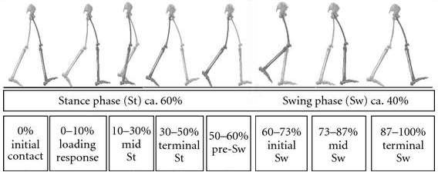

Figure 2.1. Seven sub-phases percentage of the whole gait cycle

* Temporal-spatial parameters: The length of the stride and speed of walking are the most frequent temporal-spatial factors that are evaluated during gait(Richards, 2018). The amount of distance covered in a given amount of time (meters/second) is referred to as walking speed (Richards, 2018). The average walking speed in healthy persons is around 1.2-1.3 m/s (Bohannon et al., 1987).
* Kinematics of gait: Kinematics is the study of the spatial movements of the body that cause the movement, including the joint motion, velocity, displacement, and acceleration of the body parts (Winter, 2009). The sample of the kinematics motion patterns for the feet and the ankles, knees, and hips joints throughout a GC are shown in the following figure (Figure 2.2).

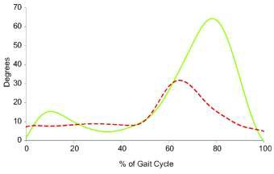

*Figure 2.2 shows the sample of joint kinematics motion patterns through GCs.*

## Post-stroke gait:

Stroke usually might cause hemiparesis which could lead to some function loss and weakness on one side of the body. Hemiparesis can influence a participant’s gait(Emos and Agarwal, 2023). According to several research, post-stroke gait kinematic characteristics differ from normal gait parameters both in terms of pattern (profile of curves) and magnitude (peak values and range)(Handelzalts et al., 2019).

Patients with hemiparesis gait often walk more slowly, with speeds ranging from (0.22 ± 0.11 m/s) to (0.72 ± 0.38 m/s)(Olney and Richards, 1996). Atypical temporal-spatial parameters are another characteristic of hemiplegic gait. For example, step and rhythm and the length of the stride of the afflicted limb are often decreased(Esquenazi et al., 2009, Hausdorff and Alexander, 2005). In addition, the

duration of the swing phase on affected limbs generally lasts longer than the normal limb(Chen et al., 2005). Additionally, 20% of patients with stroke generally have shown plantarflexion abnormality in hemiplegic gait(Barrett and Taylor, 2010).

The ankle rests in a plantarflexed condition, which is indicative of plantarflexion deformity. As a result, the heel strike of a loading reaction is lost at the moment of initial contact with the floor. The tibia is also pushed backward when the heel touches the ground. Consequently, the knee is positioned further posterior aspect (hyperextended) than normally (NHS, 2009, Perry and Burnfield, 2010) as shown in Figure 2.3. Ankle rocker is lost because of the tibia's continued forward movement being obstructed by persistent plantarflexion during mid-stance(Esquenazi et al., 2009).

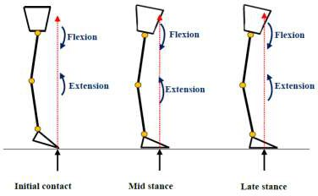

*Figure 2.3 the reason for hyperextending of the knee joint.*

The clearance of the feet from the ground during the swing phase is one of the primary gait requirements(Perry and Burnfield, 2010, Richards, 2018). Ground clearance difficulties were caused by a lack of knee flexion at the terminal stance phase (Esquenazi et al., 2009). There are several typical substitute motions, To increase foot ground clearance, which include; hip hiking (increasing of the hip

abduction of healthy stance extremity with concurrent elevation of the affected swing limb), vaulting (increased plantarflexion of the healthy stance extremity throughout mid-stance and terminal-stance), circumduction of the leg, and bend the trunk laterally in the direction of the stance extremity (Chen et al., 2005)**.** To increase foot ground clearance and minimize the risk of falling, individuals with plantarflexion deformities need to get some type of treatment.

## Orthotic management of stroke patients with plantarflexion deformity:

## Introduction:

A goal in stroke rehabilitation is to improve walking in patients with plantarflexion deformities, and this is commonly performed through physical therapy(Begg et al., 2019, Teasell et al., 2001). Moreover, ankle foot orthoses (AFOs) are used in assisting with physical therapy to manage stroke patients(Condie E, 2004, Winstein et al., 2016). In clinical practice, AFOs are the group of lower extremity orthoses that are most frequently given. (Condie and Bowers, 2008, Teasell et al., 2001) They are frequently recommended to stroke patients to encourage initial heel striking contact (by reducing/preventing the ankle's excessive plantarflexion position), to improve foot ground-clearance during the swing phase, to enhance and support the foot alignment (treat equinovarus deformity), and to decrease extension of the knee and increase hip extension through stance phase(Condie E, 2004, NHS, 2009)

## Common types of AFO:

Patients experiencing plantarflexion deformities may benefit from a variety of AFO types and designs. There are several AFO designs in (Figure 2.4), including rigid AFOs, posterior leaf springs (PLS), and hinge or articulating AFOs (HAFO).

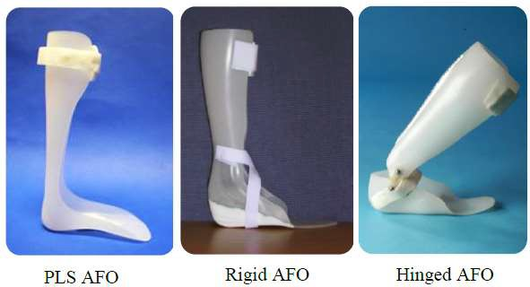

*Figure 2.4 Different AFO Types and Designs.*

* Posterior leaf spring (PLS) AFO: (PLS) frequently refers to a prefabricated AFO with a flexible design (Sumiya et al., 1996) (Figure 2.4). the main indication for the Posterior leaf spring is Isolated weakness of the dorsi-flexor to increase foot ground clearance during the swing phase (NHS, 2009). Because of the PLS's material characteristics, the AFO could release energy throughout the swing phase to improve dorsiflexion and replenish energy throughout the stance phase(Condie and Bowers, 2008, Richards, 2018). If

patients are suffering from muscular spasticity (high tone), this kind of AFO is not recommended (NHS, 2009).

* Rigid AFO: intends to prevent all foot and ankle movements (Condie E, 2004). The primary characteristic of the rigid AFO is Spasticity of the plantar flexor muscles (high tone), contracture of soleus and/or gastrocnemius, foot mediolateral instability, and/or problems of the stance phase affecting knee and hip joints(NHS, 2009).
* Hinged or articulated AFO (HAFO): It is made of two thermoplastic parts (one for the foot and another for the shank segment), which are connected together through a mechanical ankle joint that may be adjusted to permit or aid mobility in the one direction while restricting or preventing movement in other direction (Condie E, 2004, NHS, 2009) (Figure 2.4). The HAFO design permits dorsiflexion and prevents plantarflexion over the normal ankle angle (90°), HAFO design is the one that is most frequently recommended (Condie E, 2004, NHS, 2009).

# Methodology

## Method’s design:

The research subject was designed as a comparative study, and the research condition or test was administered to every participant. Each participant was assigned to both conditions (using AFO and without AFO) walking 10 meters in a straight line and doing some variable tests to collect data.

## Participants:

Forty-two participants involved in the study fourteen apparently health participants. And twenty-eight participants were diagnosed with a stroke that had a foot-drop deformity. All participants voluntarily agreed to participate in the study.

## Stroke participants:

More than forty patients diagnosed with stroke, who had a foot drop deformity have been assessed but only twenty-eight participants recruited from the Hawler teaching hospital, Rzgare hospital, PAR hospital and Europe Rehabilitation Center in Iraq. Of the 28 stroke participants, 16 were male and 12 were female (15 with hemiplegia on the right side and 13 with hemiplegia on the left side). The age of stroke participants is between (18 - 56 years), the height is between (1.49 – 1.70 m) and the body weight is between (67 - 91 kg).

The inclusion criteria for stroke participants were:

1. Patients diagnosis with stroke (at least six months ago) with drop-foot.
2. Over 18 years old.
3. Able to walk (10- 15 meters) without walking aids.
4. No spasticity.
5. Able to provide notified consent.

## control participants:

Of the fourteen normal participants, 7 were male and 7 were female, the age of the participants was between (19 - 47 years), the height was between (1.51 – 1.79 m) and the body weight was between (62 - 92 kg).

The inclusion criteria for control participants were:

1. Over 18 years of age.
2. Good general health.
3. Able to provide notified consent.

## Experimental procedure:

All participants were invited to attend two study sessions for less than 2 hours each. In the first session, the study was fully explained to the participants and any questions that the participants may have been answered then history and general information were taken from the participants (Appendix.1). During this, we checked the orthosis fitting and several exercises and gait training were given to the patients. In the second session (ten days to two weeks later) we recorded the participant’s gait. The place that the data collected from that study was within the Europe Rehabilitation Center.

## Types of AFO used:

Different types and designs of AFO can be useful for patients with plantar-flexion deformity. In this study, we used posterior leaf spring (PLS), (Figure 3.1). PLS is usually a prefabricated AFO that has a flexible design. The prime indication for PLS is to enhance foot ground clearance in the swing. The material property of PLS permits AFO to restore stored energy during the stance phase and then release it through the swing phase to assist the dorsiflexion.

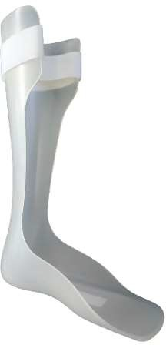

*Figure 3.1 Posterior leaf spring (PLS) used in this study.*

## Motion capture setup:

The second meeting was managed in the gait analysis laboratory that we conducted at the Europe Rehabilitation Center. The laboratory involves:

* A Two-dimensional (2D) motion capture system consists of two cameras that are placed in the back and affected side of participants, to collect kinematic data.
* Prepared area by installing chairs for participants and Graded walking area 10 meters in a straight line.

The cameras that recording the location of markers placed on the participant’s body during the test, then kinematic data were acquired.

Regarding data processing, after kinematic data were collected, they were processed using Computer gait analysis (modified Vicon software) in this research (Figure 3.2), regionally it’s a novelty study witch using software gait analysis.

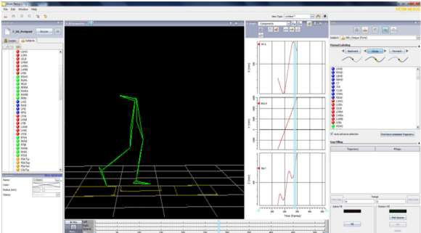

*Figure 3.2 Vicon software gait analysis in the sagittal plane.*

The motion capture consists of two main parts:

1. Camera setup:

Two cameras were used in the back and affected side of the participants of the room. They are adjusted and aligned in proper positions to obtain complete data collection from the measurement volume while walking 10 meters in a straight line. Then both cameras are connected to the computer with modified Vicon software to collect kinematic data (Figure 3.3).

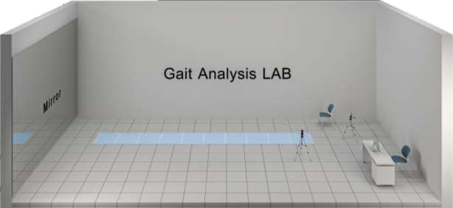

*Figure 3.3 gait analysis laboratory.*

1. marker positions:

Markers were placed on the (ankles, knee, hip and pelvic) for gait analysis. The anatomical point for measuring joint range of motion in the sagittal plane, in the ankle joint one on the side (lateral malleoli) and the second posteriorly fixed on the level of the ankle joint there are other marks on the 5th metatarsal of the foot, knee joint (Lateral epicondyle of the femur and the second one, as shown in the

picture it is posteriorly fixed on the level of the knee joint), hip joint (Greater Trochanter) and the second posteriorly fixed on the level of the hip joint, and two markers on posterior superior iliac spine. The markers were placed directly on the AFO and the affected limb of the subjects (Figure 3.4).

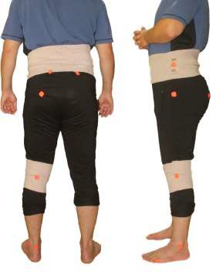

*Figure 3.4 Marks were fixed on the participant’s body to be collected and analyzed.*

## Gait laboratory procedure:

Before each participant arrived, the gait laboratory was set up and all the equipment was examined. Then after checking and calibrated that the cameras could see all the markers, asked all participants to walk 10 meters in a straight line and their gait was recorded at CWS. After each test condition, all participants were offered time to relax if necessary. Two conditions were done first (barefoot) OUT-AFO condition

asked the participants to walk barefoot with OUT-AFO. Second AFO condition the participants walk with AFO.

## Data analysis:

The GraphPad Prism (Version 9.0) program was used to analyze the data. One-way analysis of variance (ANOVA) and post hoc Tukey’s test were carried out for comparison among the three studied groups. All data were presented as Mean and Standard error. The significance level (P<0.05) was regarded as significant.

The primary outcome measures in this study were:

1. Kinematic data in the sagittal plane: Hip, Knee and ankle range of motion.
2. Temporal-distance parameters: walking speed, stride length, time up and go, stance, and swing percent.

kinematic data analysis:

cycle of the gait was defined from the initial contact of the foot to the subsequent ipsilateral (same foot) initial contact. The stance phase was defined from the initial contact of the foot to the subsequent ipsilateral toe-off. All kinematic parameters were based on the mean and the standard error of the minimum/maximum peak values within fifteen gait cycles for each condition and each participant.

Furthermore, parameters of temporal-spatial (stride length, speed, time up and go, stance, and swing time) were likewise calculated to identify the differences between the conditions tested.

# Result

The research focused on investigating the immediate benefits of using an AFO as compared to OUT-AFO on the gait of Stroke Participants (SP) regarding their joints and then compared to normal Participants (NP). Furthermore, this research focused on measuring the joint angle. The primary goal was to examine how stroke participants responded to AFO. From 42 participants we divided them into 3 groups (the first and second groups were 28 stroke participants that used AFO and with OUT-AFO and the third group was 14 normal participants with good health).

## General information about participants:

In the general information we have mentioned (Gender, Age, Hemiplegia Side, Height, and Weight) for each of stroke and normal participants separately as shown in Table (4.1, 4.2).

Of the 28 stroke participants, 16 were male and 12 were female (15 with hemiplegia on the right side and 13 with hemiplegia on the left side). The age of stroke participants is between (18 - 56 years), the height is between (1.49 – 1.70 m) and the body weight is between (67 - 91 kg). We have shown more details in Table (4.1).

*Table 4.1 General information on stroke participants.*

**Stroke participants Distribution Number of participants Percent**

|  |  |  |  |
| --- | --- | --- | --- |
| **Gender** | Male | 16 | 57.1% |
| Female | 12 | 42.9% |
| **Age** | 18-25 years | 4 | 14.3% |
| 25-45 years | 15 | 53.6% |
| 45-56 years | 9 | 32.1% |
| **Hemiplegia Side** | Right | 15 | 53.6% |
| Left | 13 | 46.4% |
| **Height** | 1.49-1.60 m | 17 | 60.7% |
| 1.60-1.70 m | 11 | 39.3% |
| **Weight** | 67-75 | 12 | 42.9% |
| 75-91 | 16 | 57.1% |

Of the fourteen normal participants, 7 were male and 7 were female, the age of the participants was between (19 - 47 years), the height was between (1.51 – 1.79 m) and the body weight was between (62 - 92 kg). Also shown are details in table (4.2).

*Table 4.2 General information of normal participants*

**Normal participants Distribution Number of participants Percent**

|  |  |  |  |
| --- | --- | --- | --- |
| **Gender** | Male | 7 | 50% |
| Female | 7 | 50% |
| **Age** | 19-25 years | 4 | 28.6% |
| 25-47 years | 10 | 71.4% |
| **Recorded Side** | Right | 7 | 50% |
| Left | 7 | 50% |
| **Height** | 1.51-1.60 m | 8 | 57.1% |
| 1.60-1.79 m | 6 | 42.9% |
| **Weight** | 62-75 | 9 | 64.3% |
| 75-92 | 5 | 35.7% |

## Temporal-spatial:

Parameters of temporal-spatial (walking speed, stride length, stance, swing percent, and time up and go) were measured to identify the differences between AFO, OUT- AFO, and normal conditions (Table 4.3).

*Table 4.3 Temporal-spatial comparison of Mean, standard error, and p-value between (Normal, AFO, and OUT-AFO groups).*

**Temporal-spatial**

**Parameters**

**Conditions**

**Mean**

**Standard Error of mean**

|  |
| --- |
| **P-Value** |

|  |  |  |  |
| --- | --- | --- | --- |
| Walking Speed | Normal | 1.19 | 0.02 |
| AFO | 0.62 | 0.04 |
| (m/s) |
|  | OUT-AFO | 0.38 | 0.03 |

|  |
| --- |
| Normal vs AFO <0.0001 |
| Normal vs OUT-AFO <0.0001 |
| AFO vs OUT-AFO <0.0001 |

|  |  |  |  |
| --- | --- | --- | --- |
| Stride length | Normal | 1.13 | 0.06 |
| AFO | 0.59 | 0.04 |
| (m) |
|  | OUT-AFO | 0.38 | 0.03 |

|  |
| --- |
| Normal vs AFO <0.0001 |
| Normal vs OUT-AFO <0.0001 |
| AFO vs OUT-AFO =0.0005 |

|  |  |  |  |  |  |  |
| --- | --- | --- | --- | --- | --- | --- |
| Stance percentage | Normal | 65.77 | 0.52 |  | Normal vs AFO | =0.0021 |
| AFO | 68.8 | 0.14 | Normal vs OUT-AFO | <0.0001 |
| (%) |
|  | OUT-AFO | 71.21 | 0.71 | AFO vs OUT-AFO | =0.0026 |

|  |  |  |  |
| --- | --- | --- | --- |
| Time up and go | Normal | 10.24 | 0.09 |
| AFO | 22.56 | 1.46 |
| (s) |
|  | OUT-AFO | 36.09 | 2.57 |

|  |
| --- |
| Normal vs AFO =0.001 |
| Normal vs OUT-AFO <0.0001 |
| AFO vs OUT-AFO <0.0001 |

## Walking Speed:

Fig.4.1 and Table 4.3, clearly show the increase in the walking speed while using AFO, and a highly significant difference (P<0.0001) was observed between both OUT-AFO conditions (0.38±0.03 m/s) and AFO condition (0.62±0.04 m/s) in SPs. While the normal participants’ walking speed is (1.19±0.02 m/s), likewise, there was a highly significant difference (P<0.0001) between the AFO condition compared to Normal participants.

The interesting results of this study exhibited that walking with AFO in stroke participants was nearly (0.24 m/s) faster as compared with OUT-AFO condition.

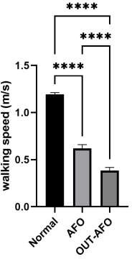

*Figure 4.1 Comparison of walking speed for (AFO, OUT-AFO, and normal groups).*

## Stride length:

As shown in Fig.4.2 and Table 4.3 the mean Stride length identically increased in AFO Participants compared to the OUT-AFO participants and a highly significant (P=0.0005) was observed between both OUT-AFO condition (0.38±0.03 m) and AFO condition (0.59±0.04 m) in SPs, while the normal participants’ Stride length is (1.13±0.06 m). Among the interesting findings of the current research displayed that walking with AFO benefits to improved pattern of gait cycle making their walking easier and safer by improving balance.

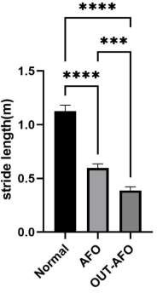

*Figure 4.2 Comparison of stride length for (AFO, OUT-AFO, and normal groups).*

## Stance percentage:

As revealed In Fig.4.3 and Table 4.3 we exhibit that increased mean stance percentage while using AFO and a significant difference (P=0.0026) was noticed between both the OUT-AFO condition (71.21±0.71 %) and AFO condition (68.8±0.14 %) in SP. While the Stance percentage of the normal participants is (65.77±0.52 %). likewise, there were significant differences between the OUT-AFO and AFO condition compared to NPs. At that point, the interesting results of this study exhibited that stance percentage with AFO closer to NPs, helps to have a better GC.

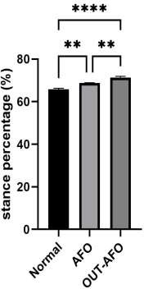

*Figure 4.3 Comparison of stance percentage for (AFO, OUT-AFO, and normal groups).*

## Time up and go (TUG):

As shown in Fig.4.4 and Table 4.3 the mean TUG identical decreased in Stroke Participants and a highly significant (P<0.0001) was observed between both OUT- AFO condition (36.09±2.57 s) and AFO condition (22.56±1.46 s) in SPs, while the normal participants’ TUG is (10.24±0.09 s). Among the interesting findings of the current research displayed that walking with AFO in stroke participants is (13.4 s) faster as compared with the OUT-AFO condition, which benefits the participants to have a better ADL that makes their daily work easier and faster.

✱✱✱✱

**50**

✱✱✱✱

✱✱✱

**40**

**Time Up and Go(s)**

**30**

**20**

**10**

**0**

*Figure 4.4 Comparison of TUG for (AFO, OUT-AFO, and normal groups).*

## Kinematic parameters:

Kinematic parameters were used as a basis for the mean of the minimum/maximum peak values of the joint movement after fifteen gait cycles (GCs) for both stroke and normal participants.

## Ankle joint kinematic:

In table 4.4 we showed the result of the Ankle joint kinematics between (Normal, AFO, and OUT-AFO groups).

*Table 4.4 Ankle joint kinematic comparison of Mean, standard error, and p-value between (Normal, AFO, and OUT-AFO groups).*

**Ankle joint kinematic**

**Parameters**

**Conditions**

**Standard**

**Error of mean**

**Mean**

|  |
| --- |
| **P-Value** |

|  |  |  |  |
| --- | --- | --- | --- |
| Ankle plantar | Normal | -11.79 | 0.25 |
| flexion peak (early stance) (Degree) | AFO | -0.53 | 0.08 |
| OUT-AFO | -2.11 | 0.16 |

|  |
| --- |
| Normal vs AFO <0.0001 |
| Normal vs OUT-AFO <0.0001 |
| AFO vs OUT-AFO <0.0001 |

|  |  |  |  |
| --- | --- | --- | --- |
| Ankle dorsal flexion | Normal | 9.82 | 0.39 |
| AFO | 1.43 | 0.16 |
| peak (Degree) |
|  | OUT-AFO | 3.13 | 0.49 |

|  |
| --- |
| Normal vs AFO <0.0001 |
| Normal vs OUT-AFO <0.0001 |
| AFO vs OUT-AFO 0.0028 |

|  |  |  |  |
| --- | --- | --- | --- |
| Ankle plantar | Normal | -18.29 | 0.19 |
| flexion peak (swing phase) (Degree) | AFO | -0.73 | 0.07 |
| OUT-AFO | -2.39 | 0.11 |

|  |
| --- |
| Normal vs AFO <0.0001 |
| Normal vs OUT-AFO <0.0001 |
| AFO vs OUT-AFO <0.0001 |

* + - 1. Ankle plantar flexion peak (early stance)

As shown in Fig.4.5 and Table 4.4 decreased plantar flexion peak in the early stance phase and a highly significant difference(P<0.0001) was observed between both OUT-AFO condition (-2.12±0.16 degrees) and AFO condition (-0.54±0.08 degrees) in SP. while the normal participants’ plantar flexion peak is (-11.8±0.25 degrees). The results of this study displayed that using AFO caused limited ankle joint movements and remained it at around 90 angle position.

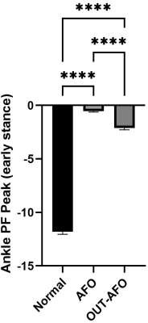

*Figure 4.5 Comparison of Ankle plantar flexion peak (early stance) for (AFO, OUT-AFO, and normal groups).*

* + - 1. Ankle dorsal flexion peak

In Fig.4.6 and Table 4.4, we exhibit that decreased dorsal flexion peaks in the early stance phase and a significant difference (P=0.0028) was observed between both OUT-AFO conditions (3.13±0.49 degrees) and AFO condition (1.43±0.16 degrees) in SPs. While the normal participants’ flexion peak is (9.82±0.39 degrees), likewise, there was a highly significant difference (P<0.0001) between the AFO condition compared to Normal participants. The results of this study exhibited that using AFO caused limited ankle joint movements and remained it at around 90 angle position.

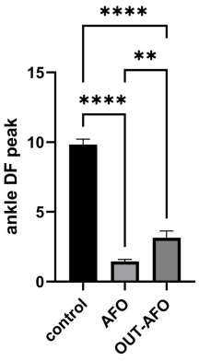

*Figure 4.6 Comparison of Ankle dorsal flexion peak for (AFO, OUT-AFO, and normal groups).*

* + - 1. Ankle plantar flexion peak (swing phase)

As shown in Fig.4.7 and Table 4.4 decreased flexion peak in the planter flexion peak in the swing phase and a highly significant difference (P<0.0001) was observed between both OUT-AFO condition (-2.39±0.11 degrees) and AFO condition (- 0.73±0.07 degrees) in SP. while the normal participants’ flexion peak is (- 18.29±0.19 degrees). The results of this study showed that using AFO caused limited ankle joint movements and remained at a near natural position.

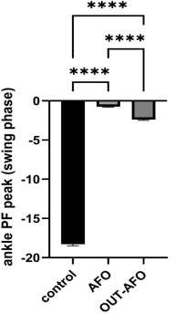

*Figure 4.7 Comparison of Ankle plantar flexion peak (swing phase) for (AFO, OUT-AFO, and*

*normal groups).*

## Knee joint kinematic:

In table 4.5 we showed the result of the Knee joint kinematics between (Normal, AFO, and OUT-AFO groups).

*Table 4.5 Knee joint kinematic comparison of Mean, standard error, and p-value between (Normal, AFO and OUT-AFO groups).*

**Knee joint kinematic**

**Parameters**

**Conditions Mean Standard Error**

**of mean**

|  |
| --- |
| **P-Value** |

|  |  |  |  |
| --- | --- | --- | --- |
| Knee flexion | Normal | 13.5 | 0.96 |
| peak (stance)  (Degree) | AFO | 16.2 | 0.26 |
| OUT-AFO | 8.2 | 0.65 |

|  |
| --- |
| Normal vs AFO 0.0138 |
| Normal vs OUT-AFO <0.0001 |
| AFO vs OUT-AFO <0.0001 |

|  |  |  |  |
| --- | --- | --- | --- |
| Knee extension | Normal | 5.6 | 0.57 |
| peak (terminal stance)(Degree) | AFO | 3.8 | 0.45 |
| OUT-AFO | 0.2 | 0.27 |

|  |
| --- |
| Normal vs AFO 0.0148 |
| Normal vs OUT-AFO <0.0001 |
| AFO vs OUT-AFO <0.0001 |

|  |  |  |  |
| --- | --- | --- | --- |
| knee plantar | Normal | 64.4 | 0.53 |
| flexion peak |
| AFO | 39.8 | 2.43 |
| (swing phase) |
| OUT-AFO | 26.1 | 1.87 |
| (Degree) |

|  |
| --- |
| Normal vs AFO <0.0001 |
| Normal vs OUT-AFO <0.0001 |
| AFO vs OUT-AFO <0.0001 |

* + - 1. Knee flex peak (stance):

Fig.4.8 and Table 4.5 clearly show the increase of the flexion peaks in the early stance phase and a highly significant difference (P<0.0001) was observed between both OUT-AFO conditions (8.16±0.65 degrees) and AFO condition (16.24±0.26 degrees) in SPs. While the normal participants’ flexion peak is (13.54±0.96 degrees), likewise, there was a significant difference (P=0.0138) between the AFO condition compared to Normal participants. The interesting results of this study exhibited that using AFO caused to have better knee flexion in early stance.

✱✱✱✱

**20**

✱✱✱✱

✱

**knee flex peak (stance)**

**15**

**10**

**5**

**0**

*Figure 4.8 Comparison of knee flex peak (Stance) for (AFO, OUT-AFO, and normal groups).*

* + - 1. Knee extension peak (terminal stance):

As shown In Fig.4.9 and Table 4.5 we exhibit that increased extension in the late stance phase and a highly significant difference (P<0.0001) was noticed between both the OUT-AFO condition (0.16±0.27 degrees) and AFO condition (3.82±0.45 degrees) in SP. While the normal participants’ extension peak is (5.65±0.57 degrees). Similarly, there were significant differences (P=0.0148) between the AFO condition compared to NPs. At that point the interesting results of this study exhibited that using AFO has caused a huge increase in the late stance of knee extension, it helps to have a better GC in the stance phase.

✱✱✱✱

**8**

✱✱✱✱

✱

**knee ext (terminal stance)**

**6**

**4**

**2**

**0**

Figure 4.9 Comparison extension peak of knee (terminal stance) in the knee joint for (AFO, OUT-AFO, and normal groups).

* + - 1. Knee flex peak (swing):

As shown in Fig.4.10 and Table 4.5 identical increased flexion peaks in the early swing phase and a highly significant difference (P<0.0001) was observed between both OUT-AFO condition (26.12±1.87 degrees) and AFO condition (39.78±2.43 degrees) in SP. while the normal participants’ flexion peak is (64.37±0.53 degrees). The interesting results of this study displayed that using AFO produced better knee flexion than the barefoot condition, it helps to eliminate scratching the foot on the floor.

✱✱✱✱

✱✱✱✱

✱✱✱✱

**80**

**60**

**40**

**20**

**0**

**knee flex peak (swing)**

*Figure 4.10 Comparison of knee flexion peak (swing) in the knee joint for (AFO, OUT-AFO, and normal groups).*

## Hip joint kinematic:

In table 4.6 we showed the result of the Hip joint kinematics between (Normal, AFO, and OUT-AFO groups).

*Table 4.6 Hip joint kinematic comparison of Mean, standard error, and p-value between (Normal, AFO and OUT-AFO groups).*

**Hip joint kinematic**

**Parameters Conditions Mean Standard Error of**

**mean**

|  |
| --- |
| **P-Value** |

|  |  |  |  |
| --- | --- | --- | --- |
| Hip ext. | Normal | -8.58 | 0.34 |
| peak  (Degree) | AFO | 13.78 | 2.05 |
| OUT-AFO | 23.9 | 1.75 |

|  |
| --- |
| Normal vs AFO <0.0001 |
| Normal vs OUT-AFO <0.0001 |
| AFO vs OUT-AFO =0.0003 |

|  |  |  |  |
| --- | --- | --- | --- |
| Hip flex peak | Normal | 32.54 | 0.29 |
| AFO | 33.96 | 0.79 |
| (Degree) |
|  | OUT-AFO | 39.1 | 0.87 |

|  |
| --- |
| Normal vs AFO =0.521 |
| Normal vs OUT-AFO <0.0001 |
| AFO vs OUT-AFO <0.0001 |

* + - 1. Hip extension peak:

In Fig.4.11 and table 4.6 We exhibit that demonstrated increased extension peaks in the stance phase and a highly significant difference (P=0.0003) was observed between both OUT-AFO conditions (13.78±2.05 degrees) and AFO conditions (23.9±1.75 degrees) in SPs. While the normal participants’ extension peak is (- 8.58±0.34 degrees), likewise, there was a highly significant difference (P<0.0001) between the AFO condition compared to Normal participants. The interesting results of this study exhibited that using AFO caused to walk with fewer hip flexion in the stance phase.

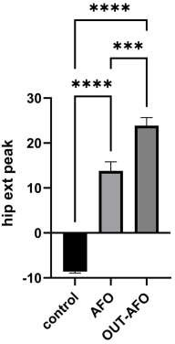

*Figure 4.11 Comparison of Hip extension peak for (AFO, OUT-AFO, and normal groups).*

* + - 1. Hip flexion peak (swing phase):

As shown in Fig.4.12 and table 4.6 Decreased flexion peak in the swing phase and a highly significant difference (P<0.0001) was observed between both OUT-AFO conditions (39.1±0.87 degrees) and AFO condition (33.96±0.79degrees) in SP. while the normal participants’ flexion peak is (32.54±0.29 degrees), on the temporary there was no significant difference (p=0.521) was observed between normal and AFO conditions. The interesting results of this study displayed that using AFO produces better hip joint GC to provide better balance and avoid falling.

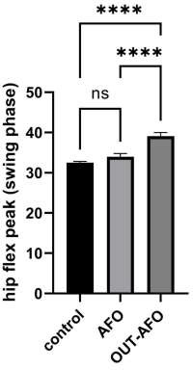

*Figure 4.12 Comparison of Hip flexion peak (swing phase) for (AFO, OUT-AFO, and normal groups).*

# Discussion

The purpose of the current study is to compare the immediate effects of wearing an AFO to those of OUT-AFO on the gait parameters of stroke participants and control participants as they walk 10 meters.

This is important to mention that, despite uncontrollable factors being made to a minimum, several factors in the research's protocols were extremely difficult to control. These factors should be taken into consideration before analyzing the results and drawing any conclusion from this study. The degree of spasticity of stroke participants' is one of the most crucial factors. As a result, the spasticity complication in stroke participants is excluded among the inclusion criteria for this research (Cakar et al., 2010). Another factor that might affect the results of this research is the time and duration of the rehabilitation program that the stroke patients underwent. Nevertheless, it has been demonstrated that ankle foot orthoses have various effects on stroke patients' gait patterns (Choo and Chang, 2021, Daryabor et al., 2018, Daryabor et al., 2022).

## Temporal-spatial parameters

As we showed in Fig 5.1 the walking speed was faster, and the Stride length was longer with using an AFO as compared to OUT-AFO in the all-stroke participants. This approves with the previous research (Guerra Padilla et al., 2014). The speed of walking of the stroke patients in the current study ranged (between 0.22 to 0.54 m/s) when they were not using an AFO, but it has been improved significantly to (ranging from 0.38 m/s to 0.62 m/s) while wearing an AFO. Prolonged usage of the AFO (after three months) resulted in an improvement in stride length and speed of

walking. However, Time up and go is better when using an AFO because the walking speed is faster and standing is easier with using an AFO compared to OUT-AFO

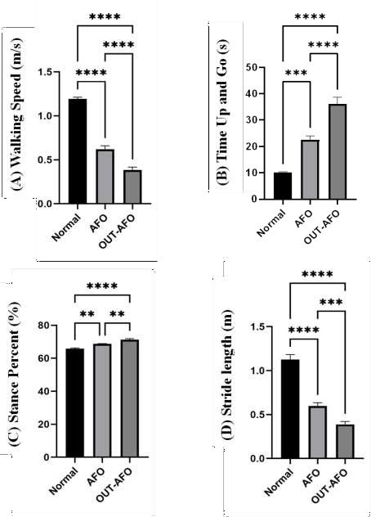

*Figure 5.1 Temporal-spatial Comparison of walking speed, Time Up and Go, Stance Percent, and Stride Length for (AFO, OUT-AFO, and normal groups).*

in the all-stroke participants, that can be because of reducing the power needed to stand when using an AFO. TUG of the stroke patients in the current study ranged (between 17.4 to 54.6 s) when they were not using an AFO but improved clinically significantly to (ranging between 16.5 to 28.7 s) while wearing an AFO. Progresses in TUG in this study were caused by enhancing the kinematic alignment nearer to the normal, mainly through the mid and terminal stance (Roelker et al., 2019). And improving getting up the chair ability.

## Kinematic parameters

Ankle joint parameters:

According to the literature (Gard and Fatone, 2003), Walking with OUT-AFO revealed common characteristics of stroke gait, which is an ankle in a plantarflexion condition. In the Initial contact and during the loading response, all participants' ankle joint is plantarflexed. In the condition of mid stance and terminal stance, a number of participants presented slight dorsiflexion, while a few slightly decreased their plantarflexed of the ankle position. Furthermore, through the swing phase, in all participants, the ankle joint remained in a plantarflexed position, which caused circumduction gait.

In (Fig 5.2) we demonstrated the stroke Participants who used an AFO for the ankle joint were affected by two factors raise first the whole ROM in the all-stroke participants was extremely limited while walking with an AFO (The limited degree of joint ROM at the ankle joint was 8.4 degrees for the SPs with OUT-AFO and 3 degrees for the stroke participants with AFO, respectively). Another point is that several stroke participants showed some plantarflexed of the ankle, particularly

during early mid-stance and loading response, which gives us an indication that they behave as a dynamic device. This ankle plantarflexion is slightly (fewer than 2 degrees). Plantarflexion has decreased during the swing phase, which indicates that the AFO has improved ground clearance for the foot, due to the spring action of the AFO in assisting dorsiflexion. These points could be the reason behind the improvement of the ankle kinematic parameters.

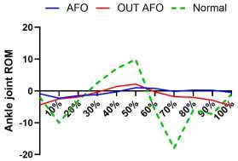

**Dorsal Flex**

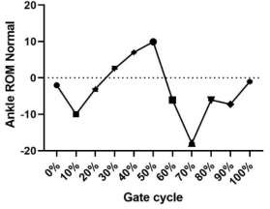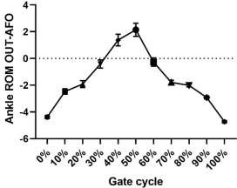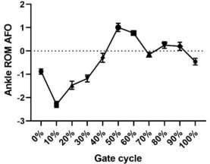

*Figure 5.2 Ankle joint kinematic Comparison of Ankle plantar flexion peak (early stance), Ankle dorsal flexion peak, and Ankle plantar flexion peak (swing phase) for (AFO, OUT-AFO, and normal groups).*

Knee joint parameters:

When speaking about knee joint kinematics we find out that the major characteristic of the knee motion during walking with OUT-AFO in stroke patients is a greatly diminished or missing knee flexion throughout the loading response, this is because of poor or not locking the ankle joint movement, that transfers the effect of the Ground Reaction Force (GRF) to the knee joint Typically, the foot is plantarflexed at initial contact, preventing knee flexion because of changing the line action of the ground reaction force during the initial contact. At that point keeping the knee in its extended position during terminal swing (Taylor et al., 2022). This remains during stance and then even causes to prolong the stance phase as compared to control groups, this is because of difficulty to flexion of the knee. In the swing phase, decreased knee flexion is a characteristic of the typical knee motion in stroke patients. Some factors might cause this. Firstly, very difficult to flex the knee through the stance phase after it has been extended in the initial contact which reduces knee flexion in the initial swing and pre-swing in the stroke participants. Secondly, in the initial-swing and pre-swing flexion of the hip was decreased in stroke participants. And mainly because of the spasticity, the patient has.

In (Fig. 5.3) we show that when comparing the participant's usage of AFO to OUT- AFO, we can notice a greater knee flexion throughout the loading response. AFO improves the knee flexion moment by initiating the gait with heel contact and getting the point of the ground reaction force to the heel, which will create a knee flexion moment. According to the study's findings, all stroke patients had significantly reduced knee extension throughout the terminal stance and enlarged knee flexion peak through the swing phase (Choi et al., 2016).

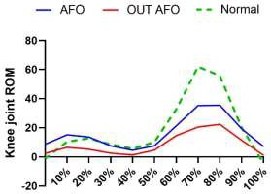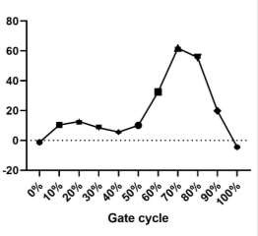

**Flex**

**Knee ROM Normal**

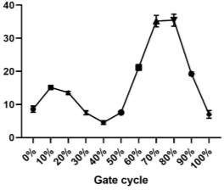 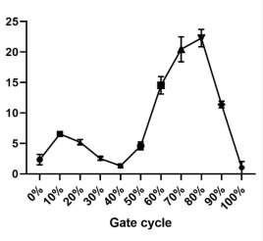

*Figure 5.3 Knee joint kinematic Comparison of knee flex peak (Stance), knee extend peak, and knee flexion peak (swing phase) for (AFO, OUT-AFO, and normal groups).*

**Knee ROM AFO**

**Knee ROM OUT-AFO**

Hip joint parameters:

The major characteristic of hip motion during walking with OUT-AFO in stroke patients is that the hip joint is flexed through the stance phase. The ground reaction force location is (in front of the knee and hip) and the hyperextension of the knee position makes it difficult to extend of hip due to the existence of an external moment

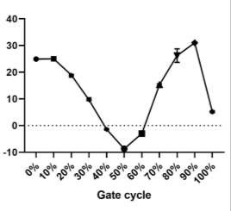in hip flexion. For better balance and to avoid falling, stroke patients try to bend their upper bodies anteriorly.

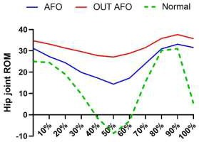

**Flex**

**Hip ROM Normal**

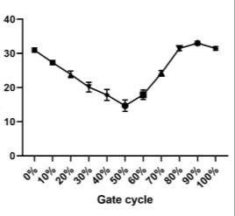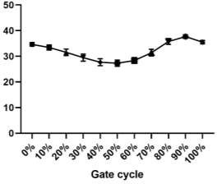

*Figure 5.4 Hip joint kinematic Comparison of Hip extension peak, and Hip flexion peak (swing phase) for (AFO, OUT-AFO, and normal groups).*

**Hip ROM AFO**

**Hip ROM OUT-AFO**

In (Fig. 5.4) we showed that the Usage of an AFO caused reduced hip flexion in most stroke participants. The peak flexion of the hip was improved in stroke participants. While using an AFO During mid to terminal stance, the GRF moves

posteriorly in relation to the hip, which will create a hip extension moment. This could help to facilitate the extension of the hip and minimize the undesirable flexion moment of the hip joint, and therefore stroke participants might walk with fewer hip flexions in the stance phase containing hip extension periods.

# Conclusion

## Conclusion:

Overall, in this study, The study showed that using a PLS AFO can be beneficial for improving ankle, knee, and Hip joint ROM and progress walking speed, Time Up and Go, Stance Percent, and Stride Length those have benefits for gait symmetry, and balance, and reducing the risk of falls. However, the effectiveness of AFOs may vary depending on the severity of the stroke and individual patient's needs.

## Recommendation:

In the present research, we discuss the effects of PLS AFO on the sagittal plane motion of the ankle, knee, and Hip joints were investigated.

In the future studies our recommended is to increase the sample size and discussed about 3-D kinematic investigation of the hip, knee, and ankle in the sagittal and frontal planes should be considered.

In this study, we only discuss the effects of PLS AFO compared to barefoot. In the future studies we recommended to use other types of AFO or compare between two types by using software gait analysis.

# References

AL-OBAIDI, H., KHIDHAIR, Z., JIRJEES, F., BARAKAT, M., ALSALAMAT, H., KHARABA, Z., ALFOTEIH, Y., HADDAD, C., MANSOUR, S., HALLIT, S., MALAEB, D. & HOSSEINI, H. 2023. Factors associated with

knowledge and awareness of stroke in the Iraqi population: a cross-sectional study. *Front Neurol,* 14**,** 1144481.

BARRETT, C. & TAYLOR, P. 2010. The effects of the odstock drop foot stimulator on perceived quality of life for people with stroke and multiple sclerosis. *Neuromodulation,* 13**,** 58-64.

BEGG, R., GALEA, M. P., JAMES, L., SPARROW, W. A. T., LEVINGER, P., KHAN, F. & SAID, C. M. 2019. Real-

time foot clearance biofeedback to assist gait rehabilitation following stroke: a randomized controlled trial protocol. *Trials,* 20**,** 317.

BOHANNON, R. W., LARKIN, P. A., SMITH, M. B. & HORTON, M. G. 1987. Relationship between static muscle strength deficits and spasticity in stroke patients with hemiparesis. *Phys Ther,* 67**,** 1068-71.

CAKAR, E., DURMUS, O., TEKIN, L., DINCER, U. & KIRALP, M. Z. 2010. The ankle-foot orthosis improves balance and reduces fall risk of chronic spastic hemiparetic patients. *Eur J Phys Rehabil Med,* 46**,** 363-8.

CHEN, G., PATTEN, C., KOTHARI, D. H. & ZAJAC, F. E. 2005. Gait differences between individuals with post- stroke hemiparesis and non-disabled controls at matched speeds. *Gait Posture,* 22**,** 51-6.

CHOI, H., BJORNSON, K., FATONE, S. & STEELE, K. M. 2016. Using musculoskeletal modeling to evaluate the effect of ankle foot orthosis tuning on musculotendon dynamics: a case study. *Disabil Rehabil Assist Technol,* 11**,** 613-8.

CHOO, Y. J. & CHANG, M. C. 2021. Effectiveness of an ankle-foot orthosis on walking in patients with stroke: a systematic review and meta-analysis. *Sci Rep,* 11**,** 15879.

CONDIE E, C. H., MARTINA D 2004. Report of a consensus conference on the orthotic management of stroke patients. Report of a Consensus Conference on the Orthotic Management of Stroke. *International Society for Prosthetics and Orthotics (ISPO)*.

CONDIE, M. & BOWERS, R. 2008. Lower limb orthoses for persons who have had a stroke In: ‘Atlas of

orthoses and assistive devices’, ed Hsu J, Michael J, Fisk JR, 4th edition. *American Academy of Orthopedic Surgeons,* **,** 433-440.

DARYABOR, A., ARAZPOUR, M. & AMINIAN, G. 2018. Effect of different designs of ankle-foot orthoses on gait in patients with stroke: A systematic review. *Gait Posture,* 62**,** 268-279.

DARYABOR, A., YAMAMOTO, S., ORENDURFF, M. & KOBAYASHI, T. 2022. Effect of types of ankle-foot orthoses on energy expenditure metrics during walking in individuals with stroke: a systematic review. *Disabil Rehabil,* 44**,** 166-176.

DEFEBVRE, L. & KRYSTKOWIAK, P. 2016. Movement disorders and stroke. *Rev Neurol (Paris),* 172**,** 483-

487.

DOMINGUEZ-TELLEZ, P., MORAL-MUNOZ, J. A., CASADO-FERNANDEZ, E., SALAZAR, A. & LUCENA-ANTON,

D. 2019. [Effects of virtual reality on balance and gait in stroke: a systematic review and meta-analysis].

*Rev Neurol,* 69**,** 223-234.

EMOS, M. C. & AGARWAL, S. 2023. Neuroanatomy, Upper Motor Neuron Lesion. *StatPearls.* Treasure Island (FL): StatPearls Publishing Copyright © 2023, StatPearls Publishing LLC.

ESQUENAZI, A., OFLUOGLU, D., HIRAI, B. & KIM, S. 2009. The effect of an ankle-foot orthosis on temporal spatial parameters and asymmetry of gait in hemiparetic patients. *Pm r,* 1**,** 1014-8.

EVERS, S. M., STRUIJS, J. N., AMENT, A. J., VAN GENUGTEN, M. L., JAGER, J. H. & VAN DEN BOS, G. A. 2004.

International comparison of stroke cost studies. *Stroke,* 35**,** 1209-15.

FEIGIN, V. L., BRAININ, M., NORRVING, B., MARTINS, S., SACCO, R. L., HACKE, W., FISHER, M., PANDIAN, J.

& LINDSAY, P. 2022. World Stroke Organization (WSO): Global Stroke Fact Sheet 2022. *Int J Stroke,* 17**,** 18- 29.

GARD, S. & FATONE, S. 2003. Biomechanics of lower limb function and gait. Report of a consensus conference on the orthotic management of stroke patients. *Copenhagen (Denmark): International Society for Prosthetics and Orthotics***,** 55-63.

GUERRA PADILLA, M., MOLINA RUEDA, F. & ALGUACIL DIEGO, I. M. 2014. Effect of ankle-foot orthosis on postural control after stroke: a systematic review. *Neurologia,* 29**,** 423-32.

HANDELZALTS, S., MELZER, I. & SOROKER, N. 2019. Analysis of Brain Lesion Impact on Balance and Gait Following Stroke. *Front Hum Neurosci,* 13**,** 149.

HAUSDORFF, J. M. & ALEXANDER, N. B. 2005. Gait disorders: evaluation and management. *Taylor & Francis US*.

IBUKI, A., BACH, T., ROGERS, D. & BERNHARDT, J. 2010. An investigation of the neurophysiologic effect of tone-reducing AFOs on reflex excitability in subjects with spasticity following stroke while standing.

*Prosthet Orthot Int,* 34**,** 154-65.

KALARIA, R. N., AKINYEMI, R. & IHARA, M. 2016. Stroke injury, cognitive impairment and vascular dementia. *Biochim Biophys Acta,* 1862**,** 915-25.

LINDQUIST, A. R., PRADO, C. L., BARROS, R. M., MATTIOLI, R., DA COSTA, P. H. & SALVINI, T. F. 2007. Gait

training combining partial body-weight support, a treadmill, and functional electrical stimulation: effects on poststroke gait. *Phys Ther,* 87**,** 1144-54.

NHS, Q. I. S. 2009. Best Practice Statement, Use of Ankle Foot Orthoses Following Stroke. Edinburgh: NHS Quality Improvement Scotland:.

OLNEY, S. J. & RICHARDS, C. 1996. Hemiparetic gait following stroke. Part I: Characteristics. Gait & posture. 136-148.

PERRY, J. & BURNFIELD, J. 2010. Gait analysis: normal and pathological function. 2nd. Thorofare, NJ: Slack Incorporated.

RATHORE, S. S., HINN, A. R., COOPER, L. S., TYROLER, H. A. & ROSAMOND, W. D. 2002. Characterization of

incident stroke signs and symptoms: findings from the atherosclerosis risk in communities study. *Stroke,*

33**,** 2718-21.

RICHARDS 2018. The Comprehensive Textbook of Biomechanics-E-Book: with access to e-learning course [formerly Biomechanics in Clinic and Research]. *Elsevier Health Sciences*.

ROELKER, S. A., BOWDEN, M. G., KAUTZ, S. A. & NEPTUNE, R. R. 2019. Paretic propulsion as a measure of walking performance and functional motor recovery post-stroke: A review. *Gait Posture,* 68**,** 6-14.

SHUMWAY-COOK A, W. M. H. 2007. Motor control: translating research into clinical practice, Lippincott Williams & Wilkins.

STEWART, J. D. 2008. Foot drop: where, why and what to do? *Pract Neurol,* 8**,** 158-69.

SUMIYA, T., SUZUKI, Y. & KASAHARA, T. 1996. Stiffness control in posterior-type plastic ankle-foot orthoses: effect of ankle trimline Part 1: a device for measuring ankle moment. *Prosthetics and Orthotics International***,** 20, 129-131.

TASSEEL-PONCHE, S., YELNIK, A. P. & BONAN, I. V. 2015. Motor strategies of postural control after hemispheric stroke. *Neurophysiol Clin,* 45**,** 327-33.

TAYLOR, J. B., WRIGHT, E. S., WAXMAN, J. P., SCHMITZ, R. J., GROVES, J. D. & SHULTZ, S. J. 2022. Ankle

Dorsiflexion Affects Hip and Knee Biomechanics During Landing. *Sports Health,* 14**,** 328-335.

TEASELL, R. W., MCRAE, M. P., FOLEY, N. & BHARDWAJ, A. 2001. Physical and functional correlations of ankle-foot orthosis use in the rehabilitation of stroke patients. *Arch Phys Med Rehabil,* 82**,** 1047-9.

WINSTEIN, C. J., STEIN, J., ARENA, R., BATES, B., CHERNEY, L. R., CRAMER, S. C., DERUYTER, F., ENG, J. J.,

FISHER, B., HARVEY, R. L., LANG, C. E., MACKAY-LYONS, M., OTTENBACHER, K. J., PUGH, S., REEVES, M. J.,

RICHARDS, L. G., STIERS, W. & ZOROWITZ, R. D. 2016. Guidelines for Adult Stroke Rehabilitation and Recovery: A Guideline for Healthcare Professionals From the American Heart Association/American Stroke Association. *Stroke,* 47**,** e98-e169.

WINTER 2009. Biomechanics and motor control of human movement. *John Wiley & Sons*.

# Appendix

## Appendix 1: Assessment Table and General Information of Participants

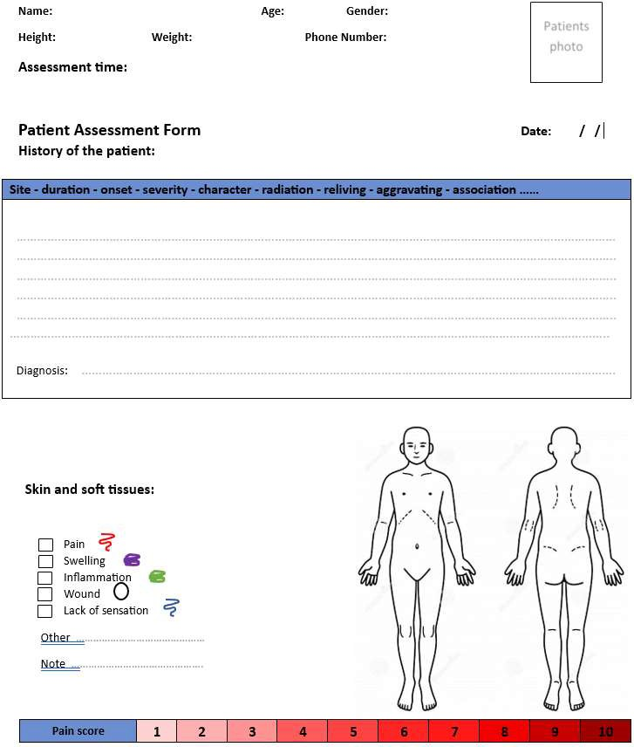

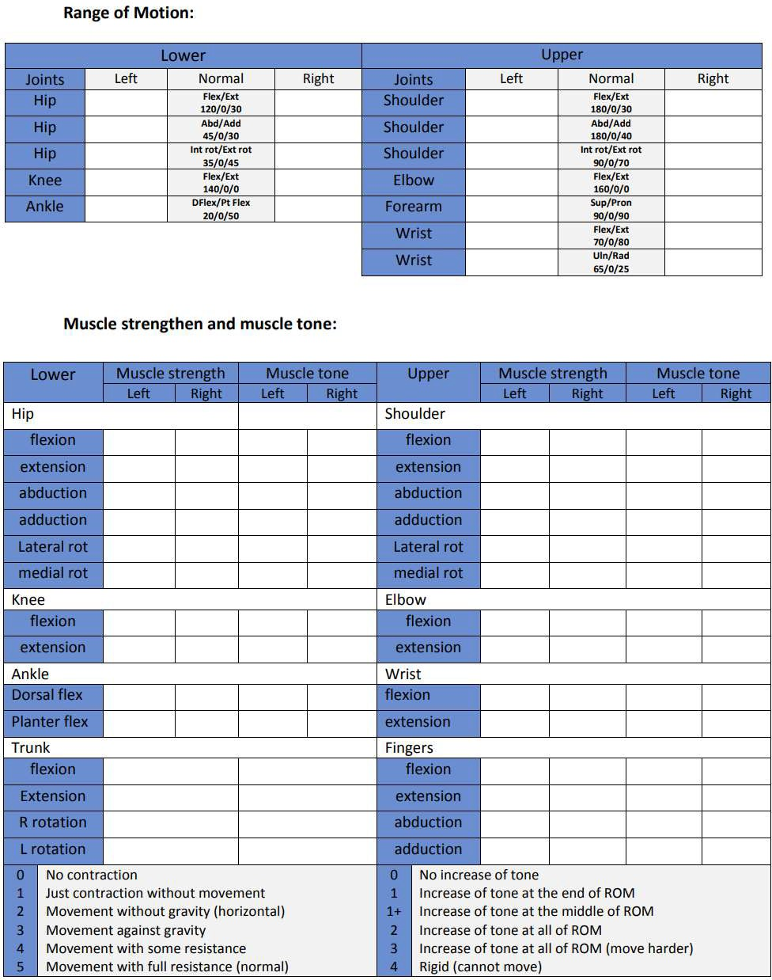

**Limitation of activity:**

…………………………………………………………………………………………………………………………………………………………

…………………………………………………………………………………………………….…………………………………………………..

…………………………………………………………………………………………………….…………………………………………………..

…………………………………………………………………………………………………….…………………………………………………..

…………………………………………………………………………………………………….…………………………………………………..

**Limitation of activity: ( mobility , transfer , balance , coordination , ADL )**

|  |  |
| --- | --- |
| Follow up Date: / / | |
| …………………… | ………………………………………………………………………………………………………………………………….. |
| …………………… | ………………………………………………………………………………………………………………………………….. |
| …………………… | ………………………………………………………………………………………………………………………………….. |
| …………………… | ………………………………………………………………………………………………………………………………….. |
| …………………… | ………………………………………………………………………………………………………………………………….. |
| …………………… | ………………………………………………………………………………………………………………………………….. |
| …………………… | ………………………………………………………………………………………………………………………………….. |

**Precaution:**

|  |  |  |
| --- | --- | --- |
| **Hypertension** | **High Cholesterol** | **Diabetes mallets** |
| **Cancer** | **Pulmonary disease** | **kidney disease** |
| **Pregnancy** | **Other: ………………. .** |  |



**لەسەر جومگەکانی**

**PLS AFO**

**هەڵسەنگاندنی کاریگەری**

**ڕۆیشتن**

**ڕێگەی شیکاری**

**شل لە**

**مێشکی نیوە**

**نەخۆشانی جەڵتەی**

**بەبەکارهێنانی کامێرا**

# نامەیەکە

پێشکە شی ئەنجومە نی کۆلێژی تەکنیکی تەندروستی و پزیشکی هەولێر کراوە لەزانکۆی

پێداویستیەکا ن بۆبەدەست هێنانی بڕوانامەی بااڵ ماستەری لە

چارەسەری سروشتی

لەالیەن

پۆلیتەکنیکی هەولێر وەکو بە شێک لە

## محمود سۆران عبدالرحمن

بەکالۆریۆس لە چارەسەری سروشتی / زانکۆی پولیتەکنیکی تەندروستی و پزشکی هەولیر

بە سەرپەرشتی

## پرۆفیسۆری یاریدەدەر غەسان حوسنی علی

٢٢٢٢

# پوختە

Orthosis Foot Ankle )AFO( زیاتر پێشنیار دەکرێت بۆ نەخۆشێکی جەڵتەی مێشک کە کێشەی لەگەڵ بێ هێزی بەرزکردنەوەی پێ هەبێت، بۆ بەرەوپێشبردن و رێک خستنی دۆخ و جوڵەی پاژنەدا (بە خۆگرتنی مانەوە لە دۆخی ئاسایی جومگەی پاژنەی پێ) و دابینکردنی بەرزکردنەوەی پێ لە زەوی لە قۆناغی دوەمی رۆیشتن، بە هەمان شێوە پشتگیری، و پێشخستنی ڕێکخستنەکانی پێیەکان بۆ کەمکردنەوەی درێژبوونەوەی جومگەی ئەژنۆ و پێشخستنی درێژبوونەوەی جومگەی ڕان لە قۆناغی یەکەمی رۆیشتن. ئامانجی توێژینەوەکە پێشکەشکردنی زانیاری قووڵتر بوو بە بەکارهێنانی کامێرا بۆ

شیکاری ڕۆیشتن بۆ کاریگەرییە بایۆمیکانیکییەکانیAFO PLS بۆ نەخۆشانی جەڵتەی مێشک.

42 بەشداربووی

و دووەم

یەکەم

3 گروپدا (گرووپی

بەسەر

دابەشکرد

بەشداربوومان

ئێمە 24

سێیەم 42

و گروپی

OUT-AFO

و لەگەڵ

بەکارهێنا

AFOیان

بوون کە

مێشک

جەڵتەی

بەشداربووی ئاسایی بوون بەبێ کێشە. هەموو بەشداربووان 41 مەتر بە هێڵێکی ڕاستدا ڕۆیشتن وە

بۆ جومگەکانی

کاتی-كاینەمەتیكس

پارامێتەرەکانی

گیراوە،

ئاسوودە

ڕۆیشتنی

خێرایی

ڕۆیشتن بە

One-way

جیاوازی

کران شیکاری

بەراورد

لە توێژینەوەکەدا

و پاژنەی پێ

ئەژنۆ

ڕان،

گروپی

لە نێوان سێ

بەراوردکردن

ئەنجامدرا بۆ

hoc Tukey’s

)(ANOVA و تاقیکردنەوەی

لێکۆڵینەوەکراودا.

AFO PLS باشتربوونی لە جووڵەی جومگەکان و پارامێتەرەکانی کاینماتیک لە نەخۆشانی جەڵتەی

کە AFO

لە باری

ئەژنۆ

جومگەی

جوڵەی

رێژەی

زیاتری

دا. باشتربوونی

نیشان

مێشکدا

چربوونەوەی ئەژنۆی باشتری هەیە لە سەرەتای قۆناغەکانی ڕۆیشتندا (لە 2.48 بۆ 48.42 پلە لەو بەشداربووانەی کە AFO بەکاردەهێنن)، زیادبوونی گەورە لە لە کۆتایی قۆناغی یەکەمی ڕۆیشتندا درێژبوونەوەی ئەژنۆ (لە 1.48 بۆ 3.24 پلە)، و باشترە نوشتانەوەی ئەژنۆ لە چاو بارودۆخی پێی

پلە بە

37.92

ڕووت بۆ

پێی

بۆ 48.4

(لە

ڕۆیشتندا

قۆناغەکانی

دووەمی

لە قۆناغی

ڕووت

جومگەکان و

جووڵەی

بۆ باشترکردنی

بێت

سوودبەخش

دەتوانێت

AFO

.)AFO

بەکارهێنانی

پێشکەوتن لە خێرایی ڕۆیشتن، سیمیتری ڕۆیشتن و هاوسەنگی، و کەمکردنەوەی مەترسی کەوتن.

**Chapter One: Introduction**

**Chapter Two: Literature Review**

**Chapter Three: Methodology**

**Chapter Four: Result**

**Chapter Five: Discussion**

**Chapter Six: Conclusion**

**References**