Immunophenotyping and IL-18 Promotor Gene Polymorphism in Acute Lymphoblastic Leukemia in Erbil

A Thesis
Submitted to the Council of the Erbil Health & Medical Technical College at Erbil Polytechnic University in Partial Fulfilment of the Requirements for the Degree of Master of Science in
Medical Laboratory Technology/Hematology

By
Mohammed Qader Mustafa
B.Sc. Medical Laboratory Technology Department_ Erbil Health and Medical Technical College, Erbil Polytechnic University

Supervised by
Asst. Prof. Dr. Goran Qader Othman

ERBIL, KURDISTAN

June 2023 Jozardan 2723 Dhu al-Qi`dah 1444

Declaration

I declare that the Master Thesis entitled: (Immunophenotyping and IL-18 Promotor Gene Polymorphism in Acute Lymphoblastic Leukemia in Erbil) is my original work, and I hereby certify that unless stated otherwise, all the work in this thesis is my independent research and has not been submitted for the award of any other degree at any institution, except where due acknowledgment is made in the text.

Signature:
Student Name: Mohammed Qader Mustafa Date: /June / 2023

Supervisor Certificate
This thesis has been written under my supervision. It has been submitted for the award of the degree of Master of Science in Medical Laboratory Technology with my approval as supervisor.

Signature: Name: Asst. Prof. Dr. Goran Qader Othman Date: / June / 2023

I confirm that all requirements have been fulfilled.

Signature:
Name: Asst. Prof. Dr. Najat Jabbar Ahmed
Head of the Medical Laboratory Technology Department Date: / June / 2023

I confirm that all requirements have been fulfilled.

Postgraduate Office

Signature: Name:
Date: / June / 2023

Examining Committee Certification

We certify that we have read this thesis (Immunophenotyping and IL-18 Promotor Gene Polymorphism in Acute Lymphoblastic Leukemia in Erbil) and examined the student as an examining committee (Mohammed Qader Mustafa) in its contents and what is related to it. We approve that it meets the standards of a thesis for the degree of Master of Science in Medical Laboratory Technology (Hematology).

Signature:
Name: Prof. Dr. Galawezh Obaid Othman.
Member
Date: /June / 2023
Signature:
Name: Asst. Prof. Dr. Sarbaz Ibrahim Mohammed.
Member
Date: / June / 2023

Signature:
Name: Asst. Prof. Dr. Goran Qader Othman.
Supervisor
Date: /June / 2023
Signature:
Name: Prof. Dr. Mustafa Saber Mustafa Al-Attar.
Head
Date: /June / 2023

Signature:
Name: Prof. Dr. Jawdat Jaafar Khattab
Dean of the Erbil Health & Medical Technical College Date: / June / 2023

Dedication

My Beloved Parents My Uncles

My Brothers and Sisters My Teachers and Friends
Scientific Communities Worldwide

Mohammed Qader Mustafa

Acknowledgements

(In the name of Allah, most Gracious and most Merciful)

First, I would like to start by expressing my profound gratitude to the almighty ALLAH for providing me with the strength to start and complete this work within the time frame.
I would also like to express my sincere gratitude to the Presidency of Erbil Polytechnic University, Erbil Health and Medical Technical College and the Head of Medical Laboratory Technology Department for their support and for providing the facilities required for this research.
My sincere appreciation goes to my supervisor in person of Asst. Prof. Dr. Goran Qader Othman for support, encouragement, and guidance throughout the supervision period.

Endless thanks to my family especially my Father, Mother, uncles, and siblings, for raising me to this level and providing enabling environment and support throughout my study years. A special thanks go to Asst. Prof. Dr. Jaafaru Sani Mohammed, Dr. Mukhlis Hamad , Mr. Shukur Wesman, Mr. Kovan Dilawer Issa and Mr. Diyar Abubaker Omar, for their guidance especially in the practical part of the research work. Finally, my sincere appreciation goes to all that helped, supported and/or encouraged me in one way or the other and were not mentioned here due to some reasons beyond my control.

Summary

Acute Lymphoblastic Leukemia (ALL) is a malignant neoplasm of the hematopoietic system that primarily affects children. The pathogenesis of ALL is complex and multifactorial, involving various genetic, epigenetic, and immunological factors. This study aimed to investigate ALL patients' immunophenotyping and DNA polymorphism of the IL-18 gene (rs1946518) and explore their potential clinical implications.

In this study, a total of 51 patients with ALL were enrolled. The average age of diagnosis was 8.7 years. Out of these 51 patients, 32 were selected for molecular studies, while 10 children were included as control subjects to analyze further the molecular data, 10 random samples out of the 32 PCR products were chosen for Sanger sequencing, and their clinical characteristics, including age, sex, and subtype of ALL, were recorded. A complete blood count (CBC) was performed to assess the hematological parameters of the patients. The expression of several CD markers, including cTDT antigens, human leukocyte antigen-DR(HLA-DR), cytoplasmic myeloperoxidase, CD117, cCD79a, CD56, CD34, CD33, CD22, CD19,CD11b, CD10,
CD7,cCD3, CD2, was analyzed using flow cytometry. Genotyping of the samples for IL-18 gene polymorphisms was conducted through Tetraprimer Amplification Refractory Mutation System Polymerase chain reaction(T- ARMS PCR). Also, the promoter region of the IL-18 gene was amplified through Polymerase Chain Reaction (PCR), and any mutations or Single Nucleotide Polymorphisms (SNPs) was analyzed via Sanger sequencing. Additionally, genotyping of the samples for IL-18 gene polymorphisms was conducted through Tetraprimer Amplification Refractory Mutation System polymerase chain reaction (T-ARMS PCR).

The results showed that most patients (75.8%) had pre- or common B-ALL, while 12.1% had T-lymphoblastic leukemia (T-ALL) , 9.1% patients had Pro- B ALL and 3% patients had Burkitt's lymphoma. Significant differences were observed in CD marker expression between patients with different CD expressions, with CD19+, CD79a+, and CD10 associated with a higher blast percentage. There seemed to be variations in CD marker manifestation among the age groups below 15 and above 15 years. CD79a, CD22, CD19, CD10, TdT, HLA-DR, and CD123 were commonly expressed positive CD markers, whereas CD45 had moderate to low expression and was not associated with these markers. In terms of IL-18 gene polymorphisms, 100% of the control population had homozygous wild-type alleles, while six patients (18.75%) had heterozygous (CA) alleles, and four patients (12.5%) had homozygous (AA) alleles. The remaining 68.75% had 2 polymorphic alleles on the promoter’s region. The current study identified 23 mutations through Sanger sequencing for 10 random samples in the promoter region of the IL-18 gene, including SNPs, insertion, deletion, and duplication. There were 11 types of variation, with 14 being sense and 9 being non-sense mutations. The study also discovered 3 previously unknown (Novel) SNPs, which increases our knowledge of genetic variation in the IL-18 gene.

In conclusion, this study highlights the importance of immunophenotyping and DNA polymorphism analysis in understanding the pathogenesis of ALL and its potential impact on patient management. The findings suggest that specific CD markers and IL-18 gene polymorphisms may be associated with a higher risk of developing ALL. Further research is needed to investigate these associations in more detail. This study provides valuable insights into the molecular and immunological mechanisms underlying ALL and lays the groundwork for future studies.

Contents

Declaration I
Supervisor Certificate II
Examining Committee Certification III
Dedication IV
Acknowledgements V
Summary VI
List of Table XI
List of Figures XII
List of Appendices XIV
List of Abbreviations XVI
CHAPTER ONE 1
- Introduction 1
CHAPTER TWO 4
- Literature Review 4
  - Leukemia: An Overview 4
  - Occurrence of Leukemia 4
    - USA distribution of leukemia 4
    - Regional Distribution 5
  - Aetiology of Leukemia 6
  - Classification of Leukemia 7
    - Acute Leukemia and its Classification 8
2.3.1.3 Classification based on French American British (FAB) system 8
2.4.4 World Health Organization (WHO)-based Classification System 10
  - Acute Myloid leukemia(AML) 11
  - Acute Lymphoblastic Leukemia (ALL) 11
    - General background 11
    - Classification of Acute Lymphoblastic Leukemia (ALL) 13
      - Classification based on WHO System 13
      - Classification Based on the Prognosis 14
        - Chromosome abnormalities 14
          - The Philadelphia chromosome 14
          - Other chromosome abnormalities 15
        - Mixed phenotype acute leukemia 15
        - Leukemia Cells in CNS 16
      - Age-based Classification of Acute Lymphoblastic Leukemia 16
        - Adult Acute Lymphoblastic Leukemia 16
        - Pediatric Acute Lymphoblastic Leukemia 16
    - Pathogenesis Mechanism of ALL 17
      - TEL-AML1 17
      - BCR-ABL1 18
2.6.3.3 PAX5 18
2.6.3.4 RAS 19
2.6.3.5 PI3K 19
2.6.3.6 Cell cycle 20
  - DNA Polymorphism in Leukemia 20
    - DNA polymorphism in ALL 21
    - Interleukin-18 gene in ALL 21
  - Immunophenotyping 23
2.8.1.a Definition 23
2.8.2.b Definition of CD Marker 24
    - Immunophenotyping in ALL 25
    - B-Lymphocytic lineage subtypes 26
    - B-precursor ALL 27
    - B- ALL 28
    - T- Lymphocytic and Natural Killer cell lineage subtypes 28
CHAPTER THREE 30
- Materials and Methods 30
  - Materials 30
    - Instruments and Equipment 30
    - Chemical and Reagents 31
  - Study Flow Chart 32
  - Sample Collection 32
    - Patients and sample 32
3.4. Flow Cytometric Data Analysis 34
  - Molecular Investigation 34
    - DNA Extraction. 34
    - DNA Quantification by Spectrophotometric Method 35
    - Tetra-Primer ARMS PCR 36
    - Agarose Gel Electrophoresis of PCR Standards 37
    - Screening of IL-18 mMutationsby Sanger Sequencing 37
      - Post-PCR Cleaning 38
  - Cycle Sequencing 38
  - Statistical Analysis 39
CHAPTER FOUR 40
- Results 40
  - Clinical Findings of the Studied Patients 40
  - Studying DNA Polymorphism of IL-18 In ALL Patients 46
    - Polymorphic Analysis By Gel Electrophoresis 46
    - Polymorphism Detection by Gel Electrophoresis 49
    - Polymorphism Detection Sanger Sequencing 50
CHAPTER FIVE 54
- Discussion 54
  - Immunophenotyping 54
  - IL-18 Gene Polymorphism 55
CHAPTER SIX 62
- Conclusion and Recommendations 62
  - Conclusions 62
  - Recommendations 63
APPENDICES 93

- References 64

List of Tables

Table | Title | Page
Table 2.1 | Morphology-based classification and Description of three fundamental components of a cell (cytoplasm, nucleus, and chromatin) | 9-10
Table 2.2 | Classification of ALL based on the WHO system | 13
Table 2.3 | Classifications of acute lymphoblastic leukemia  according to their immunophenotypes. | 26
Table 3.1 | The instruments and equipment which are sed in the  project | 30
Table 3.2 | Chemicals and reagents used in the project | 31
Table 3.3 | Show all sets of primer for IL-18 -607 C/A polymorphism with melting points, time, and band size | 37
Table 3.4 | Cycle Sequence components | 38
Table 3.5 | Thermocycler protocol for cycle sequencing | 39
Table 4.1 | Demographic characteristics and clinical  presentation of B-ALL studied patients | 40
Table 4.2 | Sanger sequencing analysis of the promoter region of the IL-18 gene in 10 patients of ALL. | 50
Table 4.3 | Variants identified in ALL patients analyzed with  mutation DNA variant analysis | 51-52

List of Figures

Figure | Title | Page
Figure 2.1 | Presents an expanded understanding of the various  factors that contribute to the development of ALL. | 7
Figure 2.2 | Overall Survival from Clinical Trials for Patients  Suffering from ALL, 1966–2017 | 12
Figure 2.3 | Illustrates the locations of the genetic variations (polymorphic sites) of interleukin-18 (IL-18), specifically rs1946519, rs1946518, and rs187238,  on chromosome 11. | 23
Figure 3.1 | presented illustrates the intricacies of a study focusing on the utilization of samples to examine various parameters such as hematological,  immunological, and molecular aspect. | 33
Figure 4.1 | The percent distribution of various acute lymphoblastic leukemia subtypes depends on  immunophenotyping expression | 41
Figure 4.2 | Distribution of CD markers among patients with  acute lymphoblastic leukemia. | 42
Figure 4.3 | The difference between CD 34 positive by Dark Black color and CD34 negative by light grey color for response therapy in different stages of induction, consolidation, and maintenance by  WBC absolute count | 42
Figure 4.4 | Expression of CD marker according to patients  older than 15 years old and less than 15 years old | 43
Figure 4.5 | Expression of various CD markers in B-ALL  patients, categorized by low or moderate expression of CD45 | 44
Figure 4.6 | The correlation of lymphocytes with different CD markers. | 45

Figure 4.7 | The correlation of Blast percentage with different CD markers. None of them was a significant correlation | 46
Figure 4.8 | The 2% agarose gel electrophoretic plate demonstrating the amplified PCR product of the promotor IL-18 gene region by ARMS PCR through tetra primer indicating bands for the wild-  type alleles in the normal control group | 47
Figure 4.9 | The 2% agarose gel electrophoresis demonstrated the amplified PCR product of the promotor IL-18 gene region by ARMS PCR through tetra primer, indicating three different bands at 440 bp (for control band), 278 bp (for polymorphic allele A)  and 208 bp (for the allele C). | 48
Figure 4.10 | The 2% agarose gel electrophoretic plate demonstrated the amplified PCR product of the promotor IL-18 gene region by ARMS PCR through the only outer forward primer and the corresponding reverse primer indicating the  different bands at 440 bp for the patients’ samples | 48
Figure 4.11 | The 2% agarose gel electrophoretic plate demonstrated the amplified PCR product of the promotor IL-18 gene region by ARMS PCR through the only outer forward primer and the corresponding reverse primer indicating the  different bands at 440 bp for the Normal samples | 49
Figure 4.12 | Show Three different polymorphisms (mutations) on the IL-18 promoter region. The shift from A to AT (30953A>AT$25) is called a nonsense mutation, the shift from T to TG (31033T>TG$43), and A to AC  (31082A>AC$28) are referred to as sense  mutations, which causes changes in amino acid molecules | 53

List of Appendices

Appendices | Title | Page
Appendix 1 | First sample displays of three different polymorphisms (mutations) on the IL-18 promoter region. The shift from A to AT (30953A>AT$25) is called a nonsense mutation, the shift from T to TG (31033T>TG$43), and A to AC (31082A>AC$28) are referred to as sense mutations, which causes changes in amino acid  molecules. | 94
Appendix 2 | The second sample presents two different polymorphisms (sense mutations) on the IL-18 promoter region. The shift from T to TG (31033T>TG$40) and the shift from A to AC (31082A>AC$32), signifies that the two mutations lead to changes in the amino acid  molecules. | 96
Appendix 3 | sample 3 illustrates three different polymorphisms (mutations) on the IL-18 promoter region. The shift from A to AT (30953A>AT$46), T to TG (31033T>TG$44),  and A to AC (31082A>AC$65). The shift A to  TG and A to AC were sense mutations, meanwhile, shift A to AT was nonsense. | 98
Appendix 4 | (Sample 4) revealed two polymorphisms (mutations) on the IL-18 promoter region. The shift from T to TG (31033T>TG$37) and A to AC (31082A>AC$29) were both sense mutations, again, causing changes in the amino acid  molecule. | 100
Appendix 5 | Sample 5 flaunted three different polymorphisms (mutations) on the IL-18 promoter region. The shift from A to AT (30953A>AT$42), which is a sense mutation, a shift from T to TG (31033T>G$116), and A to AT (31082A>C$85)  are nonsense mutations. Thus, the sense mutation  affects amino acid molecules in the sequence. | 102
Appendix 6 | Sample 6 shows three different polymorphisms (mutations) on the IL-18 promoter region, out of which two were newly discovered in the present  findings. The existing SNP is a shift from T to TG | 104

(31033T>TG$32) a senesce mutation. The newly discovered SNPs are the shift from T to TA (31040T>TA$14) and A to AT
(31045A>AT$15), with an additional insertion mutation that is linked to the promoter region. Again, the sense mutation affects the amino acid
molecules synthesis.
Appendix 7 | (Sample 8): this result shows no mutations on the  patients IL-18 promoter region. Thus, there was no any effect on amino acid molecule synthesis. | 106
Appendix 8 | this result shows no mutations on the patients IL- 18 promoter region. Thus, there was no any effect  on amino acid molecule synthesis. | 108
Appendix 9 | (Sample 9): the result revealed two different polymorphisms that happened to be sense mutation. The shift from T to G (31033T>G$110) and shift from A to C (31082A>C$80) and both  affect amino acid molecule synthesis. | 110
Appendix 10 | (Sample 10): This result shows that there is a deletion mutation (31081het delG$4) and two SNPs mutations, one of which is a sense mutation (31033T>G$115) and the other of is a novel SNP  and nonsense (31079G>GA$7). Both mutations were detected during the patient's genetic testing. | 112

List of Abbreviations

Abbreviations | Full Name
ALL | Acute Lymphoblastic Leukemia
AML | Acute Myeloid Leukemia
BM | Bone Marrow
BMA | Bone Marrow Biopsy
CALLA | Common ALL Antigen
CBC | Complete Blood Count
CBP | Complete Blood Picture
CD | Clusters Of Differentiation
CLL | Chronic Lymphoblastic Leukaemia
CML | Chronic Myeloid Leukemia
CNS | Central nervous system
CNS | Central Nervous System
FAB | French-American-British
FACS | Fluorescence-Activated Cell Sorter
FCM | Flow Cytometry
HLA-DR | Human Leukocyte Antigen-DR
HSC | Hematopoietic Stem Cell
ICH | Iraqi Center For Hematology
IL-18 | Interleukin 18
Jak | Janus Kinase
L1 | Leukemia One
L2 | Leukemia Two
L3 | Leukemia Three
moAbs | Monoclonal Antibodies
MPAL | Mixed Phenotypic Acute Leukemias
MRD | Minimal Residual Disease
NGS | Next-Generation Sequencing
NK | Natural Killer
OS | Overall survival
PALL | Pediatric Acute Lymphoblastic Leukemia

PCR | Polymerase Chain Reaction
PerCP | Peridinin Chlorophyll Protein
Ph Chr. | Philadelphia Chromosome
PTEN | Phosphatase Protein And Tensin Homolog
SIg | Surface Membrane Ig
SNPs | Single Nucleotide Polymorphisms
T-ALL | Acute Lymphoblastic Leukemia
T-ARMS PCR | Tetraprimer Amplification Refractory Mutation  System polymerase chain reaction
TBE | Tris borate EDT
TNM | Tumor Size, Lymph Node Involvement And  Metastasis
UV | Ultraviolet
WHO | World Health Organization

Chapter One Introduction

CHAPTER ONE
- Introduction

Acute lymphoblastic leukemia (ALL) is the most common type of cancer in pediatrics, especially those of two to five years old(Brillantino et al., 2021). ALL is considered a malignancy resulting from the transformation and proliferation of progenitor lymphoid cells. It causes a reduction of the number of mature lymphocytes and increased blast cells in both peripheral blood and bone marrow (Belver et al., 2021). Furthermore, the male patient can spread the malignant cells to the central nervous system, liver, spleen, and testicles, whereas boys appear to be three folds at risk of ALL development than girls(Belver et al., 2021). In 2021, about 6700 new cases were estimated in the United States of America(U.S.A) by the American Cancer Society, including 80% of cases involving young adults and children (El-Zine et al., 2021). A documented report on the Iraqi population shows that 8,570 new pediatric leukemia cases with a 1.32 to 1 ratio of males to females were observed between 2000 and 2019 (El-Zine et al., 2021). ALL is the most widely diagnosed form of leukemia, accounting for around 33.56 % of all cases(El- Zine et al., 2021).
The criteria for classification and diagnosis of ALL were based on the
2021 recommended guideline of the World Health Organization that uses morphology, cytochemistry, and immunophenotyping in diagnosing ALL(Gritsch et al., 2022). It is an essential factor that affects the choice of treatment, the methods of follow-up, and the outcome(Iacobucci and Mullighan, 2017).
Immunophenotyping is the sole method for distinguishing between B- cell acute lymphoblastic leukemia (B-ALL) and T-cell acute lymphoblastic leukemia (T-ALL). B-ALL has three subcategories: Pro B-ALL, Pre B-ALL, and typical B-ALL (Attarbaschi et al., 2006). Besides utilizing

Immunophenotyping, important laboratory assessments for ALL diagnoses include examining chromosomal abnormalities such as rearrangements and aneuploidy, which can cause dysregulation of oncogenes or expression of chimeric fusion genes (Bassan et al., 2014). Furthermore, single nucleotide polymorphisms (SNPs) seemed to be crucial markers reported by many studies that link sequence variations to phenotypic changes; such studies are expected to advance the understanding of human physiology and elucidate the molecular bases of the diseases(Kim and Misra, 2007).
Leukemia has been linked to many environmental variables, including ionizing radiation and atmospheric benzene molecules reported affecting acute leukemia development directly (Spinelli et al., 2014). Understanding the potential risk factors could significantly reduce exposure to harmful elements, with perhaps the consequent decrease in the incidence of pediatric leukemia(Spinelli et al., 2014). Despite the high cost of treatment, data indicate that pediatric patients with ALL who receive treatment in high-income countries have a survival rate exceeding 90%(Inaba et al., 2013).
DNA polymorphisms that have been associated with ALL include variations in genes involved in cell cycle regulation, DNA repair, and immune function (de Lourdes Perim et al., 2013). The polymorphism can potentially change the gene regulation of the Interleukin-18 gene. This polymorphism could alter the binding location of the nuclear factor histone four transcription factor-1, which may affect the activity of the IL-18 gene (Giedraitis et al., 2001).
As a result, the administration of chemotherapy occurs in four crucial stages: remission induction, consolidation, reinduction (also known as delayed intensification), and maintenance(Gocho et al., 2021). The most critical predictive factor for the prognosis of ALL is a minimal residual disease (MRD), which guides the intensity of post-induction therapy for ALL(Jeha et al., 2021).

Aims of Study

  - Studying the Immunophenotyping characteristics of ALL patients.

  - Relation of immunophenotyping results with clinical characteristics of ALL patients (Demographic characteristics and hematological parameters).

  - Finding ALL patients' DNA polymorphism of the IL-18 promotor gene (rs1946518).

Chapter Two Literature Review

CHAPTER TWO
- Literature Review

Leukemia: An Overview
The term leukemia entails blood cancer type associated with the rapid growth of irregular blood cells. However, it differs in etiology, pathophysiology, prognosis, and therapeutic responses (Bain, 2010). However, leukemia affects all age groups ranging from adults to children less than a year old. These make it a great concern worldwide (Kampen, 2012). According to recent data released by the World Health Organization (WHO), leukemia is among the top 15 most common types of cancer affecting children and adults (Kampen, 2012). Therefore, understanding the lineage of blood cells, the different types of leukemia, the diagnostic methods that are currently used, the treatment options, as well as the prognostic factors that are associated with leukemia are of great importance (Kampen, 2012).

Occurrence of Leukemia

USA distribution of leukemia

Leukemia is one of the most widely spread malignant diseases affecting people worldwide. In 2018, 437,033 new cases of leukemia were diagnosed globally, with about 309,006 mortality, consequently making it to the eleventh leading cause of death due to malignant illnesses (Modvig et al., 2019). There is no exclusion to the regional distribution of leukemia; yet, the more developed nations have a higher prevalence rate and total fatality rate. Developing countries, On the other hand, the mortality rate in underdeveloped countries is higher. However, they lack information detailing the general pattern of cancer and leukemia (Tebbi, 2021). In 2021, the American Cancer Society revealed that 5,690 new cancer cases were detected in people living in the United States

of America (U.S.A), including children and adults. Eighty percent (80%) of all patients are classified as children or young adults (Sheykhhasan et al., 2022).
About ten percent (10%) of those detected with leukemia in the USA have ALL (Sasaki et al., 2021). It is projected that up to 25 percent of all malignancies identified in children under the age of 15 years are cases of acute ALL, which is regarded as the type of cancer that is mostly affected (Board, 2022).

Regional Distribution

According to the Iraqi cancer records from the Ministry of Health, about 8,570 new cases were recorded as pediatric leukemia between 2000 and 2019. This number includes newly diagnosed cases and relapses, with a ratio of about
1.32 males for every female. However, Al-Hashimi (2021) reported that the most widely extensive leukemia type was ALL, reporting for around 33.56 % of all leukemia cases (Al-Hashimi, 2021). Although the Iraqi Center for Hematology (ICH) documented 3,102 leukemia cases from January 2018 to December 2019, the proportion of males diagnosed with leukemia was much higher than that of females. ALL was the most recurrent leukemia in 2018, with 498 cases (65%) occurring in men and 273 female patients (35%), while chronic lymphocytic leukemia (CLL) recorded 59 patients (84.3%) for males with 11 female patients (15.7%), while acute myeloid leukemia (AML) included 8 cases (29%) for males and 20 cases (71 %) for females, and finally chronic myeloid leukemia (CML) with 8 cases (29 %) for males and 20 cases (71%) for females(Abdulridha et al., 2021).

Aetiology of Leukemia

There is still much unknown about the cause of leukemia. However, based on the available revealed records, the occurrence of the disease is due to numerous factors, including environmental and heritable factors (Buffler et al., 2005). Moreover, some reports have highlighted two high-risk factors associated with an increased risk of developing leukemia: exposure to high amounts of radiation energy and long-term exposure to various industrial chemicals like benzene (Buffler et al., 2005, Spitz et al., 1990). Moreover, it has been demonstrated that smoking either doubled or tripled the risk of AML (Buffler et al., 2005). Gender and age can also affect the occurrence of CML, ALL, and AML (Hjalgrim et al., 2003). CML and AML have been discovered to be more predominant in males than in females, and it is predicted that the incidence of acute lymphoid leukemia will rise with the increasing aged population (Hjalgrim et al., 2003). In addition, genetics is an essential component in the pathogenesis of leukemia. For instance, even though a person's family history is not a factor in the development of most leukemias. Developing of AML, ALL, and CLL increased in first-degree relatives who have leukemias (Rauscher et al., 2002).
Similarly, it is determined that genetic abnormalities can be one of the
key relevant risk factors connected with particular types of leukemia. For instance, the increased risk of developing leukemia has been linked to several syndromes resulting from inherited genetic defects. Among these are Fanconi anemia, bloom syndrome, and black fan diamond. In addition, Down syndrome, caused by a defect on chromosome 21, has been linked to an increased chance of developing leukemia. Risk factors of ALL are shown in Figure 2.1 (Weng et al., 2004).

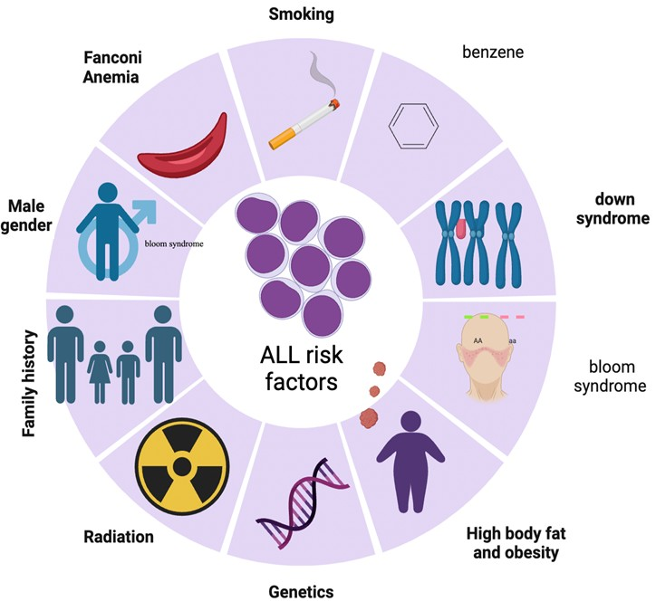

Figure 2.1 Presents an expanded understanding of the various factors that contribute to the development of ALL.

Classification of Leukemia

In leukemia, a disruption in the WBC maturation process causes generative immature (blasts) cells. To be generated, Blast cel, iss unable to carry out their usual role, proliferate incessantly, infiltrate the bone marrow (BM), and finally replace all the normal cells (Shafat et al., 2017). Leukemia is typically categorized as acute or chronic because of how quickly its immature cells (blast) multiply (Bain, 2010). Leukemia can be further classified depending on the predominant cell type in the peripheral blood and bone

marrow, as determined by cell lineage, as either myeloid or lymphoid (Ciesla, 2007). Consequently, there are four distinct forms of leukemia acute lymphoblastic Leukemia(ALL), Chronic lymphoblastic leukemia CLL), Acute Myeloid Leukemia(AML), and chronic Myeloid Leukemia(CML) (Dezhakam et al., 2022, Salman et al., 2002).

Acute Leukemia and its Classification

The current approaches for classifying acute leukemia have been developed based on the morphology of cells, the chemistry of cells, immunophenotyping, immunogenetics,s, and molecular cytogenetics. Therefore, morphology is typically used as the primary categorization criteria in the beginning stages of acute leukemia (Van der Velden et al., 2003). Although the appropriate standards for classifying lymphoid from acute myeloid leukemia are debatable, the significance of such classification cannot be interrogated. The natural history is distinct, and the best current treatment methods are sufficiently distinct for a wrong type to impact the prognosis negatively (Van der Velden et al., 2003). Currently, acute leukemia can be classified into lymphoid and myeloid subtypes. The subsequent sections will discuss the characteristics associated with each classification type.

2.3.1.3 Classification based on French American British (FAB) system

The FAB Collaborative group has recognized standard modalities to determine acute leukemia's nature and classify it into subgroups. The morphological and cytochemical features of bone marrow and peripheral blood smears are the only foundation for the FAB categorization (Bennett et al., 1981). A group of hematologists from France,U the nited States, and the United Kingdom worked together to develop the FAB classification of acute leukemia.

This was a momentous step forward in the leukemia classification, as it allowed reliable types of these diseases over twenty years (Bennett et al., 1981). According to the FAB classification, ALL is divided into three major subtypes (L1, L2, L3), whereas AML is divided into eight major subtypes as follows: M0, M1, M2, M3, M4, M5, M6, and M7. The morphological characteristics of ALL cells belonging to all categories are fragmented and summarised in Table
2.1 (Cairo et al., 2012, Mattsson et al., 2010, Bach et al., 2009, Fulci et al., 2007). The FAB Cooperative Group has established standardized criteria that can be used to identify the specific kind of acute leukemia and further categorize the disease. The PB and BM smears are evaluated only according to morphological and cytochemical parameters to conclude the FAB classification field (Bennett et al., 1981, Cairo et al., 2012).

Table 2.1: Morphology-based classification of acute Lymphoblastic leukemia with a description of three fundamental components of a cell (cytoplasm, nucleus, and chromatin)(Ladines-Castro et al., 2016).
Blasts | Subty  pes | Morphology | Nuclear  shape | Chromatin | Cytoplasm
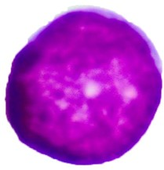 | L1 | Small blasts with very little cytoplasm and very little diversity from cell to cell | Homo- genous, round | Slightly reticulated with perinucleolar clumping | Scant blue
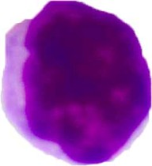 | L2 | Bigger cells with a higher volume of cytosol and greater cell-cell variations, irregular nuclei with many nucleoli in each  cell | Inhomo- geneous, irregular | Fine | Moderate pale

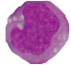 | L3 | Large cells have a very basophilic cytoplasm, frequent vacuoles,finitely numerous nucleoli | Homo- genous, round to oval. | Coarse with clear parachromati n | Moderate blpara cparainy vacuolated

2.4.4 World Health Organization (WHO)-based Classification System

The cytochemisCytochemistryare essential to detect acute leukemia; however, cytogenetic analysis, immunophenotyping, and molecular genetic analysis (using either RNA or DNA) also significantly contribute to the diagnostic process (Bain, 2008). The WHO, the European Association of Hematopathology, and the Hematopathological Society have all worked together to generate a new categorization of acute leukemia; this categorization scheme was only recently made available to the public aware only made public. Over a hundred pathologists, physicians, and scientists collaborated to develop this consensus classification. The combined expertise and experience of the professionwas were fanfiction ofthee he ideas for such classification (Lamb Jr et al., 1999). As discussed earlier, the ranking system of classification for blast cells by FAB was mainly based on their morphological characters when making their determinations. On the other hand, the WHO categorization method calls for an extra examination of the blast cells based on genetic analysis and flow cytometry (Lad et al., 2015, Angelescu et al., 2012).

2.5 Acute Myloid leukemia(AML)

AML is a type of leukemia where the bone marrow, blood, and other tissues are infiltrated by abnormal and clonal cells of the hematopoietic system. These cells have abnormal characteristics and can multiply quickly, leading to various health problems. AML can happen in both adults and children. Fifty years ago, all adult patients with AML died; however, about 35–40 % of adults and 5-15% of younger children are cured today. (Döhner et al., 2015). Also, Patients over the age of 65 years who are unable to stand intense treatment have a terrible prognosis, with a median life of 5-10 months. In spite of the fact that AML's cytogenetic heterogeneity has been well-known for over 3 decades, the disease's significant molecular heterogeneity has just become progressively apparent over the past 15 years. This biological heterogeneity is widely documented as having prognostic significance, but its application to better treatment is just being started (Döhner et al., 2010).

Acute Lymphoblastic Leukemia (ALL)

General background

In the USA, around 6000 new ALL cases are identified each year; of these, approximately half are diagnosed in children and adolescents. ALL is the most prevalent type of cancer in children in the USA, and it is also the key leading cause of cancer-related deaths in those below the age of twenty (Smith et al., 2010, Linabery and Ross, 2008). ALL symptoms that first become apparent include bruising or bleeding due to thrombocytopenia, pallor, weariness from anemia, and infection from neutropenia. At the time of diagnosis, it is usual for patients to have liver-based leukemia filtration, mediastinum, lymph nodes, and spleen. Extramedullary leukemia that is found in the testicles or CNS can call for very precise adjustments to the treatment plan (Hunger and Mullighan, 2015).

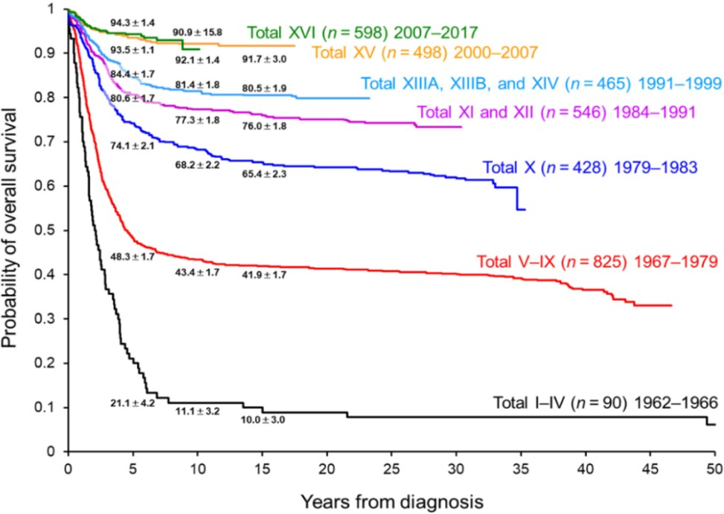

Figure 2.2. Overall Survival from Clinical Trials for Patients Suffering from ALL, 1966–2017 (Inaba and Pui, 2021).

Since the initial announcement, made in 1948, of temporary leukemia recovery based on chemotherapy (Farber et al., 1948). The treatment of ALL in pediatric patients could serve as a model representing improvements in survival rates. This has been accomplished through the gradual enhancement of the efficacy of multiagent chemotherapy regimens, as well as through the stratification of treatment intensity according to the patient's clinical characteristics, the biological characteristics of the leukemia cells, and the premature response to medication. According to the data shown in Figure 1, the percentage of pediatric ALL patients who survive after receiving treatment has increased by 90 percent. Given the existing high incidence of cancer survival, it will be difficult to achieve further improvements in patient outcomes using conventional treatment. To put it differently, the difference in overall survival (OS) between our two latest frontline studies on ALL treatment - St. Jude Total Therapy XV (5-year OS: 93.5%) and XVI (5-year OS: 93.9%) - was minimal. The overall survival (OS) rate only slightly increased to 94.3% after 5 years, as depicted in Figure 2.2 (Inaba and Pui, 2021).

Classification of Acute Lymphoblastic Leukemia (ALL)

Several ALL subtypes are connected with a certain kind of lymphocyte. B cells, also known as B lymphocytes, are 85% of ALL cases, whereas T cells are responsible for 15% (also called T lymphocytes) (Group, 1986).

Classification based on WHO System
WHO created the following classifications for ALL based on the immunophenotype of leukemic cells (Table 2.2). Laboratory studies, such as cell type, flow cytometry, and cytogenetic assays, are used to identify the immunophenotype of the leukemic cells. Occasionally, acute leukemia will share features with both ALL and AML. Mixed phenotypic acute leukemias (MPAL) are an extremely uncommon type of leukemia (McGregor et al., 2012).

Table 2.2: classification of ALL based on the WHO system (McGregor et al., 2012)
Lymphoblastic cell subtype | WHO subtype indications
Pro B cell | lymphoma and leukemia of B lymphoblastic origin, not otherwise  specified, NOS
Precursor B cell | B-cell lymphoblastic lymphoma/leukemia with several recurrent cytogenetic abnormalities:  With t(1:19) With t(5:14) With t(12:21) With t(v:11q23) with t(9;22)  with hypodiploidy (less than 50 chromosomes)  with hyperdiploidy (more than 50 chromosomes)
Precursor T cell | T lymphoblastic leukemia/lymphoma

The old FAB approach classifies ALL based on the appearance of the leukemia cells using a microscope. It is predicated on the morphology (size, shape, and structure) of the cancer cells that cause leukemia, the WHO grouping method is the one that is used by the vast majority of medical professionals since it makes use of more recent laboratory tests that categorize ALL in a more precise manner(McGregor et al., 2012).

Classification Based on the Prognosis

The following characteristics are what clinical hematologists use to define ALL. In addition to the WHO categorization, they consider several other considerations, including:

Chromosome abnormalities.

In about 70% of adults with ALL, the leukemia cells have specific changes to chromosomes or chromosome abnormalities (Demirhana et al., 2019). In acute lymphoblastic leukemia (ALL), up to (90%) of case of childhood (ALL) has been found to have one or more karyotypic abnormalities (Al-Attar, 2004).

The Philadelphia Chromosome
The Philadelphia (Ph) chromosome, also known as t(9;22), is a chromosomal aberration frequently seen in the leukemia cells of individuals with ALL. The long arm of chromosome 9 is exchanged for the other arm of chromosome 22, and vice versa. Translocation is the term used to describe this kind of alteration. Because of this translocation, the BCR-ABL fusion gene is created, ultimately forming ALL (Abou Dalle et al., 2019b).

Leukemia cells with the Ph chromosome are seen in approximately one in every four persons with ALL. These individuals are said to have a Ph- positive ALL, also written as Ph⁺ ALL. Those individuals who do not possess the Ph chromosome are referred to as having Ph negative, or Ph–, ALL. These individuals have an ALL gene. Ph⁺ ALL is more prevalent in patients of advanced age(Abou Dalle et al., 2019a).
Leukemia can originate in either the blood or the bone marrow. This chromosomal aberration is hereditary. However, it is not passed down from parent to child. Because it is an acquired aberration, this condition manifests itself at some point in a person's life after birth. It does not appear to be inherited by any other family members. This indicates that a person who has ALL cannot pass on to their offspring the BCR-ABL fusion gene (Giebel et al., 2019).

Other chromosome abnormalities
Translocations between chromosomes are another type of abnormality, but one that is far less common. A translocation occurs if a portion of one chromosome is moved to another, such as in the case of the t (4;11) genetic condition, which is a translocation involving chromosomes 4 and 11 (Demirhana et al., 2019).

Mixed phenotype acute leukemia (MPAL)
Sometimes the leukemia cells are believed to be of mixed lineage because they possess features of both myeloid and lymphoid cells. Leukemia cells can have both myeloid and lymphoid characters on the same cell, or specific leukemia cells can have myeloid features while other leukemia cells have lymphoid elements. According to the WHO categorization system, acute leukemias with a mixed phenotype, also known as MPAL, are separated into unique groups (Wang et al., 2018).

Leukemia Cells in CNS
At the time of laboratory analysis, leukemia cells are present in the central nervous system (CNS) of around 5–10 percent of persons with ALL. The brain and spinal cord are the components that make up the central nervous system. It is estimated that the CNS will be affected by ALL in around 35 percent of patients who do not get prophylactic therapy (Lenk et al., 2020).

Age-based Classification of Acute Lymphoblastic Leukemia

Adult Acute Lymphoblastic Leukemia
ALL is the most prevalent kind of childhood tumor (Kolaczkowski and Thornton, 2004), demonstrating almost a 90% survival rate over five years in children (Santiago et al., 2017, Balboni et al., 2010, Linabery and Ross, 2008), and between 75% and 85% among young adults and adolescents (Smith et al., 2010). About 15%-25% of adults will develop this kind of acute leukemia, which is distinguished from the childhood version by several biochemical features; the results were worse for older persons, with overall survival rates ranging from 35–55 % in adults of middle age and less than 30% in adults over the age of 60 years (Faderl et al., 2010, Gökbuget et al., 2012, Korfi et al., 2016).

Pediatric Acute Lymphoblastic Leukemia
ALL is the most prevalent kind of childhood tumour (Kolaczkowski and Thornton, 2004), demonstrating almost a 90% survival rate over five years in children (Santiago et al., 2017, Balboni et al., 2010, Linabery and Ross, 2008), and between 75% and 85% among young adults and adolescents (Smith et al., 2010). About 15%-25% of adults will develop this kind of acute leukemia, which is distinguished from the childhood version by several biochemical features; the results were worse for older persons, with overall survival rates ranging from 35–55 % in adults of middle age and less than 30 % in adults over

the age of 60 years (Faderl et al., 2010, Gökbuget et al., 2012, Korfi et al., 2016).

Pathogenesis Mechanism of ALL
During the first stages of the development of lymphoid cells, pluripotent hematopoietic stem cells in the bone-marrow serve as the source of lymphoid cells. There are three phases of development for B cells, which start from normal lymphoid progenitor cells. These stages are called pro-B, pre-B, and mature B cells. In most cases, the management of the maturation process may be accomplished relatively well by utilizing cell signal transduction, active transcription factors, and positive/negative selection (Zhou et al., 2012). On the other side, lymphoid malignancies can disrupt lymphoid development, leading to abnormal cell proliferation and survival in the case of B-ALL (Zuckerman and Rowe, 2014). It is well established that the onset of B-ALL is associated with a sequence of gene variations, most of which start in the pluripotent stem cell stage. After this, the subsequent steps of clonal expansion, cell proliferation, differentiation, and dysregulated cell apoptosis occur, ultimately replacing normal lymphoid cells with malignant cells (Zuckerman and Rowe, 2014). The next part will explain a more in-depth discussion of various biochemical pathways and gene expressions associated with ALL.

TEL-AML1
The TEL-AML1 fusion gene is a mutation that might be present many years before any clinical symptom occurs, and in most cases, the transformation occurs earlier in gestation (Schindler et al., 2009). This oncogene can operate on the hematopoietic stem cell (HSC), which results in the production of gene lesions; following a second genetic mutation (or environmental hit), the

multistep cascade that leads to ALL is then initiated (Ford et al., 1998, Sabaawy et al., 2006). The TEL-AML1 mutation is, therefore, the genetic lesion that causes the illness; in this case, the leukemic cells continue to exist at the pro- B-cell stage (Sabaawy et al., 2006). The TEL-AML1 gene mutation is supported by the experiments performed on samples taken from umbilical cord blood Fields(Sabaawy et al., 2006). TEL-AML1-positive individuals are significantly more likely to develop ALL (Schindler et al., 2009).

BCR-ABL1
To create the BCR-ABL fusion gene, the ABL gene, which is located on chromosome 9, swaps places with the BCR gene, which is located on chromosome 22. The term "Philadelphia chromosome" refers to the configuration of chromosome 22 that contains the novel fusion gene (Ph) (El Fakih et al., 2018). The BCR-ABL1 tyrosine kinase gene, which is transcribed on the Ph chromosome, carries the mutation that causes B-cell ALL more frequently than any other. Ph, also known as the BCR-ABL-1 positive gene mutation, is commonly associated with the disease's most severe prognosis (Blatt et al., 2018, Cilloni and Saglio, 2012).

PAX5
Protein with paired-box domains B cells can be activated by a protein known as Pax-5, which encodes for nuclear transcriptional factors. It regulates the functions of B cells, such as development, migration, differentiation, and proliferation (Mullighan et al., 2008). Pax-5 controls B cell development from immature to mature B cells. Abnormally expressed Pax-5 can cause leukemic transformation at the early onset of tumor generation in the B form of ALL (Mullighan et al., 2009). The growth of pro B cells is inhibited in an environment where Pax-5 expression is downregulated, indicating the crucial role Pax-5 plays in B cell formation. Over 99% of children and adolescents

diagnosed with B-ALL have an elevated level of Pax-5 (Mullighan et al., 2008). Pax-5 can combine with other enzymes, like Janus kinase (Jak) 2, to form a fully active protein kinase domain. This can then lead to the proliferation of B cells via the Jak-STAT signaling pathways (Huang et al., 2020).

RAS
RAS is a family of genes that encode proteins responsible for controlling signaling pathways that regulate cell growth, survival, and death, including the leukemic cells. Mutations usually occur on the RAS gene during chemotherapy and can be seen in clones of relapsed leukemic cells. ALL patients that experienced relapses typically have mutations in the RAS pathways (Irving et al., 2014). These RAS mutations can also be found in around 40% of juvenile patients with ALL who have experienced recurrence (Irving et al., 2014). It is estimated that about 15% of pediatric patients diagnosed with ALL possessed mutations on KRAS and NRAS genes. On the other hand, there is no link between these mutations and any other clinical sign (Shu et al., 2004, Al- Kzayer et al., 2015).

PI3K
Both the process of cell division and survival are influenced by the PI3K/Akt signaling pathway. PI3K regulates the levels of expression of mTOR, Bcl-2, and NF-B, all proteins that stimulate cell proliferation (Li et al., 2014, Wu et al., 2017). In many liquid tumors, such as B cell precursor-ALL, the PI3K/Akt signaling pathway is turned on (Toosi et al., 2018). Consequently, it plays a significant role in pathogenesis (Morishita et al., 2012). It is common to find an overactive PI3K pathway in B-ALL, and this overactivation is related to glucocorticoid resistance (Evangelisti et al., 2018). Patients suffering from B-ALL who have mutations in negative regulators of PI3E, such as phosphatase protein and tensin homolog (PTEN), may have an increased chance of failure

in therapy failure and recurrence (Silveira et al., 2015).

Cell Cycle
B-ALL development has been linked to cell cycle dysregulations in several studies (Sánchez-Beato et al., 2003). The result of leukemia can be caused by the unchecked multiplication of HSC and premature cells of the lymphoblast (Huang and Zhu, 2012). In B-ALL, an increased expression of the c-MYC protein is linked to a faster advancement through the cell cycle (Baxevanis et al., 2003, Yang et al., 2018). The deregulation of c-MYC is seen in individuals with aggressive B-ALL and is linked to aggressive disease progression, chemoresistance, and a poor prognosis (Ren et al., 2018).

DNA Polymorphism in Leukemia
DNA polymorphisms are differences in a population's or a specific DNA sequence that can be found within that population or species. Single nucleotide polymorphisms, sometimes known as SNPs, can occur at individual nucleotides level. In contrast, larger DNA segments can also be involved (insertions, deletions, and copy number variations)(Kurokawa, 2006). There are several types of leukemia, and each type may have different DNA polymorphisms associated with it. For example, in ALL, specific DNA polymorphisms in genes involved in the immune system have been identified as risk factors for developing the disease. In acute myeloid leukemia (AML), specific DNA polymorphisms in cell differentiation and DNA repair genes have been associated with a poorer prognosis and reduced survival rates(Inaba et al., 2013, Foran, 2010).

DNA Polymorphism in ALL
DNA polymorphisms that have been associated with ALL include variations in genes involved in cell cycle regulation, DNA repair, and immune function (de Lourdes Perim et al., 2013). For example, polymorphisms in the TP53 gene, which is involved in cell cycle regulation and DNA damage response, These DNA polymorphisms have been associated with a higher likelihood of developing ALL(de Lourdes Perim et al., 2013).

Interleukin-18 gene in ALL
Interleukin-18 happens to be a member of the Interleukin-1 cytokine family (Dias-Melicio et al., 2015). The location of the Interleukin-18 gene on chromosome 11q22.2-q22.23 has been determined in Figure 2.3. show the location and the most important SNPs in IL-18 (Tsuboi et al., 2004). A wide variety of immune and nonimmune cells, including T and B lymphocytes, Natural Killer cells (NK), macrophages, monocytes, Kupffer cells, and cells of Langerhans, are responsible for its production (Baxevanis et al., 2003, Tschoeke et al., 2006, Lebel-Binay et al., 2000).
Several studies showed the pro-and anticancer actions of interleukin-18. It can stimulate T and NK cells, encouraging the response of Th1, leading to the removal of tumor cells(Günel et al., 2002, Dinarello, 1999, Gillies et al., 1993, Okamura et al., 1995). Conversely, reports show that interleukin-18 can trigger migration, angiogenesis, immune escape, and proliferation of tumor cells(Park et al., 2007). Several varieties of cancer, including gastric and breast cancer, have been found to have elevated levels of IL-18 (Dinarello, 2000, Ye et al., 2007, Eissa et al., 2005). Despite these findings, the link between IL-18 and cancer risk is still debatable(Yalçın et al., 2015). Numerous single nucleotide polymorphisms (SNPs) have been found and are currently being investigated. Compared to the transcriptional start site, the promoter of Interleukin-18 gene r -137G/C (rs187238) polymorphism is among the most

prevalent. This polymorphism can potentially change the gene regulation of the Interleukin-18 gene. This polymorphism could alter the binding location of the nuclear factor histone four transcription factor-1, which may affect the activity of the IL-18 gene (Giedraitis et al., 2001).
However, in the study conducted on the Turkish population by Yalcin et al. (2014), the C/C and G/C genotypes were linked with the chance of chronic myeloid leukemia development, while the C/C genotype was associated with the chance of chronic lymphoid leukemia development. Thus, suggesting a correlation between the polymorphism and chronic leukemias development, which is characterized by the increase in division of mature cells with subsequent functionality loss, these findings point to a possible link between mutations in the IL-18 gene and an increased chance of developing cancer; however, the significance of this relationship is not yet clear(Yalçın et al., 2015).

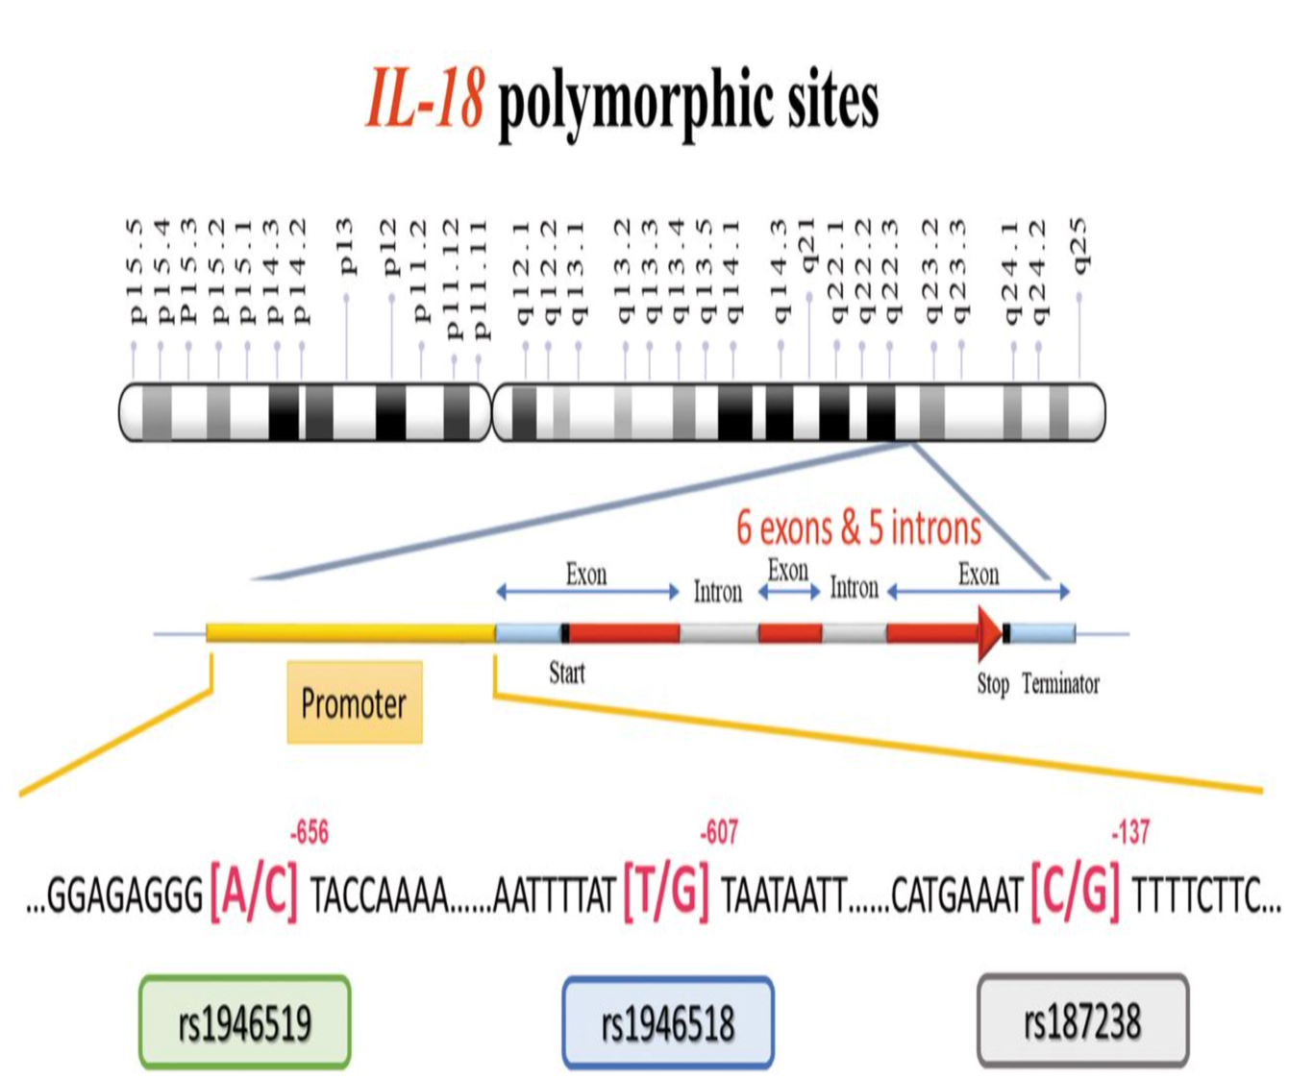

Figure 2.3 Illustrates the locations of the genetic variations (polymorphic sites) of interleukin-18 (IL-18), specifically rs1946519, rs1946518, and rs187238, on chromosome 11 (Yalçın et al., 2015)..

Immunophenotyping

2.8.1.a Definition
Immunophenotyping is a method for classifying cells according to the antigens or markers found on their surfaces. This method is used to identify individual cells. Differentiation of leukemia cells can be identified with the proper selectionantigensigen (Ding et al., 2015). Advanced medical technology known as a flow cytometer is used to do immunophenotyping. Flow cytometric techniques are complex, high-priced, and require highly trained personnel experience and knowledge. There is frequently a lack of accessible access to

technical assistance and quality assurance programs for flow cytometry in nations that are short on resources (Zijenah et al., 2006). Despite this, the current standard of care dictates that all cases of acute leukemia must be immunophenotyped to ensure accurate categorization (Paietta, 1998).

2.8.2.b Definition of CD Marker
Studying both normal and abnormal hematopoiesis may be accomplished with the help of flow cytometry, a method that is both powerful and widely used. So far, over two hundred hematopoietic membrane and cytoplasmic markers have been categorized as "clusters of differentiation" (CD), and the expression patterns of these markers have been utilized to characterize the differentiation phases of cells belonging to diverse hematopoietic lineages (e.g. erythro,id, myeloid and lymphoid). The most recent generation of fluorescence-activated cell sorter (FACS) equipment can detect four or more CD markers concurrently, each of which is a distinct fluorophore (Zamir et al., 2005).
Stem cells, stimulated by cytokines such as colony-stimulating factors, specialize and proliferate to become blood cells along the lymphoid and myeloid lineages. Different precursor cells from various lineages each express a unique action of surface molecules; most of these molecules are currently designated by CD antigens. There is a possibility that the CD antigens connected with the plasma membranes of leukocytes are molecules engaged in various tasks(adhesion molecules, immunoglobins, enzymes, transporter, ion channels, cell signaling, cytokine receptors, or cell-cell interactions). Flow cytometric examination of leukemia using panels of monoclonal antibodies presently yields an accuracy of 98% for differentiating acute leukemia of lymphoid and myeloid origin. This technique also has the potential to discriminate a range of chronic leukemias and lymphomas (Belov et al., 2001).

Immunophenotyping in ALL
Since the 1970s, immunophenotyping of leukemia has been a possibility. At the current time, the diagnosis of ALL is dependent on immunophenotyping. Approximately 85%` of children diagnosed with ALL have the phenotype associated with the B-lineage, whereas the remaining 15% have the T-lineage. There is a possibility that ALL blasts will display myeloid markers such as CD13, CD33, and CD65(Horibe et al., 2000).
Flow cytometry has been the method of choice for lineage assignment and examination of maturation in ALL because of the simplicity with which it may be applied, the precision with which it can diagnose, and the quantifiability of the findings obtained. Flow cytometry is a highly effective method since it is feasible to determine a specific lineage for ALL blasts in more than 98 percent of the leukemic blasts. Even though divided into several immunophenotypic several stable groups, differentially significant differentiation between progenitors is B-cell, mature B-cell, and T-cell ALL(Bast Jr and Holland, 2010). Immunophenotyping has resulted in the discovery of considerable new information on the variability of ALL and has laid the groundwork for a categorization system that is both reliable and repeatable (Toth et al., 1999). The availability of monoclonal antibodies (moAbs) that are highly specific for leukocyte antigens, along with the analytical capabilities of flow cytometry (FCM), has led to significant improvements in the knowledge of the differentiation of human hematopoietic cells during the past few years. Identifying pathogenic cells is the primary objective of immunophenotyping, followed by phenotypic evaluation of the cells (Rezaei1adef et al., 2003).
It is reasonable to first identify an ALL as belonging to either the T
lineage (by testing positive for cyCD3 and CD7) or the B lineage by using immunological markers (positivity to CD79 and CD19). One more categorization recognizes the existence of three primaries: there are four

primary categories of subgroups for ALL of B origin: B(Clyg-Smlg+), transitional pre-B-B(Cylg+ Smlg+), pre-B(cylg+Smlg-), C-ALL (CD10+ Cylg–) and three major T ALL: T mature (SCD3+), T thymic (CDa+ Cylg-) and pre-T (CD1a- SCD3-)(Macedo et al., 1995). The precursor B ALL blasts are positive for TdT, d-related human leukocyte antigens (HLA-DR), and virtually invariably positive for the B-cell differentiation markers CD19 and CD79a. All precursor B ALL blasts share these characteristics. With the assistance of additional markers, precursor B ALL can be further subdivided, based on the stage of maturation of the blasts, into (1) pre-pre-B ALL ("pro-B- ALL"), (2) pre-B ALL, and (3) common ALL. These three subtypes are differentiated because (1) pre-pre-B ALL is the earliest stage of precursor B ALL(Bast Jr and Holland, 2010). classification of ALL is shown in Table 2.3.

Table 2.3: Classifications of acute lymphoblastic leukemia according to their immunophenotypes (Bast Jr and Holland, 2010)
Types | FAB  Class | Tdt | T cell  Associate antigen | B cell  associate antigen | c Ig | s Ig
Precursor B | L1,L2 | + | - | + | -/+ | -
Precursor T | L1,L2 | + | + | - | - | -
B-cell | L3 | - | - | + | - | +

B-Lymphocytic lineage subtypes
B-cell lineage is responsible for around 80% of ALL cases. These instances favor the ALL common antigen, often known as CALLA, which was recently dubbed CD10. Additionally, these cells have undergone gene rearrangements encoding for immunoglobulin heavy and/or light chains and

display additional markers for B-cell development, including CD20 and CD19. The presence or absence of cytoplasmic immunoglobulin allows for further subcategorization of these CD10 cells. Most cases are classified as early B- precursor ALL because they do not exhibit cytoplasmic immunoglobulin (Devine and Larson, 1994). Blasts that are positive for CD22, CD79a, or CD19 but negative for other B-cell development antigens are characteristic of the earliest recognizable stage of pre-pre-B ALL. CD19-positive, CD10-negative, and cytoplasmic immunoglobulin-negative Infants with ALL often have B- lineage ALL with coexpression of myeloid markers(Bast Jr and Holland, 2010).

B-precursor ALL
The FAB criteria usually classify these cells as L1 or L2. In other instances, the CD45 level may be extremely low or nonexistent, which would cause them to be merged with the erythroid cluster on the CD45-side scatter. The CD19, HLA-DR, and TdT phenotypes are all positive in this patient. Because CD10+ patients have a better prognosis than CD10- patients, we divide them into CD10- and CD+ subgroups. The majority of cases are also positive for CD34 and CD24. CD20 levels tend to rise as people become older. By definition, B-precursor ALL is characterized by the absence of surface membrane Ig (SIg). CD10 negative may be particularly significant in babies, as they signify a physiologically unique subgroup (Jennings and Foon, 1997). The early B-precursor of ALL resembles a more primitive level in the
B-lineage than the Pre-B ALL does. This phenotype is seen in around 25% of
children diagnosed with ALL, but its prevalence in adults has not been well investigated. Cells are typically CD10+, cytoplasmic CD22+, HLA-DR+, CD24+ and CD19+. The levels of TdT and CD20 are not constant. CD34 exhibits a lack of positivity in most cases. The presence of a cytoplasmic heavy chain is the identifying feature of this condition. The pre-B phenotype has

historically been linked to a less favorable prognosis than the early B-precursor phenotype (Jennings and Foon, 1997).
Common-ALL ("cALL," "early pre-B ALL") It is distinguished by the presence of CD10 in the cells (common ALL antigen [CALLA]). Common ALL is a prevalent immunophenotype with Philadelphia chromosome (Ph)- positive ALL, which may be one possible explanation for the poorer prognosis of adults compared to CD10-positive ALL in infancy (Bast Jr and Holland, 2010).

B- ALL.
The mature B-cell form of ALL is extraordinarily uncommon and accounts for about 1–2% of all cases. The presence of surface immunoglobulin, most frequently IgM, that is monoclonal for either light chains is what distinguishes this kind of ALL from others (Jennings and Foon, 1997).
Blasts with Burkitt's leukemia, known as mature B-cell ALL, express immunoglobulins on their surfaces but do not exhibit TdT. CD10 positivity may be linked to a more favorable outcome, and around half of patients have it. CD20 expression, which also has important clinical implications, is always present in mature B-cell acute lymphoblastic leukemia (ALL) (Bast Jr and Holland, 2010).

T- Lymphocytic and Natural Killer cell lineage subtypes
Around 15-20% of ALL cases develop from T-cells. These T-cells display specific antigens such as CD5 and CD7 and may also have CD10 present. In many instances, at least one of the genes encoding the T-cell receptor undergoes rearrangement. T-cell ALL can be classified into early, intermediate, or mature thymocyte subtypes based on the presence of distinct T-cell differentiation antigens. A tiny fraction of ALL patients do not exhibit

B-cell or T-cell characteristics; these instcalled null-cell ALL(Devine and Larson, 1994). The T-ALL expresses at different CD5, CD4, CD3, CD2, and CD1a levels. CD8 and levels CD4 are either double-negative or double- positive. The CD7 seems to be the most sensitive T-cell biomarker, although it lacks specificity since instances of AML or natural killer cell leukemia are sometimes CD7-positive (Bast Jr and Holland, 2010). Also, CD3 on the cell surface is the marker for T-cell differentiation that is the most lineage-specific. It is frequently positive in cases of adult cell acute lymphoblastic leukemia. A positive test result for CD4 or CD8 is seen in mature T-cell ALL but not for both markers. Blasts caused by pre–T-cell ALL do not display surface CD3, although they may still express cytoplasmic CD3 in some cases. CD4 and CD8 are absent in pre–T-cell aggressive lymphoblastic leukemia.

Chapter Three Materials and Methods

CHAPTER THREE
- Materials and Methods

Materials

Instruments and Equipment
All the equipment and instruments wherein the study are shown in Table 3.1.

Table 3.1: The instruments and equipment are used the study
Name of Item | Company | Origin
Autoclave | Lab Tech | Korea
Balance | Shimadzu | Japan
Cooled Centrifuge | Nuve | Turkey
Freezer | Hisense | China
Gel Electrophoresis System | Nogen | Iran
Hood | Pars Azma Co | Iran
Incubator | Memmert | Germany
Light Microscope | Olympus | Japan
Microwave | Hisense | China
SeqStudio Genetic Analyzer | ThermoFisher | USA
Micropipettes | Accumax | Germany
Nanodrop- Spectrophotometer 2000 | Thermo Scientific | Germany
Verititm 96-Well Fast Thermal  Cycler | Thermofisher | USA
Refrigerator | Hisense | China
Shaking Water Bath | Al-Rawan | Iraq
Spinner | Neuation Technologies | India
Thermoshaker | Labgene Scientific | Switzerland
Vortex Mixer | Neuation Technologies | India

Chemical and Reagents
The utilized chemicals and reagents are mentioned in Table 3.2.

Table 3.2: Chemicals and reagents used in the study

Item Name | Name of Manufacturer | Origin
Agarose – electrophoresis grade | Gene DireX | USA
DNase-free water | Promega | USA
DNA ladder (100bp) | Gene DireX | USA
DNA Extraction kit | Jena bioscience | Germany
SuperdyeTM Cycle Sequencing kit | Advanced Seq | USA
Loading dye | ADDBIO INC | Korea
PCR master mix | Promega | USA
Primer | Genomed | Poland
GoldView I Nuclear Staining Dye,  10000x | Biohippo | USA

Study Flow Chart
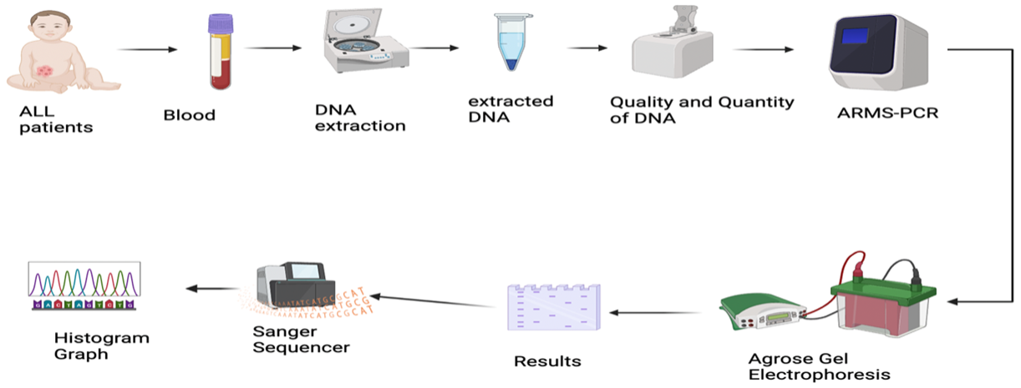

Sample Collection

Patients and sample

Between June 16, 2021, and April 2, 2022, a retrospective study was carried out in which data on 51 patients (87.9% were B ALL and 12.1% were T ALL) were collected from the Nanakali Oncology and Hematology specialized hospital in the Iraqi Kurdistan region's Erbil city. The average age was 8.7. Of these 51 patients, 32 were selected for molecular studies, while ten children were included as control subjects to analyze the molecular data further.
10 random samples from the 32 PCR products were chosen for Sanger sequencing. The detail of the study design shown in Figure 3.1, and their clinical characteristics, including age, sex, and subtype of ALL, were recorded. The information obtained from the study included bone marrow aspiration reports, immunophenotyping results, and treatment protocols. The Human Ethics Committee of the Erbil Health & Medical Technical College, Erbil

Polytechnic University, approved the study. Standard procedures were followed throughout the research process.
The research was conducted at several esteemed institutions, including Erbil Polytechnic Research Center, Tabriz University, Tishk International University, Noble Lab, and Zheen Genetics Lab.

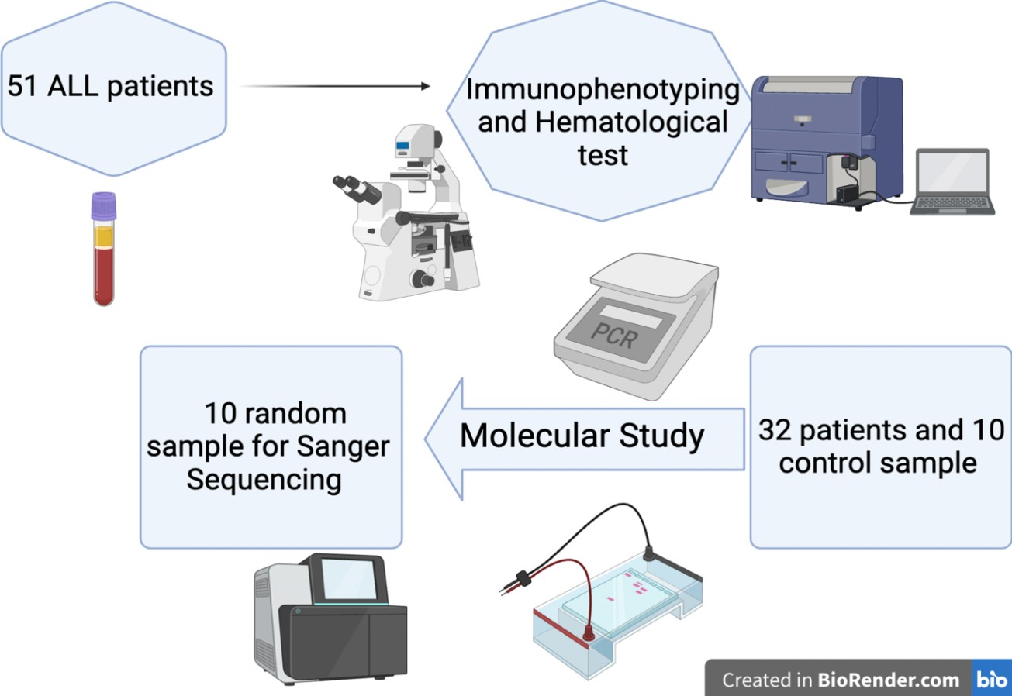

Figure 3.1 presented illustrates the intricacies of a study focusing on the utilization of samples to examine various parameters such as hematological, immunological, and molecular aspect.

3.4. Flow Cytometric Data Analysis

For detection of cTDT antigens, human leukocyte antigen-DR(HLA- DR), cytoplasmic myeloperoxidase, CD117, cCD79a, CD56, CD34, CD33, CD22, CD19,CD11b, CD10, CD7,cCD3, CD2, fluorescein isothiocyanate, phycoerythrin or peridinin chlorophyll protein (PerCP), and Allophycocyanin, have been obtained. The FACS CANTO Diva software was used to aanalyzethe data on the BD FACS-CantoII system (Becton-Dickinson)(Jaafar and Kadhom, 2018).

Molecular Investigation

DNA Extraction.
Gena Bioscience kit successfully performed DNA extraction and purification on 42 frozen samples, comprising 32 patient samples and ten control samples.s First, harvested the cells by centrifuging at 15,000 g for 1 min and discardingrd the supernatant. Added 900 µl RBC lysis solution and inverted ten times also 3 minutes incubation with occasional inversion; after completed lysis of red blood cell, centrifuged for at 15,000 g; removed supernatant with a pipet, left cell pellet. Did not exceed 20 µ of liquid. This was crucial for protein and DNA precipitation in later phases. To resuspend the white cells in the remaining liquid, give the tube a vigorous shake for ten seconds. The white cell pellet had to be thoroughly resuspended in the medium. The cells should be lysed by adding 300 l of Cell Lysis Solution and pipetted up and down until no clumps of cells remain. Added 100 ul protein precipitation solution to the cell lysate, then vortexed for 20 seconds to mix well. Tiny particles should not be visible. Centrifuged at 15,000 g for 1 min. The precipitated protein was a compressed pellet. If the shot was not tight, repeated mixing, incubated on ice for 10 minutes, and then centrifuge again.

Transferred the supernatant to a clean 1.5 ml microtube containing 300 l of 99.99 % isopropanol. Mixed the sample by gently inverting it 50 times. Centrifuged at 15,000 g for 1 min. The DNA saw as a pellet with a color spectrum ranging from almost white to light green. Immediately after removing the supernatant and drain tube, place them on clean absorbent paper. Washed the DNA pellet with 500 l of washing buffer by inverting the line multiple times. Centrifuged at 15,000 g for 1 min. Discarded the washing buffer carefully.
Air dry at room temperature for 10- 15 min to evaporate all ethanol. Dried DNA pellets must be rehydrated using 50-100 l of DNA Hydration Solution. Added 1.5 µl of RNase to lysate is an optional step. Eventually, Hydrated the DNA by incubating the sample at 65 °C for 30 min to accelerate rehydration for short-timeDNA storageA at 4 °four. For long-time storage, pplacingthe sample at -2,0 °C or for more extended storage required a deep freezer - 80 °C.

DNA Quantification by Spectrophotometric Method

Quantity and purity of DNA were measured with a Nanodrop- Spectrophotometer 2000 (Thermo Scientific). After bringing the samples to room temperature, thorough mixing should be done. After using a lint-free tissue soaked in nuclease-free water, the pedestals of the spectrophotometer were given a new dry tissue to finish the cleaning process. Nuclease-free water was measured as a blank, and the OD260 value was determined. The measurement of the absorption ratio at 260:280 nm was used to determine the purity of the DNA, with normal levels ranging between 1.7 and 1.9. (Optimum 1.8). The presence of phenol or protein contamination was indicated by readings lower than 1.7 or higher than 1.9 (Bunu et al., 2020).

Tetra-Primer ARMS PCR

Four set primers were designed previously by primer three software to amplify the IL-18 (rs1946518) polymorphism. All sets of primers are mentioned in Table 3.3, and the calculated melting common temperature was 54 °C for all primers. The common fragment length was 440 bp as the control band, 278 bp for the A allele, and 208 bp for the C allele. The final volume of PCR was 25 µl. The genotyping of the IL-18 -607 C/A polymorphism has been provided using the tetra-primer ARMS (T-ARMS) PCR method, as previously explained by (Taheri et al., 2012). In addition, PCR was carried out by the manufacturer's instructions using a commercially available PCR premix (Promega master mix). The PCR reaction was performed in a total volume of 25 µl containing 12.5 µl master mix, 1 µl from each forward outer primer, Reverse outer primer, forward inner primer, Reverse inner primer become 4 µl,
2.5 µl from extracted DNA, 6 µl from nuclease-free water. The PCR settings were as follows: initial denaturation at 95°C for 5 minutes followed by 35 cycles, each consisting of 30 sec at 95°C for denaturation, 20 seconds for annealing at 54°C and 30 seconds at 72°C for extension cycle, with a final extension stage at 72°C for 10 minutes. Eight microliters of PCR products were loaded to 2% agarose gel electrophoresis to see results.

Table 3.3: Show all primer sets for IL-18 -607 C/A polymorphism with annealing temperature and band size (Taheri et al., 2012).
Primers | Sequence | Annealing  Temp | Band Size
Forward  Outer Primer | 5’-  CCTACAATGTTACAACACTTAAAAT- 3’ | 54°C | 440 bp  (Common band)
Forward  Inner Primer | 5’- GATACCATCATTAGAATTTTGTG-  3’ |  | 278 bp A allele
Reverse Inner Primer | 5’- GCAGAAAGTGTAAAAATTATCAA-  3’ |  | 208 bp C allele
Reverse  Outer Primer | 5’-  ATAAGCCCTAAATATATGTATCCTTA- 3’

Agarose Gel Electrophoresis of PCR Standards

Agarose gel electrophoresis was used to detect and visualize PCR products. The agarose gel with a concentration of 2% was prepared by heating the 1X Tris borate EDTA (TBE) buffer and dissolving the agarose powder. The 15-micron safe stain was added, and the solution was poured very carefully poured sette onto which combs had been placed. After the gel had been set, it was transferred to an electrophoresis tank containing 1X TBE buffer. PCR products were carefully loaded into wells along which 100 bp DNA ladder (Gene DireX). Electrophoresis was conducted at 45 V for 15 minutes. Then change the voltage to 135 V for 35 minutes. The gel was transferred to the Uv name of the Gel and visualized under ultraviolet (UV) light.

Screening of IL-18 mMutationsby Sanger Sequencing
Sequencing workflows consist of two parts Post PCR Cleaning and Cycle Sequencing like.

Post-PCR Cleaning
Following the PCR process, the reaction mixtures are subjected to post- PCR cleaning to remove any incorporated primers and dNTPs that could affect the experiment results. Initially, use the magnetic bead purification method to clean the DNA. Secondly, after adding 20 µL of magnetic beads to the PCR product and mixing thoroughly, the tubes could be placed in a magnetic separator to collect the beads on the magnetic side of the tube, resulting in a clear solution. Third, discard the solution completely. Fourth, Transferred 20 µL of the purified PCR product into a new tube.

Table 3.4: Cycle Sequence Components

Components | Function
dH₂O | Completes the volume to 20 μl
BrightDye | Fluorescent dyes to label ddNTPs
Primer | 5’-CCTACAATGTTACAACACTTAAAAT-3’
Buffer | Regulates the concentration of a specific DNA  sequence
Template | Target DNA (purified PCR product)

Cycle Sequencing
Primers of a certain kind are included in the cycle sequencing process. In the following table are detailed descriptions of each component utilized in the cycle sequencing procedure.

Table 3.5: Thermocycler Protocol for Cycle Sequencing

Temperature | Time
95°C | 20 sec | 50 cycles
50°C | 25 sec
60°C | 2 min
12°C | ∞

Statistical Analysis

All data were entered into an Excel master sheet and prepared for statistical analysis using Graph Pad Prism (Version 9.0.). Most of the data were presented as percent values. Mann Whitney U Test was applied to compare two independent samples regarding the frequency of positive cells, and the data were expressed as Median and 75th percentile values. Correlation between CD markers with other independent variables was performed using Spearman’s rank correlation test. A mutation surveyor (version 5.1.2.) was applied to analyze mutations of the IL-18 gene.

Chapter Four Results

CHAPTER FOUR
- Results

4.1 Clinical Findings of the Studied Patients
The study subjects consisted of 51 individuals, 23 (45.1%) males and 28 (54.9%) females. The overall mean age of the patient was ±8.73 years old and SD ±7.29, and the mean of weight was ±21.52 Kg and SD ±13.42. The major compliments were fever in 42 (82.4%) patients and bleeding in 4 (7.8%). Physical examination revealed pallor as the primary finding detected in 9 (17.1%) patients,10 (19.6%) patient had anemia, followed by lymphadenopathy, hepatomegaly, and splenomegaly in 18 (35.6 %), 13
(15.7%) and 15 (29.4%), respectively, as shown in Table 4.1.

Table 4.1: Demographic characteristics and clinical presentation of ALL studied patients.
Clinical  Presentation | Mean | Std. Deviation
Age | ± 8.73 | ± 7.29
Weight | ± 21.52 | ± 13.42
Gender | Male (23) (45.1%) | Female (28) (54.9%)
Fever | Yes (42) (82.4%) | No (9) (17.6%)
Bleeding | Yes (4) (7.8%) | No (47) (92.2%)
Pallor | Yes (9) (17.1%) | No (42) (82.9%)
Lymphadenopathy | Yes (18) (35.6%) | No (33) (64.4%)
Weight loss | Yes (23) (45.7%) | No (28) (54.3%)
Anaemia | Yes (10) (19.6%) | No (41) (80.4%)
Hepatomegaly | Yes (13) (15.7%) | No (43) (84.3%)
Splenomegaly | Yes (15) (29.4%) | No (36) (70.6%)

More than two-thirds of patients had pre- or common B-ALL, represented by 75.8% of the patients (Figure 4.1), while 12.1% of patients were affected with T-ALL, 9.1% percent of patients had Pro-B ALL, and only one patient suffered from Burkitt's lymphoma.

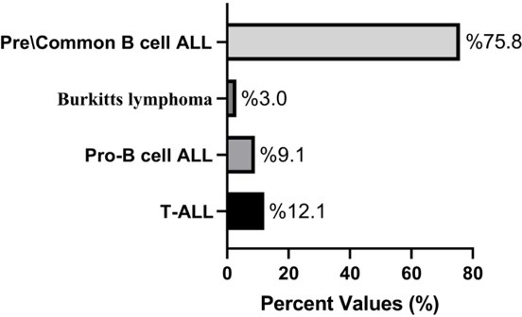

Figure 4.1 The Percent distribution of various acute lymphoblastic leukemia subtypes depends on immunophenotyping expression.

The results of Mann Whitney U Test revealed that Blast percent values recorded a significant (P<0.05) difference between patients who expressed CD19+, CD79a+, and CD10- (The Median and 75% percentile values were
86.75 and 7.23, respectively) and the patients with CD19+, CD79a+, CD10+ (The Median and 75% percentile values were 77 and 12.1 respectively). The age distribution of the ALL subtypes Patients with B-ALL can be differentiated according to their CD10 status: positive for common B-ALL or negative for pre-B ALL and T-ALL
(Figure 4.2) showed that T-ALL has a maximum median range of 11 year, but patients with CD19+, CD79a+, CD10-, and CD19+, CD79a+, CD10+ have a less median range of 10 and 5 year , respectively.

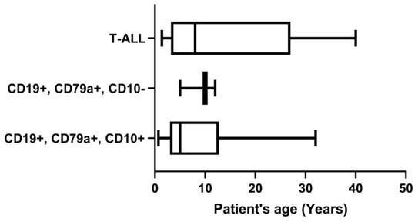

Figure 4.2. Distribution of CD markers among patients with acute lymphoblastic leukemia.

There is a clear difference in WBC counts in the phase of chemotherapy, like induction between CD34 Positive and CD34 Negative at a level of non- significance. Still, there are no differences in the phase of chemotherapy, like consolidation and maintenance in both CD34 positive and negative, as illustrated in Figure 4.3.

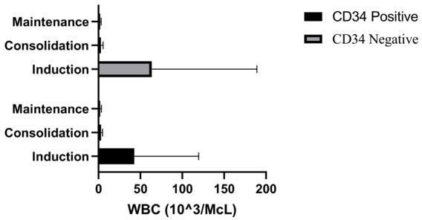

Figure 4.3. The difference between CD 34 positive by Dark Black colour and CD34 negative by light grey colour for response therapy in different stages of induction, consolidation, and maintenance by WBC absolute count.

Interestingly, there are also apparent differences in CD marker expression between patients over 15 and under 15. Figure (4.4) shows the difference in mean frequency of positive cells by CD markers that are mostly specific for the B-ALL subtype for patients younger than 15 years old were CD79a (68.4), CD22 (47.8), CD19 (77), CD10(65.54), TdT (52.21), HLA-DR
117(72.35), CD123 (21.5), Myeloid marker cytoplasm (MPO) (0), CD33 (0),
CD34 (24.1), CD117 (0), CD2 (19), CD3 (7.5), CD7 (6.1) and for patients older
than 15 years old were CD79a (84.5), CD22 (22), CD19 (89.25) CD10(77.5),
TdT (70.5), HLA-DR 117(91), CD123 (21.5), Myeloid marker cytoplasm
(MPO) (0), CD33 (0), CD34 (91.5), CD117 (0), CD2 (0), CD3 (0), CD7 (0).

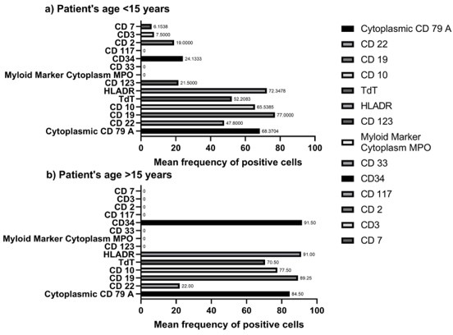
Figure 4.4. Expression of CD marker according to patients older than 15 years old and less than 15 years old.

CD45, also known as Common leukocyte antigen (Figure 4.5) was Moderately or low expressed in almost all studied patients. The relation of CD45 expression with other positive common CD markers like Cytoplasmic

CD79a, CD22, CD19, CD10, TdT, HLA-DR, and CD123 showed various results. In CD45 low expressed, the mean frequency of positive cells were as follow; Cytoplasmic CD79a(79.8), CD22 (42.2), CD10 (74.2), TdT (57.4),
HLA-DR(81), CD123 (73). When CD45 was moderately expressed the frequency mean range were as follows; Cytoplasmic CD79a(71.7), CD22 (31.5), CD10 (92.75), TdT (55.5), HLA-DR(67), CD123 (43).

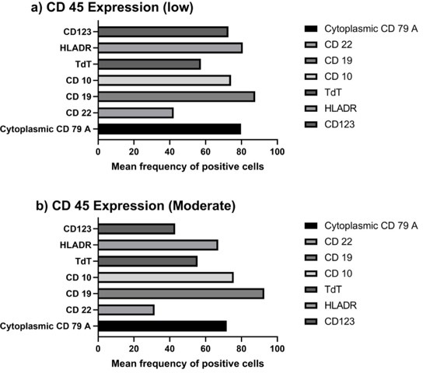

Figure 4.5. Expression of various CD markers in B-ALL patients, categorized by low or moderate expression of CD45.

In Figure 4.6, there is a correlation between lymphocyte percentage and the expression of Cytoplasmic CD79a, CD19, TdT, CD22, CD10, and HLA- DR, but only HLA-DR had a significant correlation with lymphocyte percentage. In contrast, the other CDs like CD79a, CD19, TdT, CD22, and CD10 had no significant difference.

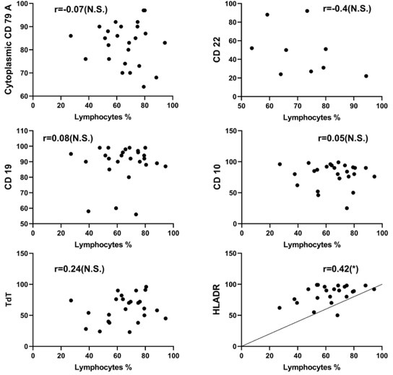

Figure 4.6. The correlation of lymphocytes with different CD markers.

On the other hand, according to our findings, the correlation between blast percentage and cytoplasmic CD79a, CD19, TdT, CD10, and HLA-DR has been illustrated in (Figure 4.7). However, None of the CD markers was significantly associated with the blast proportion.

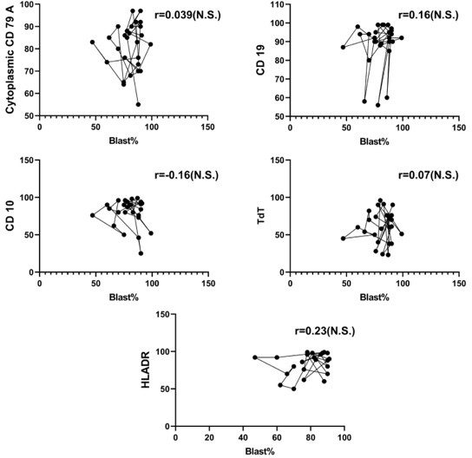

Figure 4.7. The correlation of Blast percentage with different CD markers.
None of them was a significant correlation.

Studying DNA Polymorphism of IL-18 In ALL Patients

Polymorphic Analysis By Gel Electrophoresis
The DNA IL-18 (rs1946518) promoter polymorphism of Pediatric Acute Lymphoblastic Leukemia (PALL), were detected using polymerase chain reaction (PCR). A total of 42 samples, in which 32 out of the total 42 samples were from PALL patients and the remaining 10 were from the normal children (control). Four pairs of specific primers were used for ARMS PCR amplification of a specific region of the IL-18 gene promoter. The amplified products were run on 2% resolution agarose gel electrophoresis concurrently with the DNA ladder and the results revealed bands at the different molecular weights in accordance with the DNA ladder. Upon comparison with the ladder, it was observed that 440 bp corresponded to the homozygous wild-type (CC),
278 bp to the heterozygous polymorphic allele (CA), and 208 bp to the

homozygous polymorphic allele (AA). This result indicated the presence of polymorphisms in the promoter region of the gene. Therefore, the PCR products were subjected to sequencing analysis, and the results are presented in (Figure 4.8 to Figure 4.11).

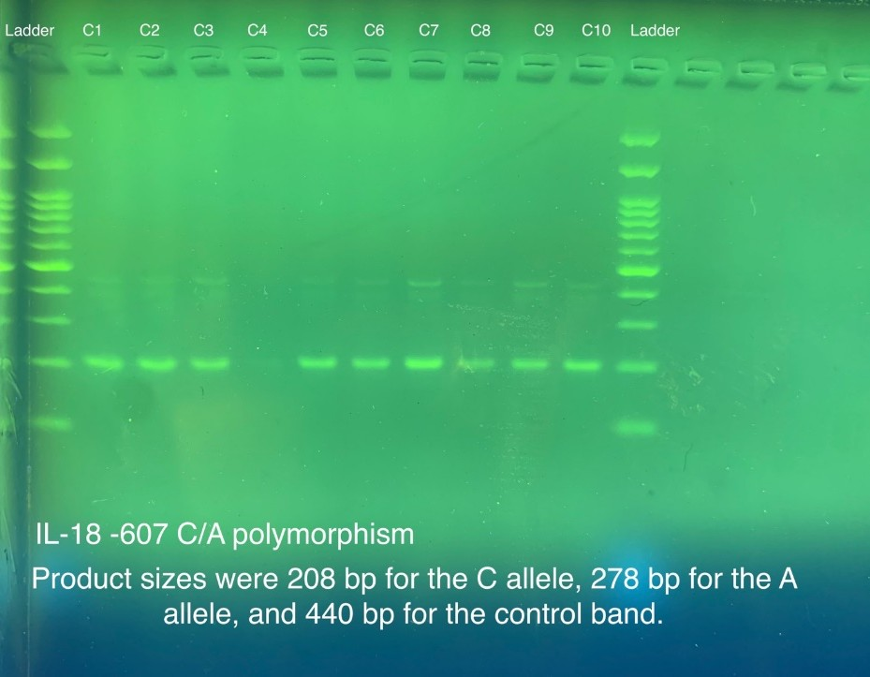
Figure. 4.8. The 2% agarose gel electrophoretic plate demonstrating the amplified PCR product of the promotor IL-18 gene region by ARMS PCR through tetra primer indicating bands for the wild-type alleles in the normal control group.

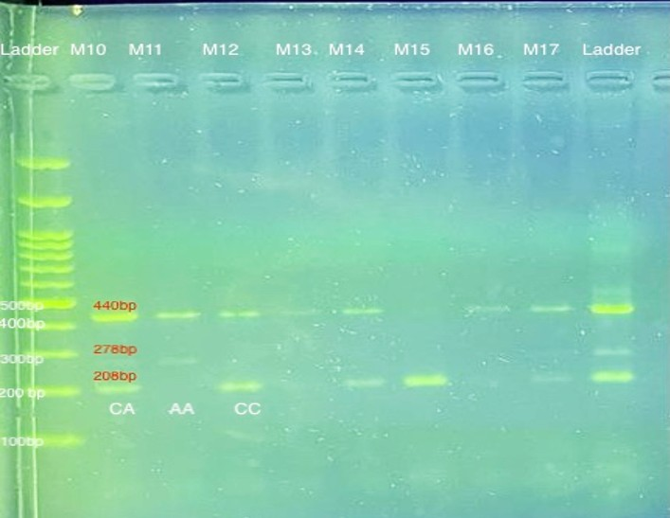

Figure 4.9. The 2% agarose gel electrophoresis demonstrated the amplified PCR product of the promotor IL-18 gene region by ARMS PCR through tetra primer, indicating three different bands at 440 bp (for control band), 278 bp (for polymorphic allele A) and 208 bp (for the allele C).

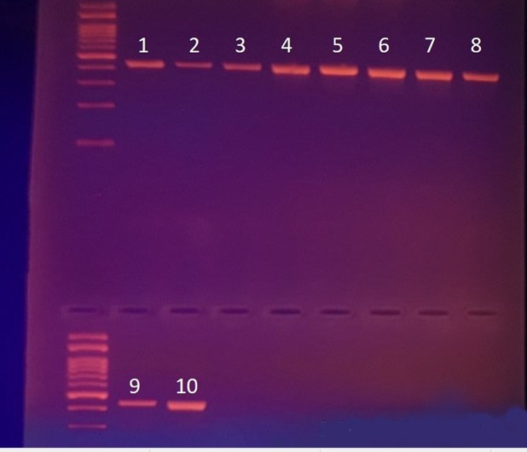
Figure 4.10. The 2% agarose gel electrophoretic plate demonstrated the amplified PCR product of the promotor IL-18 gene region by ARMS PCR through the only outer forward primer and the corresponding reverse primer indicating the different bands at 440 bp for the patients’ samples.

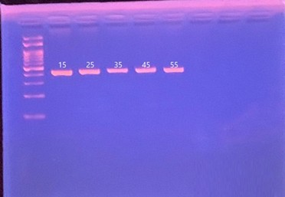

Figure 4.11. The 2% agarose gel electrophoretic plate demonstrated the amplified PCR product of the promotor IL-18 gene region by ARMS PCR through the only outer forward primer and the corresponding reverse primer indicating the different bands at 440 bp for the Normal samples.

Polymorphism Detection by Gel Electrophoresis

The study detected polymorphisms in the promoter region of the IL-18 (rs1946518) gene in patients' samples using gel electrophoresis of the PCR products (see Figure 4.1 and Figure 4.2). The results showed that 68.75% (22 patients) of the total had homozygous (CC) wild-type alleles, indicating no polymorphic allele in their IL-18 promoter region. Among the remaining patients, 18.75% (6 patients) possessed heterozygous (CA) alleles, and 12.5% (4 patients) showed homozygous (AA) alleles, indicating two polymorphic alleles in the promoter region. In contrast, the promoter region of the IL-18 genes in the control population showed 100% homozygous (CC) wild-type alleles. After completing the DNA sequencing, the study identified three new single nucleotide polymorphisms, corresponding to sense and nonsense mutations, respectively.

Polymorphism Detection Sanger Sequencing

In this study, the promoter region of the IL-18 (rs1946518) gene in patients' samples was analyzed for polymorphisms using Sanger sequencing. A total of 23 mutations were detected across 10 randomly selected PCR products, as detailed in Tables (4.2 and 4.3) and also Figures (4.12 ). These mutations comprised 20 SNPs, 1 insertion, 1 deletion, and 1 duplication, with a total of
11 different variation types. Of the mutations detected, 14 were sense mutations, and 9 were nonsense mutations. Significantly, this research also revealed the presence of 3 previously unreported SNPs, highlighting the importance of this study in expanding our understanding of genetic variation in the IL-18 gene.

Table 4.2: Sanger sequencing analysis of the promoter region of the IL- 18 gene in 10 patients of ALL.
Sort of  variati ve | A>A T | T>T G | A>A C | T> G | A> C |  | T>T A | A>A T | G>G A | het_in sT | het_du pC | het_d el | tot al
No. | 3 | 5 | 4 | 3 | 2 |  | 1 | 1 | 1 | 1 | 1 | 1 | 23
Sense |  |  |  |  |  | 14
Non Sense |  |  |  |  |  | 9 (3 newly discovered)

Table 4.3: Variants identified in ALL patients analyzed with mutation DNA variant analysis.
Gene | Chromosome Position | Mutation | Mutation Genotype | Type of mutation | Heterozygous/ Homozygous | Variants
1-IL18 | 11:1120353  78 | Substitution | A>AT | Nonsense  mutation | Heterozygous | 30953A>AT$25
1-IL18 | 11:1120354  58 | Substitution | T>TG | Sense mutation | Heterozygous | 31033T>TG$43
1-IL18 | 11:1120354  01 | Substitution | A>A  C | Sense mutation | Heterozygous | 31082A>AC$28
2-IL18 | 11:1120354  58 | Substitution | T>TG | Sense mutation | Heterozygous | 31033T>TG$40
2-IL18 | 11:1120354  58 | Substitution | A>A  C | Sense mutation | Heterozygous | 31082A>AC$32
3-IL18 | 11:1120354  01 | Substitution | A>AT | Nonsense  mutation | Heterozygous | 30953A>AT$46
3-IL18 | 11:1120354  01 | Substitution | T>TG | Sense mutation | Heterozygous | 31033T>TG$44
3-IL18 | 11:1120354  01 | Substitution | A>A  C | Sense mutation | Heterozygous | 31082A>AC$65
4-IL18 | 11:1120343  97 | Substitution | T>TG | Sense mutation | Heterozygous | 31033T>TG$37
4-IL18 | 11:1120343  97 | Substitution | A>A  C | Sense mutation | Heterozygous | 31082A>AC$29
5-IL18 | 11:1120355  07 | Substitution | A>AT | Nonsense  mutation | Heterozygous | 30953A>AT$42
5-IL18 | 11:1120355  07 | Substitution | T>G | Sense mutation | Homozygous | 31033T>G$116
5-IL18 | 11:1120355  07 | Substitution | A>C | Sense mutation | Homozygous | 31082A>C$85
6-IL18 | 11:1120354  58 | Substitution | T>TG | Sense mutation | Heterozygous | 31033T>TG$32
6-IL18 | 11:1120354  58 | Substitution | T>TA | Nonsense  mutation | Heterozygous | 31040T>TA$14
6-IL18 | 11:1120355  04 | Substitution | A>AT | Nonsense  mutation | Heterozygous | 31045A>AT$15
6-IL18 | 11:1120355  07 | Insertion | T | Nonsense mutation | Heterozygous | 31046_31047het  _insT$5

7-IL18 | 11:1120355  07 | Duplication | C | Nonsense mutation | Heterozygous | 30976het_dupC  $18
8-IL18 | None | none | none | none | none | None
9-IL18 | 11:1120353  78 | Substitution | T>G | Sense mutation | Homozygous | 31033T>G$110
9-IL18 | 11:1120353  78 | Substitution | A>C | Sense mutation | Homozygous | 31082A>C$80
10-  IL18 | 11:1120352  84 | Substitution | T>G | Sense mutation | Homozygous | 31033T>G$115
10- IL18 | 11:1120352  84 | Substitution | G>G A | Nonsense mutation | Heterozygous | 31079G>GA$7
10- IL18 | 11:1120352  84 | Deletion | G | Nonsense mutation | Heterozygous | 31081het_delG$ 4

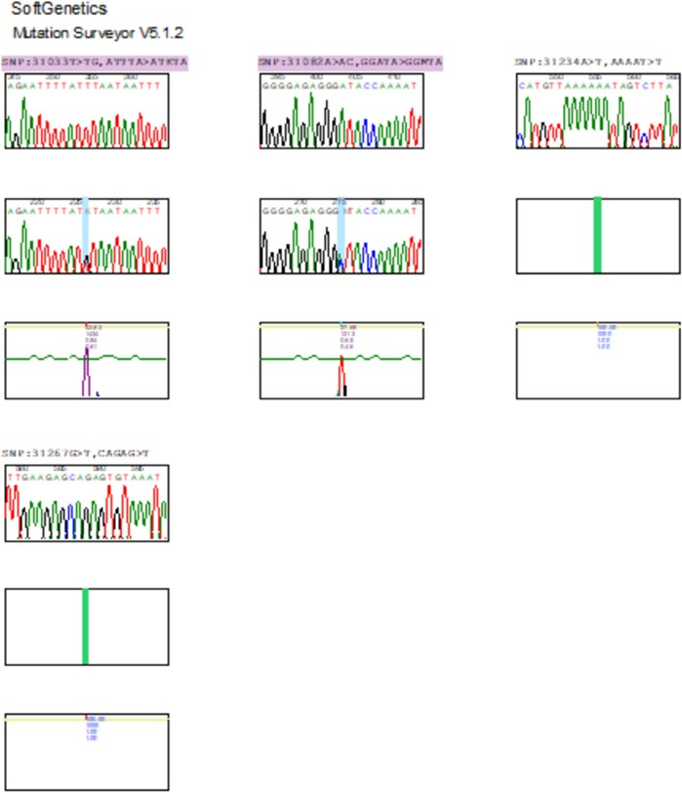

Figure 4.12. Show three different polymorphisms (mutations) on the IL-18 promoter region. The shift from A to AT (30953A>AT$25) is called a nonsense mutation, the shift from T to TG (31033T>TG$43), and A to AC (31082A>AC$28) are referred to as sense mutations, which causes changes in amino acid molecules.

Chapter Five Discussion

CHAPTER FIVE

- Discussion

Immunophenotyping
Immunophenotyping play a pivotal role in basic research to diagnose diseases, such as specific types of leukemia and lymphoma. According to (Abdurrahman, 2011) study , who carried out research in Duhok, male patients were more prevalent than female patients; nevertheless, (Conforti et al., 2013) found that female patients were more common than male patients. The median age of patients in his study was 4.9 years old, less than half of the patients lost weight, 23 (45.7%), and around 10 (19.6%) patients had anemia, as seen in Table 4.1. The Leukemia and Lymphoma Society reports that 75 percent of ALL cases are B-ALL, and 25 percent of ALL cases are T-ALL (Society, 2022).
However, according to study (Bachir et al., 2009) study, the age range of patients diagnosed with B-ALL, in general, is between the ages of (5-13), while individuals diagnosed with T-ALL are between 0.5-17 years old. According to the study, individuals who tested positive for CD10 had a much more significant blast proportion than those who tested negative for CD10. Moreover, it also was demonstrated that a positive CD score was associated with adverse markers such as a more significant blast percentage, a larger total leucocyte count, and a lower platelet count. According to (Wimalachandra et al., 2020) studies separate CD markers according to pediatric and adult age. For instance, in this study level of CD79a is more expressed in pediatric age, but in adults, age is less expressed, although, in our study, it is vice versa. However, CD10 and CD19 are relatively expressed in the current study; CD33 is not expressed at all in pediatric and adult ages. The (Wimalachandra et al., 2020) studies expressed approximately 25 percent in pediatrics and adults. In the immunophenotypic characterization, the most sensitive markers for diagnosing

B-ALL were CD19 and Cyto CD79 a, with more than 90% positivity. Ninety- three percent of pediatric B-ALL and 67% of adult B-ALL were CD10 positive common ALL. CD20 expression was seen in only 27.9% of adult B-ALL cases and 17.7% of childhood B-ALL cases. These findings regarding the expression of different CDs for ALL patients younger and older than 15 years old mirror those previously presented in most other studies (SWERDLOW, 2008, Rowe, 2010, Hann et al., 1998). According to (Ratei et al., 1998) studies, when CD45 is an approximately negative or low expression, CD34, CD10, TdT, CD22, and CD24 are highly expressed or positive. Still, for those patients there, CD45 almost moderately, no expression of CDs has not been expressed except for CD33 in most cases, while in our study in, both CD45 positive and negative CD22 have been expressed.
In contrast, in (Ratei et al., 1998) study CD22 was expressed when CD45 was negative, but CD10 and TdT expressed by the same amount for both CD45 positive and negative. While the study(Ratei et al., 1998) study only expressed when CD45 was not expressed. Also, according to (Amirghofran et al., 2016), there was no significant association between CD marker and blast. In the research conducted by (Jaafar and Kadhom, 2018). CD34 and CD10 were shown to have adverse tags like higher peripheral blood blasts percentage, higher total leucocyte count, and lower platelet count (Ying et al., 2011).

IL-18 Gene Polymorphism
IL-18 was discovered in 1999 as a member of the IL-1 cytokine family. It is hidden by various cells, such as monocytes T and B lymphocytes, Langerhans cells, natural killer cells, and macrophages (Rex et al., 2020). Interleukin-18 (IL-18) factor, participating in both innate and acquired immune response, is considered a crucial cytokine produced due to

inflammasome activation of NLRP3 gene (Kaplanski, 2018). Moreover, according to the previous studies, increasing the IL-18 level in the blood of patients suffering with multiple myeloma is linked to decreased patient survival rates and disease progression (Nakamura et al., 2018b).
Multiple studies have provided evidence suggesting a potential association between IL-18 and cancer progression. Specifically, these studies have highlighted the risk posed by IL-18 in the development and advancement of various types of cancer, including. According to a meta-analysis of the(Yang et al., 2013) results, the IL-18 gene promoter -607 C>A polymorphism significantly correlates with elevated cancer risk. This association is particularly pronounced in cases of nasopharyngeal carcinoma and gastrointestinal cancer(Yang et al., 2013).The meta-analysis of (Chute, 2021) study findings indicates that the -607C/A polymorphism in the promoter region of the IL-18 gene is linked to a notable rise in cancer risk, particularly for breast cancer, nasopharyngeal carcinoma and esophageal cancer. These associations were observed in populations of Asian and Mixed ethnicities(Chute, 2021).
The findings of the (Huang et al., 2018)study suggest that individuals
who possess the IL-18 -607 A/C polymorphism in a heterozygous state have a higher propensity for developing colorectal cancer(Nikiteas et al., 2007).The Suamaya study indicates that IL-18 is crucial in developing Taiwan's nasopharyngeal carcinoma (NPC). Additionally, the study suggests a correlation between the genotype and phenotype of the IL-18 -607 polymorphism about NPC(Huang et al., 2018).
A study conducted by (Sáenz-López et al., 2010)found that there may be a correlation between polymorphisms in the IL-18 gene, particularly IL-18-607 and IL-18-137, and an unfavorable prognosis in renal carcinoma. The study indicated that increased production of IL-18 might substantially impact the progression, invasion, and spread of renal cancer(Sáenz-López et al., 2010). A survey by (Yalçın et al., 2015) indicates a potential link between the IL-18 gene

promoter rs187238(G/C) polymorphism and chronic leukemia in the Turkish population. However, it is essential to note that the study had limited participants, focusing specifically on patients with CLL and CML. Initial findings suggest an association between the -137G/C polymorphism and these patients.
Further large-scale studies incorporating haplotype and expression analysis must confirm these results(Yalçın et al., 2015). According to the findings of (Farjadfar et al., 2009), IL-18 polymorphism may contribute to an elevated risk of lung cancer, particularly in patients with squamous cell carcinoma (SC). The study suggests that genetic variations in IL-18 could potentially play a role in the development or progression of lung cancer, with a particular impact on the SC subtype (Farjadfar et al., 2009).
Contrary findings suggest that studies indicate no significant effect of IL- 18 on cancer progression. A Chinese study suggests that the IL-18 -607 A/C polymorphism is associated with an elevated risk of non-small cell lung cancer (NSCLC) in the Chinese population. However, this polymorphism does not appear to have a functional impact on IL-18 levels (Jia et al., 2016b).
According to the study conducted by (Samsami Dehaghani et al., 2009), it was observed that IL-18 promoter polymorphisms at positions −607 (C/A) and −137 (G/C) do not seem to be associated with increased susceptibility to ovarian cancer in the Iranian population. However, it was noted that the serum level of IL-18 is elevated in patients with ovarian cancer (Samsami Dehaghani et al., 2009).
IL-18 rs1946518 and rs187238 genotypes have been investigated for their association with the risk of various types of solid cancers. Positive associations have been reported in esophageal, colorectal, ovarian, bladder, prostate, breast, and lung cancer (Jia et al., 2016a, Jiang and Elliott, 2017, Wei et al., 2007). However, some studies report no association (Wei et al., 2007, Nong et al., 2009). These inconsistent conclusions might be explained not only

by ethnic differences but also by the type of cancer and should be validated in various populations with large sample sizes (Wu et al., 2022). Based on the available literature, there is no or little information about IL-18 promoter polymorphism related to IL-18 607 C/A polymorphic alleles in persons with ALL in Middle East Countries, thus, the idea of this work was conceived.
IL-18 was discovered in 1999 as a member of the IL-1 cytokine family. It is hidden by a variety of cells, such as monocytes T and B lymphocytes, Langerhans cells, natural killer cells, and macrophages (Rex et al., 2020).
In 2022, researchers in Taiwan presented the results of the world's first study on IL-18 and its relationship to ALL. The results indicated that genotypes of IL-18 rs1946519, rs1946518, and rs187238 were not linked to pediatric ALL (Chen et al., 2022). It has been shown that IL-18 is bidirectional, with both anti- tumor and pro-tumor effects (Chen et al., 2021). However, IL-18 can also promote many tumor cell characteristics, such as, proliferation, immune evasion, migration and angiogenesis(Bassani et al., 2019). Although IL-18 SNPs may not be effective as biomarkers for detecting children ALL at an early stage in Taiwan, but could do so in other population at some parts of the world (Chen et al., 2022). Their findigs also supported the idea that IL-18 in some way contributes significantly to the etiology of ALL (Chen et al., 2022).
The primary mechanism by which IL-18 exerts its effects was through
the induction of IFN-c production in T lymphocytes; this, in turn, results in the recruitment of T cells and macrophages as reported by (Arend et al., 2008) IL- 18 proteins influence the host's response to oncogenesis and angiogenesis, which plays a key role in pathophysiology of cancer especially ALL in children(Arend et al., 2008). It has been shown that the blood level of IL-18 in patients with de novo myeloma is greater at stage III in comparison to stages II and I, and a higher level of IL-18 is related with a bad prognosis (Alexandrakis et al., 2004). Morever, genetic polymorphism of IL-18 in the promoter of IL- 18 gene triggers the immune response and relates to the risk of numerous types

of illnesses, including cancer, stroke, coronary artery disease and tuberculosis, according to previous research (Tsai et al., 2013).
The study has shown that C-allele at position -607 of rs1946518 is linked to an elevated risk of sarcoidosis in the Japanese population, as reported by Takada and colleagues. The report shows that when comparing tumor size, lymph node involvement and metastasis (TNM) and stage, the IL-18-607CC genotype is significantly associated with the unwanted outcomes (Takada et al., 2002). However, a study conducted by Ying et al. reported no correlation between IL-18 blood levels and the IL18 genotype or allele frequency (rs1946518) (Takada et al., 2002).
Even though the study on China’s population focused on the IL-18 genetic polymorphism (rs1946518), a correlation between the polymorphic gene and with clinicopathological characteristics of AML patients was recorded (Wang et al., 2017). The Authors discovered that the individuals with AML who had the TT genotype had a smaller bone marrow blast than those who carried the GG or GT genotypes (Wang et al., 2017). Thus, supporting the findings reported in the present study. The authors further identified the level of IL-18 expression in AML patients, the plasma levels of IL-18 were found to be significantly greater in AML patients who had the genotypes GT or TT compared to those who carried the GG genotype. Again, this strengthening the claims reported in this study. Additionally, it was discovered that the persons with GT genotype had a significantly lower chance of surviving in comparison to other genotypes(Wang et al., 2017).
The present results showed that the GG genotype of IL-18 rs187238 can
be a predictor of childhood ALL survival, although the detailed mechanism needs more investigation. In contrast, the findings of the pilot study showed that IL-18 rs1946519, rs1946518, and rs187238 genotypes were not associated with for childhood ALL risk, as seen in other solid tumors. However, the

variant GC and CC genotypes of IL-18 rs187238 may serve as a predictor of higher risk and shorter survival.
Likewise, certain SNPs of inflammatory genes were found to be associated with the susceptibility and treatment response of in children (Ji et al., 2023). Such findings may help in the early detection, diagnostic evaluation, and making individual chemotherapy regimen for ALL children according to the genotype of these sites at the time of initial diagnosis. Again, to further strengthen the claim of the present study, a recent report by Qu and colleagues revealed that a minor allele of IL-18 rs1946518 and rs187238 polymorphisms might positively associate with the AML susceptibility with subsequent change in IL-18 concentration (Qu et al., 2020).
Depite having an over-expression of IL-18 in serum as a good marker for solid cancers, such as lung cancer (Wu et al., 2022) and its association with a decreased risk of AML (Wu et al., 2022). there has been a debate on whether the serum level of IL-18 is a good marker for ALL or not. Also, the previous studies hinted that the dynamic alterations of IL-18 protein make it difficult to conclude whether IL-18 protein can serve as a good marker for ALL (Wu et al., 2022).
However, it may be the significance of this relationship is not yet clear (Yalçın et al., 2015). the C/C and G/C genotypes were linked with the chance of chronic myeloid leukemia development, while the C/C genotype was associated with the chance of chronic lymphoid leukemia development. Thus, suggesting a correlation between the polymorphism and chronic leukemias development which is characterised by the increase in division of mature cells with subsequent functionality loss. These findings point to a possible link between mutations in the IL-18 gene and an increased chance of developing cancer; however, the significance of this relationship is not yet clear(Yalçın et al., 2015).

On the other hand interleukin-1β rs16944 SNP was also found to be correlated with ALL risk stage in children, certain SNPs of inflammation genes were also associated with the susceptibility and treatment response of ALL children (Nakamura et al., 2018a). These findings may help in the early detection, diagnostic evaluation, and making individual chemotherapy regimen for ALL children according to the genotype of these sites at the time of initial diagnosis.

Chapter Six Conclusion and Recommendations

CHAPTER SIX
- Conclusion and Recommendations

Conclusions

    - The present study ascertain that less than 10% of patients in Erbil City, Iraq were diagnosed with Pro-B Acute Lymphoblastic Leukemia (ALL) based on flow cytometric analysis.
    - The present study observed that CD10-negative patients had a higher percentage of blast cells, while CD34 positivity was associated with the age of different ALL subtypes. There was no correlation between CD markers and other laboratory findings.
    - This study highlight on the complex nature of ALL and its association with different immunophenotyping and IL-18 gene polymorphim.
    - This study is the first to report on the association between SNPs (rs1946518) on the promoter region of the IL-18 gene and Kurdish children's population, despite the absence of previous literature on this topic.
    - The study found 23 mutations through Sanger Sequencing in the IL-18 gene's promoter region, which included SNPs, insertion, deletion, and duplication. There were 11 types of variation, with 14 being sense and 9 being non-sense mutations. Additionally, the study uncovered 3 new SNPs, providing further insight into genetic variation in the IL-18 gene.
    - This may inspire eager researchers in the field to conduct further investigations, ultimately benefiting society.

Recommendations

- Further researches are recommended as prospective clinical trials to affirm the claim of this study and to further explore other markers that could be used in the prognosis and diagnosis of ALL
- The qRT-PCR can be utilized to assess the expression of the IL-18 gene in patients with ALL.
- Next-generation sequencing (NGS) offers a powerful tool for the investigation of the IL-18 gene in patients with ALL

7. References
ABDULRIDHA, R. H., JAWAD, N. K. & NUMAN, A. T. 2021. Prevalence
and Risk of Leukemia Reported Cases, Observational Descriptive Statistic from Iraqi Center for Hematology in Baghdad Province. Indian Journal of Forensic Medicine & Toxicology, 15, 2429.
ABDURRAHMAN, K. N. 2011. A rare presentation of childhood acute lymphoblastic leukemia with obstructive jaundice due to pancreatic involvement-case report. Duhok Medical Journal, 5.
ABOU DALLE, I., JABBOUR, E., SHORT, N. J. & RAVANDI, F. 2019a.
Treatment of Philadelphia chromosome-positive acute lymphoblastic leukemia. Current treatment options in oncology, 20, 1-13.
ABOU DALLE, I., JABBOUR, E., SHORT, N. J. & RAVANDI, F. 2019b.
Treatment of Philadelphia chromosome-positive acute lymphoblastic leukemia. Current treatment options in oncology, 20, 1-13.
AL-HASHIMI, M. M. 2021. Incidence of Childhood Leukemia in Iraq, 2000- 2019. Asian Pacific Journal of Cancer Prevention: APJCP, 22, 3663.
AL-KZAYER, L. A. F. Y., SAKASHITA, K., AL-JADIRY, M. F., AL-
HADAD, S. A., GHALI, H. H., UYEN, L. T., LIU, T., MATSUDA, K., ABDULKADHIM, J. M. & AL-SHUJAIRI, T. A. 2015. Analysis of
KRAS and NRAS gene mutations in Arab Asian children with acute leukemia: high frequency of RAS mutations in acute lymphoblastic leukemia. Pediatric blood & cancer, 62, 2157-2161.
ALEXANDRAKIS, M., PASSAM, F., SFIRIDAKI, K., MOSCHANDREA, J., PAPPA, C., LIAPI, D., PETRELI, E., ROUSSOU, P. & KYRIAKOU,
D. 2004. Interleukin-18 in multiple myeloma patients: serum levels in relation to response to treatment and survival. Leukemia Research, 28, 259-266.
AMIRGHOFRAN, Z., ASIAEE, E. & KAMAZANI, F. M. 2016. Soluble CD
44 and CD 44v6 and prognosis in children with B-cell acute lymphoblastic leukemia. Asia-Pacific Journal of Clinical Oncology, 12, e375-e382.
ANGELESCU, S., BERBEC, N. M., COLITA, A., BARBU, D. & LUPU, A.
R. 2012. Value of multifaced approach diagnosis and classification of acute leukemias. Mædica, 7, 254.
AREND, W. P., PALMER, G. & GABAY, C. 2008. IL-1, IL-18, and IL-33
families of cytokines. Immunological reviews, 223, 20-38.
ATTARBASCHI, A., MANN, G., KÖNIG, M., STEINER, M., STREHL, S., SCHREIBERHUBER, A., SCHNEIDER, B. R., MEYER, C., MARSCHALEK, R. & BORKHARDT, A. 2006. Mixed Lineage
Leukemia–rearranged childhood pro-B and CD10-negative pre-B acute lymphoblastic leukemia constitute a distinct clinical entity. Clinical cancer research, 12, 2988-2994.

BACH, C., MUELLER, D., BUHL, S., GARCIA-CUELLAR, M. & SLANY,
R. 2009. Alterations of the CxxC domain preclude oncogenic activation of mixed-lineage leukemia 2. Oncogene, 28, 815-823.
BACHIR, F., BENNANI, S., LAHJOUJI, A., CHERKAOUI, S., KHATTAB, M., NASSEREDDINE, I., ZAFAD, S. & EL AOUAD, R. 2009.
Characterization of acute lymphoblastic leukemia subtypes in Moroccan children. International journal of pediatrics, 2009.
BAIN, B. 2008. Chronic eosinophilic leukemia, not otherwise specified. World Health Organization Classification of Tumors of Haematopoietic and Lymphoid Tissues, 51-53.
BAIN, B. J. 2010. Myeloid and lymphoid neoplasms with eosinophilia and abnormalities of PDGFRA, PDGFRB or FGFR1. haematologica, 95, 696.
BALBONI, T. A., PAULK, M. E., BALBONI, M. J., PHELPS, A. C.,
LOGGERS, E. T., WRIGHT, A. A., BLOCK, S. D., LEWIS, E. F.,
PETEET, J. R. & PRIGERSON, H. G. 2010. Provision of spiritual care to patients with advanced cancer: associations with medical care and quality of life near death. Journal of Clinical Oncology, 28, 445.
BASSAN, R., SPINELLI, O., OLDANI, E., INTERMESOLI, T., TOSI, M., PERUTA, B., BORLENGHI, E., POGLIANI, E., DI BONA, E. &
CASSIBBA, V. 2014. Different molecular levels of post-induction minimal residual disease may predict hematopoietic stem cell transplantation outcome in adult Philadelphia-negative acute lymphoblastic leukemia. Blood cancer journal, 4, e225-e225.
BASSANI, B., BACI, D., GALLAZZI, M., POGGI, A., BRUNO, A. &
MORTARA, L. 2019. Natural killer cells as key players of tumor progression and angiogenesis: old and novel tools to divert their pro- tumor activities into potent anti-tumor effects. Cancers, 11, 461.
BAST JR, R. C. & HOLLAND, J. F. 2010. Holland-Frei cancer medicine 8, PMPH-USA.
BAXEVANIS, C. N., GRITZAPIS, A. D. & PAPAMICHAIL, M. 2003. In
vivo antitumor activity of NKT cells activated by the combination of IL- 12 and IL-18. The Journal of Immunology, 171, 2953-2959.
BELOV, L., DE LA VEGA, O., DOS REMEDIOS, C. G., MULLIGAN, S. P.
& CHRISTOPHERSON, R. I. 2001. Immunophenotyping of leukemias using a cluster of differentiation antibody microarray. Cancer research, 61, 4483-4489.
BELVER, L., ALBERO, R. & FERRANDO, A. A. 2021. Deregulation of
enhancer structure, function, and dynamics in acute lymphoblastic leukemia. Trends in immunology, 42, 418-431.
BENNETT, J., CATOVSKY, D., DANIEL, M.-T., FLANDRIN, G., GALTON, D., GRALNICK, H. & SULTAN, C. 1981. The
morphological classification of acute lymphoblastic leukaemia:

concordance among observers and clinical correlations. British journal of haematology, 47, 553-561.
BLATT, K., MENZL, I., EISENWORT, G., CERNY-REITERER, S., HERRMANN, H., HERNDLHOFER, S., STEFANZL, G., SADOVNIK, I., BERGER, D. & KELLER, A. 2018. Phenotyping and
target expression profiling of CD34+/CD38− and CD34+/CD38+ stem- and progenitor cells in acute lymphoblastic leukemia. Neoplasia, 20, 632-642.
BOARD, P. P. T. E. 2022. Childhood acute lymphoblastic leukemia treatment (PDQ®). PDQ Cancer Information Summaries [Internet]. National Cancer Institute (US).
BRILLANTINO, C., ROSSI, E., BIFANO, D., MINELLI, R., TAMASI, S., MAMONE, R., BIGNARDI, E., ZECCOLINI, R., ZECCOLINI, M. &
VALLONE, G. 2021. An unusual onset of pediatric acute lymphoblastic leukemia. Journal of Ultrasound, 24, 555-560.
BROWN, M. & WITTWER, C. 2000. Flow cytometry: principles and clinical applications in hematology. Clinical chemistry, 46, 1221-1229.
BUFFLER, P. A., KWAN, M. L., REYNOLDS, P. & URAYAMA, K. Y. 2005.
Environmental and genetic risk factors for childhood leukemia: appraising the evidence. Cancer investigation, 23, 60-75.
BUNU, S. J., OTELE, D., ALADE, T. & DODORU, R. T. 2020. Determination
of serum DNA purity among patients undergoing antiretroviral therapy using NanoDrop-1000 spectrophotometer and polymerase chain reaction. Biomedical and Biotechnology Research Journal (BBRJ), 4, 214.
CAIRO, M. S., SPOSTO, R., GERRARD, M., AUPERIN, A., GOLDMAN, S. C., HARRISON, L., PINKERTON, R., RAPHAEL, M., MCCARTHY,
K. & PERKINS, S. L. 2012. Advanced stage, increased lactate dehydrogenase, and primary site, but not adolescent age (≥ 15 years), are associated with an increased risk of treatment failure in children and adolescents with mature B-cell non-Hodgkin's lymphoma: results of the FAB LMB 96 study. Journal of Clinical Oncology, 30, 387.
CHEN, C.-C., TZENG, H.-E., KUO, C.-C., LIM, S. N. S., HSU, P.-C., HSU,
Y.-N., CHIN, Y.-T., CHANG, W.-S., WANG, C.-H. & TSAI, C.-W.
2022. Significant Contribution of Interleukin-18 Genotypes to Childhood Acute Lymphocytic Leukemia Risk in Taiwanese. Anticancer Research, 42, 5283-5290.
CHEN, Y., LI, Y., GUO, H., ZHANG, Z., ZHANG, J., DONG, X., LIU, Y.,
ZHUANG, Y. & ZHAO, Y. 2021. The Effects of Adoptively Transferred IL-23/IL-18-Polarized Neutrophils on Tumor and Collagen-Induced Arthritis in Mice. Journal of Inflammation Research, 14, 4669.
CIESLA, B. 9 Leukopoiesis and Leukopoietic Function. Library of Congress Cataloging-in-Publication Data, 2007. 129.

CILLONI, D. & SAGLIO, G. 2012. Molecular Pathways: BCR-ABLBCR-
ABL. Clinical Cancer Research, 18, 930-937.
CONFORTI, A., BIAGINI, S., DEL BUFALO, F., SIRLETO, P., ANGIONI, A., STARC, N., LI PIRA, G., MORETTA, F., PROIA, A. & CONTOLI,
B. 2013. Biological, functional and genetic characterization of bone marrow-derived mesenchymal stromal cells from pediatric patients affected by acute lymphoblastic leukemia. PLoS One, 8, e76989.
DE LOURDES PERIM, A., GUEMBAROVSKI, R. L., ODA, J. M. M., LOPES, L. F., ARIZA, C. B., AMARANTE, M. K., FUNGARO, M. H. P., DE OLIVEIRA, K. B. & WATANABE, M. A. E. 2013. CXCL12 and
TP53 genetic polymorphisms as markers of susceptibility in a Brazilian children population with acute lymphoblastic leukemia (ALL). Molecular biology reports, 40, 4591-4596.
DEMIRHANA, O., TANRıVERDIA, N. & SÜLEYMANOVAA, D. 2019.
Frequency and types of chromosomal abnormalities in acute lymphoblastic leukemia patients in Turkey. Archives of Community Medicine and Public Health, 5, 055-061.
DEVINE, S. M. & LARSON, R. A. 1994. Acute leukemia in adults: recent developments in diagnosis and treatment. CA: a cancer journal for clinicians, 44, 326-352.
DEZHAKAM, H., DEZHAKAM, A. & HAGHIGHATFARD, A. 2022. Taper
up-off treatment of opium may reverse some dysregulations of gene expression patterns caused by four type of leukemia, AML, ALL, CML and CLL; a pilot animal model study.
DIAS-MELICIO, L. A., FERNANDES, R. K., RODRIGUES, D. R., GOLIM,
M. A. & SOARES, A. M. V. C. 2015. Interleukin-18 increases TLR4 and mannose receptor expression and modulates cytokine production in human monocytes. Mediators of inflammation, 2015.
DINARELLO, C. 2000. Interleukin-18, a proinflammatory cytokine. European cytokine network, 11, 483-486.
DINARELLO, C. A. 1999. IL-18: A TH1-inducing, proinflammatory cytokine and new member of the IL-1 family. Journal of Allergy and Clinical Immunology, 103, 11-24.
DING, W., WANG, J., ZHAO, S., YANG, Q., SUN, H., YAN, J., GAO, L.,
YAO, W., ZHANG, W. & LIU, W. 2015. Clinicopathological study of pulmonary extranodal nature killer/T-cell lymphoma, nasal type and literature review. Pathology-Research and Practice, 211, 544-549.
DÖHNER, H., ESTEY, E. H., AMADORI, S., APPELBAUM, F. R., BÜCHNER, T., BURNETT, A. K., DOMBRET, H., FENAUX, P.,
GRIMWADE, D. & LARSON, R. A. 2010. Diagnosis and management of acute myeloid leukemia in adults: recommendations from an international expert panel, on behalf of the European LeukemiaNet.

Blood, The Journal of the American Society of Hematology, 115, 453- 474.
DÖHNER, H., WEISDORF, D. J. & BLOOMFIELD, C. D. 2015. Acute
myeloid leukemia. New England Journal of Medicine, 373, 1136-1152. EISSA, S., ZAKI, S. A., EL-MAGHRABY, S. M. & KADRY, D. Y. 2005.
Importance of serum IL-18 and RANTES as markers for breast carcinoma progression. J Egypt Natl Canc Inst, 17, 51-5.
EL-ZINE, M. A. Y., ALHADI, A. M., ISHAK, A. A. & AL-SHAMAHY, H.
A. 2021. Prevalence of different types of leukemia and associated factors among children with leukemia in children’s cancer units at Al-Kuwait Hospital. Sana’a City: a cross-sectional study. Glob J Ped Neonatol Car, 3.
EL FAKIH, R., JABBOUR, E., RAVANDI, F., HASSANEIN, M., ANJUM,
F., AHMED, S. & KANTARJIAN, H. 2018. Current paradigms in the management of P hiladelphia chromosome positive acute lymphoblastic leukemia in adults. American journal of hematology, 93, 286-295.
EVANGELISTI, C., CAPPELLINI, A., OLIVEIRA, M., FRAGOSO, R., BARATA, J. T., BERTAINA, A., LOCATELLI, F., SIMIONI, C.,
NERI, L. M. & CHIARINI, F. 2018. Phosphatidylinositol 3-kinase inhibition potentiates glucocorticoid response in B-cell acute lymphoblastic leukemia. Journal of Cellular Physiology, 233, 1796- 1811.
FADERL, S., O'BRIEN, S., PUI, C. H., STOCK, W., WETZLER, M., HOELZER, D. & KANTARJIAN, H. M. 2010. Adult acute
lymphoblastic leukemia: concepts and strategies. Cancer: Interdisciplinary International Journal of the American Cancer Society, 116, 1165-1176.
FARBER, S., DIAMOND, L. K., MERCER, R. D., SYLVESTER JR, R. F. &
WOLFF, J. A. 1948. Temporary remissions in acute leukemia in children produced by folic acid antagonist, 4-aminopteroyl-glutamic acid (aminopterin). New England Journal of Medicine, 238, 787-793.
FORAN, J. M. 2010. New prognostic markers in acute myeloid leukemia: perspective from the clinic. Hematology 2010, the American Society of Hematology Education Program Book, 2010, 47-55.
FORD, A. M., BENNETT, C. A., PRICE, C. M., BRUIN, M., VAN WERING,
E. R. & GREAVES, M. 1998. Fetal origins of the TEL-AML1 fusion gene in identical twins with leukemia. Proceedings of the National Academy of Sciences, 95, 4584-4588.
FULCI, V., CHIARETTI, S., GOLDONI, M., AZZALIN, G., CARUCCI, N., TAVOLARO, S., CASTELLANO, L., MAGRELLI, A., CITARELLA,
F. & MESSINA, M. 2007. Quantitative technologies establish a novel microRNA profile of chronic lymphocytic leukemia. Blood, The Journal of the American Society of Hematology, 109, 4944-4951.

GIEBEL, S., MARKS, D. I., BOISSEL, N., BARON, F., CHIARETTI, S., CICERI, F., CORNELISSEN, J. J., DOUBEK, M., ESTEVE, J. &
FIELDING, A. 2019. Hematopoietic stem cell transplantation for adults with Philadelphia chromosome-negative acute lymphoblastic leukemia in first remission: a position statement of the European Working Group for Adult Acute Lymphoblastic Leukemia (EWALL) and the Acute Leukemia Working Party of the European Society for Blood and Marrow Transplantation (EBMT). Bone marrow transplantation, 54, 798-809.
GIEDRAITIS, V., HE, B., HUANG, W.-X. & HILLERT, J. 2001. Cloning and
mutation analysis of the human IL-18 promoter: a possible role of polymorphisms in expression regulation. Journal of neuroimmunology, 112, 146-152.
GILLIES, S. D., YOUNG, D., LO, K. M. & ROBERTS, S. 1993. Biological
activity and in vivo clearance of anti-tumor antibody/cytokine fusion proteins. Bioconjugate chemistry, 4, 230-235.
GOCHO, Y., LIU, J., HU, J., YANG, W., DHARIA, N. V., ZHANG, J., SHI,
H., DU, G., JOHN, A. & LIN, T.-N. 2021. Network-based systems pharmacology reveals heterogeneity in LCK and BCL2 signaling and therapeutic sensitivity of T-cell acute lymphoblastic leukemia. Nature cancer, 2, 284-299.
GÖKBUGET, N., KNEBA, M., RAFF, T., TRAUTMANN, H., BARTRAM, C.-R., ARNOLD, R., FIETKAU, R., FREUND, M., GANSER, A. &
LUDWIG, W.-D. 2012. Adult patients with acute lymphoblastic leukemia and molecular failure display a poor prognosis and are candidates for stem cell transplantation and targeted therapies. Blood, The Journal of the American Society of Hematology, 120, 1868-1876.
GROUP, F. M. C. S. 1986. Morphologic, immunologic, and cytogenetic (MIC) working classification of acute lymphoblastic leukemias: report of the workshop held in Leuven, Belgium, April 22–23, 1985. Cancer Genetics and Cytogenetics, 23, 189-197.
GÜNEL, N., COŞKUN, U., SANCAK, B., GÜNEL, U., HASDEMIR, O. &
BOZKURT, Ş. 2002. Clinical importance of serum interleukin-18 and nitric oxide activities in breast carcinoma patients. Cancer: Interdisciplinary International Journal of the American Cancer Society, 95, 663-667.
HALLBÖÖK, H. 2005. Acute Lymphoblastic Leukaemia in Adult Patients: Studies of Prognostic Factors, Treatment Results and in vitro Cellular Drug Resistance. Acta Universitatis Upsaliensis.
HANN, I., RICHARDS, S., EDEN, O. & HILL, F. 1998. Analysis of the
immunophenotype of children treated on the Medical Research Council United Kingdom Acute Lymphoblastic Leukaemia trial XI (MRC UKALLXI). Leukemia, 12, 1249-1255.

HJALGRIM, L. L., ROSTGAARD, K., SCHMIEGELOW, K., SÖDERHÄLL, S., KOLMANNSKOG, S., VETTENRANTA, K., KRISTINSSON, J., CLAUSEN, N., MELBYE, M. & HJALGRIM, H. 2003. Age-and sex-
specific incidence of childhood leukemia by immunophenotype in the Nordic countries. Journal of the National Cancer Institute, 95, 1539- 1544.
HORIBE, K., HARA, J., YAGI, K., TAWA, A., KOMADA, Y., ODA, M., NISHIMURA, S.-I., ISHIKAWA, Y., KUDOH, T. & UEDA, K. 2000.
Prognostic factors in childhood acute lymphoblastic leukemia in Japan. Japan Association of Childhood Leukemia Study. International journal of hematology, 72, 61-68.
HUANG, F. L., LIAO, E. C., LI, C. L., YEN, C. Y. & YU, S. J. 2020.
Pathogenesis of pediatric B-cell acute lymphoblastic leukemia: Molecular pathways and disease treatments. Oncology letters, 20, 448- 454.
HUANG, M.-M. & ZHU, J. 2012. The regulation of normal and leukemic hematopoietic stem cells by niches. Cancer Microenvironment, 5, 295- 305.
HUNGER, S. P. & MULLIGHAN, C. G. 2015. Acute lymphoblastic leukemia in children. New England Journal of Medicine, 373, 1541-1552.
IACOBUCCI, I. & MULLIGHAN, C. G. 2017. Genetic basis of acute lymphoblastic leukemia. Journal of Clinical Oncology, 35, 975.
INABA, H., GREAVES, M. & MULLIGHAN, C. G. 2013. Acute
lymphoblastic leukaemia. The Lancet, 381, 1943-1955.
INABA, H. & PUI, C.-H. 2021. Advances in the diagnosis and treatment of pediatric acute lymphoblastic leukemia. Journal of clinical medicine, 10, 1926.
IRVING, J., MATHESON, E., MINTO, L., BLAIR, H., CASE, M., HALSEY, C., SWIDENBANK, I., PONTHAN, F., KIRSCHNER-SCHWABE, R.
& GROENEVELD-KRENTZ, S. 2014. Ras pathway mutations are prevalent in relapsed childhood acute lymphoblastic leukemia and confer sensitivity to MEK inhibition. Blood, The Journal of the American Society of Hematology, 124, 3420-3430.
JAAFAR, F. H. & KADHOM, A. E. 2018. Expression of CD45, CD34, CD10,
and human leukocyte antigen-DR in acute lymphoblastic leukemia. Iraqi Journal of Hematology, 7, 14.
JABBOUR, E. J., FADERL, S. & KANTARJIAN, H. M. Adult acute
lymphoblastic leukemia. Mayo Clinic Proceedings, 2005. Elsevier, 1517-1527.
JEHA, S., CHOI, J., ROBERTS, K. G., PEI, D., COUSTAN-SMITH, E., INABA, H., RUBNITZ, J. E., RIBEIRO, R. C., GRUBER, T. A. &
RAIMONDI, S. C. 2021. Clinical Significance of Novel Subtypes of Acute Lymphoblastic Leukemia in the Context of Minimal Residual

Disease–Directed TherapyLeukemia Subtypes and MRD in Childhood ALL. Blood cancer discovery, 2, 326-337.
JENNINGS, C. D. & FOON, K. A. 1997. Recent advances in flow cytometry: application to the diagnosis of hematologic malignancy. Blood, The Journal of the American Society of Hematology, 90, 2863-2892.
JI, H., LI, F., SONG, L., XING, Y., LIU, G., LU, Y. & ZHAO, P. 2023.
Inflammation-related Gene Polymorphisms Associated With Childhood Acute Lymphoblastic Leukemia. Journal of Pediatric Hematology/Oncology, 45, e9-e13.
JIA, Y., ZANG, A., JIAO, S., CHEN, S. & YAN, F. 2016. The interleukin-18
gene promoter-607 A/C polymorphism contributes to non-small-cell lung cancer risk in a Chinese population. OncoTargets and therapy, 1715-1719.
JIANG, X.-P. & ELLIOTT, R. L. 2017. Decreased iron in cancer cells and their microenvironment improves cytolysis of breast cancer cells by natural killer cells. Anticancer Research, 37, 2297-2305.
KAMPEN, K. R. 2012. The discovery and early understanding of leukemia.
Leukemia research, 36, 6-13.
KAPLANSKI, G. 2018. Interleukin-18: Biological properties and role in disease pathogenesis. Immunological reviews, 281, 138-153.
KIM, S. & MISRA, A. 2007. SNP genotyping: technologies and biomedical applications. Annu. Rev. Biomed. Eng., 9, 289-320.
KOLACZKOWSKI, B. & THORNTON, J. W. 2004. Performance of
maximum parsimony and likelihood phylogenetics when evolution is heterogeneous. Nature, 431, 980-984.
KORFI, K., SMITH, M., SWAN, J., SOMERVAILLE, T. C., DHOMEN, N.
& MARAIS, R. 2016. BIM mediates synergistic killing of B-cell acute lymphoblastic leukemia cells by BCL-2 and MEK inhibitors. Cell death & disease, 7, e2177-e2177.
KUROKAWA, M. 2006. AML1/Runx1 as a versatile regulator of hematopoiesis: regulation of its function and a role in adult hematopoiesis. International journal of hematology, 84, 136-142.
LAD, D. P., VARMA, S., VARMA, N., SACHDEVA, M. U. S., BOSE, P. &
MALHOTRA, P. 2015. Regulatory T-cell and T-helper 17 balance in chronic lymphocytic leukemia progression and autoimmune cytopenias. Leukemia & lymphoma, 56, 2424-2428.
LAMB JR, L., GEE, A. P., HAZLETT, L. J., MUSK, P., PARRISH, R., O'HANLON, T., GEIER, S., FOLK, R., HARRIS, W. & MCPHERSON,
K. 1999. Influence of T cell depletion method on circulating γδ T cell reconstitution and potential role in the graft-versus-leukemia effect. Cytotherapy, 1, 7-19.
LEBEL-BINAY, S., BERGER, A., ZINZINDOHOUE, F., CUGNENC, P.-H., THIOUNN, N., FRIDMAN, W. & PAGES, F. 2000. Interleukin-18:

biological properties and clinical implications. European cytokine network, 11, 15-26.
LENK, L., ALSADEQ, A. & SCHEWE, D. M. 2020. Involvement of the central nervous system in acute lymphoblastic leukemia: opinions on molecular mechanisms and clinical implications based on recent data. Cancer and Metastasis Reviews, 39, 173-187.
LI, H., ZENG, J. & SHEN, K. 2014. PI3K/AKT/mTOR signaling pathway as a therapeutic target for ovarian cancer. Archives of gynecology and obstetrics, 290, 1067-1078.
LINABERY, A. M. & ROSS, J. A. 2008. Trends in childhood cancer incidence in the US (1992–2004). Cancer: Interdisciplinary International Journal of the American Cancer Society, 112, 416-432.
MACEDO, A., ORFAO, A., VIDRIALES, M., LOPEZ-BERGES, M., VALVERDE, B., GONZALEZ, M., CABALLERO, M., RAMOS, F.,
MARTINEZ, M. & FERNÁNDEZ-CALVO, J. 1995. Characterization of aberrant phenotypes in acute myeloblastic leukemia. Annals of Hematology, 70, 189-194.
MATTSSON, G., TURNER, S. H., CORDELL, J., FERGUSON, D. J., SCHUH, A., GRIMWADE, L. F., BENCH, A. J., WEINBERG, O. K.,
MARAFIOTI, T. & GEORGE, T. I. 2010. Can cytoplasmic nucleophosmin be detected by immunocytochemical staining of cell smears in acute myeloid leukemia? Haematologica, 95, 670.
MCGREGOR, S., MCNEER, J. & GURBUXANI, S. Beyond the 2008 World
Health Organization classification: the role of the hematopathology laboratory in the diagnosis and management of acute lymphoblastic leukemia. Seminars in diagnostic pathology, 2012. Elsevier, 2-11.
MODVIG, S., MADSEN, H., HALLBÖÖK, H., SIITONEN, S. M., OSNES,
L. T., ROSTHØJ, S., TIERENS, A., JUVONEN, V., VÅLERHAUGEN,
H. & HULTDIN, M. 2019. Value of Flow Cytometry for MRD-Based Relapse Prediction in B-Cell Precursor Acute Lymphoblastic Leukemia in a Multi-Center Setting. Blood, 134, 2755.
MORISHITA, N., TSUKAHARA, H., CHAYAMA, K., ISHIDA, T., WASHIO, K., MIYAMURA, T., YAMASHITA, N., ODA, M. &
MORISHIMA, T. 2012. Activation of Akt is associated with poor prognosis and chemotherapeutic resistance in pediatric B-precursor acute lymphoblastic leukemia. Pediatric blood & cancer, 59, 83-89.
MULLIGHAN, C. G., MILLER, C. B., RADTKE, I., PHILLIPS, L. A., DALTON, J., MA, J., WHITE, D., HUGHES, T. P., LE BEAU, M. M.
& PUI, C.-H. 2008. BCR–ABL1 lymphoblastic leukaemia is characterized by the deletion of Ikaros. Nature, 453, 110-114.
MULLIGHAN, C. G., SU, X., ZHANG, J., RADTKE, I., PHILLIPS, L. A.,
MILLER, C. B., MA, J., LIU, W., CHENG, C. & SCHULMAN, B. A.

2009. Deletion of IKZF1 and prognosis in acute lymphoblastic leukemia.
New England Journal of Medicine, 360, 470-480.
NAKAMURA, K., KASSEM, S., CLEYNEN, A., CHRETIEN, M.-L., GUILLEREY, C., PUTZ, E. M., BALD, T., FÖRSTER, I., VUCKOVIC,
S. & HILL, G. R. 2018a. Dysregulated IL-18 is a key driver of immunosuppression and a possible therapeutic target in the multiple myeloma microenvironment. Cancer cell, 33, 634-648. e5.
NAKAMURA, K., KASSEM, S., CLEYNEN, A., CHRÉTIEN, M.-L., GUILLEREY, C., PUTZ, E. M., BALD, T., FÖRSTER, I., VUCKOVIC,
S. & HILL, G. R. 2018b. Dysregulated IL-18 is a key driver of immunosuppression and a possible therapeutic target in the multiple myeloma microenvironment. Cancer cell, 33, 634-648. e5.
NONG, L.-G., LUO, B., ZHANG, L. & NONG, H.-B. 2009. Interleukin-18
gene promoter polymorphism and the risk of nasopharyngeal carcinoma in a Chinese population. DNA and cell biology, 28, 507-513.
OKAMURA, H., TSUTSUI, H., KOMATSU, T., YUTSUDO, M., HAKURA, A., TANIMOTO, T., TORIGOE, K., OKURA, T., NUKADA, Y. &
HATTORI, K. 1995. Cloning of a new cytokine that induces IFN-γ production by T cells. Nature, 378, 88-91.
PAIETTA, E. 1998. Detection of terminal transferase in leukemia. Flow Cytometry Protocols. Springer.
PARK, S., CHEON, S. & CHO, D. 2007. The dual effects of interleukin-18 in tumor progression. Cell Mol Immunol, 4, 329-335.
QU, H., CHENG, S. & XIE, W. 2020. L-18 Polymorphisms Impose Considerable Impacts on Acute Myeloid Leukemia Occurrence.
RATEI, R., SPERLING, C., KARAWAJEW, L., SCHOTT, G., SCHRAPPE, M., HARBOTT, J., RIEHM, H. & LUDWIG, W.-D. 1998.
Immunophenotype and clinical characteristics of CD45-negative and CD45-positive childhood acute lymphoblastic leukemia. Annals of hematology, 77, 107-114.
RAUSCHER, G. H., SANDLER, D. P., POOLE, C., PANKOW, J., MITCHELL, B., BLOOMFIELD, C. D. & OLSHAN, A. F. 2002.
Family history of cancer and incidence of acute leukemia in adults.
American journal of epidemiology, 156, 517-526.
REN, Y., BI, C., ZHAO, X., LWIN, T., WANG, C., YUAN, J., SILVA, A. S., SHAH, B. D., FANG, B. & LI, T. 2018. PLK1 stabilizes a MYC-
dependent kinase network in aggressive B cell lymphomas. The Journal of clinical investigation, 128, 5517-5530.
REX, D., AGARWAL, N., PRASAD, T. K., KANDASAMY, R. K.,
SUBBANNAYYA, Y. & PINTO, S. M. 2020. A comprehensive pathway map of IL-18-mediated signalling. Journal of cell communication and signaling, 14, 257-266.

REZAEI1ADEF, A., ADIB1CF, M., MOKARIAN2BC, F.,
TEBIANIAN2BCD, M. & NASSIRI, R. 2003. Leukemia markers expression of peripheral blood vs. bone marrow blasts using flow cytometry. Signature, 9, 362.
ROWE, J. M. 2010. Prognostic factors in adult acute lymphoblastic leukaemia.
British journal of haematology, 150, 389-405.
SABAAWY, H. E., AZUMA, M., EMBREE, L. J., TSAI, H.-J., STAROST,
M. F. & HICKSTEIN, D. D. 2006. TEL-AML1 transgenic zebrafish model of precursor B cell acute lymphoblastic leukemia. Proceedings of the National Academy of Sciences, 103, 15166-15171.
SALMAN, A., KHURSHID, I. & NAEEM, S. 2002. A study of clinical haematological and morphological features of acute myeloblastic leukemia. Annals of King Edward Medical University, 8.
SÁNCHEZ-BEATO, M., SÁNCHEZ-AGUILERA, A. & PIRIS, M. A. 2003.
Cell cycle deregulation in B-cell lymphomas. Blood, The Journal of the American Society of Hematology, 101, 1220-1235.
SANTIAGO, R., VAIRY, S., SINNETT, D., KRAJINOVIC, M. &
BITTENCOURT, H. 2017. Novel therapy for childhood acute lymphoblastic leukemia. Expert opinion on pharmacotherapy, 18, 1081- 1099.
SASAKI, K., JABBOUR, E., SHORT, N. J., JAIN, N., RAVANDI, F., PUI, C.
H. & KANTARJIAN, H. 2021. Acute lymphoblastic leukemia: A population-based study of outcome in the U nited S tates based on the surveillance, epidemiology, and end results (SEER) database, 1980– 2017. American journal of hematology, 96, 650-658.
SCHINDLER, J. W., VAN BUREN, D., FOUDI, A., KREJCI, O., QIN, J.,
ORKIN, S. H. & HOCK, H. 2009. TEL-AML1 corrupts hematopoietic stem cells to persist in the bone marrow and initiate leukemia. Cell stem cell, 5, 43-53.
SHAFAT, M. S., GNANESWARAN, B., BOWLES, K. M. & RUSHWORTH,
S. A. 2017. The bone marrow microenvironment–Home of the leukemic blasts. Blood reviews, 31, 277-286.
SHEYKHHASAN, M., MANOOCHEHRI, H. & DAMA, P. 2022. Use of CAR
T-cell for acute lymphoblastic leukemia (ALL) treatment: A review study. Cancer Gene Therapy, 1-17.
SHU, X. O., PERENTESIS, J. P., WEN, W., BUCKLEY, J. D., BOYLE, E.,
ROSS, J. A. & ROBISON, L. L. 2004. Parental exposure to medications and hydrocarbons and ras mutations in children with acute lymphoblastic leukemia: a report from the Children's Oncology Group. Cancer Epidemiology Biomarkers & Prevention, 13, 1230-1235.
SILVEIRA, A. B., LARANJEIRA, A. B. A., RODRIGUES, G. O. L., LEAL,
P. C., CARDOSO, B. A., BARATA, J. T., YUNES, R. A., ZANCHIN,
N. I. T., BRANDALISE, S. R. & YUNES, J. A. 2015. PI3K inhibition

synergizes with glucocorticoids but antagonizes with methotrexate in T- cell acute lymphoblastic leukemia. Oncotarget, 6, 13105.
SMITH, M. A., SEIBEL, N. L., ALTEKRUSE, S. F., RIES, L. A., MELBERT,
D. L., O'LEARY, M., SMITH, F. O. & REAMAN, G. H. 2010. Outcomes for children and adolescents with cancer: challenges for the twenty-first century. Journal of clinical oncology, 28, 2625.
SOCIETY, T. L. L. 2022. ALL SUBTYPES [Online]. Available:
https://www.lls.org/leukemia/acute-lymphoblastic- leukemia/diagnosis/all-subtypes [Accessed August 8, 2022].
SPINELLI, O., TOSI, M., PERUTA, B., MONTALVO, M. L. G., MAINO, E., SCATTOLIN, A. M., PAROLINI, M., VIERO, P., RAMBALDI, A. &
BASSAN, R. 2014. Prognostic significance and treatment implications of minimal residual disease studies in Philadelphia-negative adult acute lymphoblastic leukemia. Mediterranean Journal of Hematology and Infectious Diseases, 6.
SPITZ, M. R., FUEGER, J. J., NEWELL, G. R. & KEATING, M. J. 1990.
Leukemia and cigarette smoking. Cancer Causes & Control, 1, 195-196.
STEWART, C. C. & STEWART, S. J. 1995. Clinical immunophenotyping by flow cytometry. Med TechNet Presentations [online].
SULLIVAN, J. G. & WIGGERS, T. B. 2000. Immunophenotyping leukemias: the new force in hematology. Clinical Laboratory Science, 13, 117.
SWERDLOW, S. 2008. Acute myeloid leukaemia with myelodysplasia-related changes. WHO classification of tumours of haematopoietic and lymphoid tissues, 124-126.
TAHERI, M., HASHEMI-SHAHRI, S., HAMZEHNEJADI, M., NADERI, M., MOAZENI-ROODI, A., BAHARI, G. & HASHEMI, M. 2012. Lack of
association between interleukin-18-607 C/A gene polymorphism and pulmonary tuberculosis in Zahedan, Southeast Iran. Prague Med Rep, 113, 16-22.
TAKADA, T., SUZUKI, E., MOROHASHI, K. & GEJYO, F. 2002.
Association of single nucleotide polymorphisms in the IL-18 gene with sarcoidosis in a Japanese population. Tissue antigens, 60, 36-42.
TEBBI, C. K. 2021. Etiology of acute leukemia: A review. Cancers, 13, 2256. TOOSI, B., ZAKER, F., ALIKARAMI, F., KAZEMI, A. & ARDESTANII, M.
T. 2018. VS-5584 as a PI3K/mTOR inhibitor enhances apoptotic effects of subtoxic dose arsenic trioxide via inhibition of NF-κB activity in B cell precursor-acute lymphoblastic leukemia. Biomedicine & Pharmacotherapy, 102, 428-437.
TOTH, B., WEHRMANN, M., KAISERLING, E. & HORNY, H. 1999.
Immunophenotyping of acute lymphoblastic leukaemia in routinely processed bone marrow biopsy specimens. Journal of clinical pathology, 52, 688-692.

TREJO-AYALA, R., LUNA-PÉREZ, M., GUTIÉRREZ-ROMERO, M., COLLAZO-JALOMA, J., CEDILLO-PÉREZ, M. & RAMOS-
PEÑAFIEL, C. 2015. Bone marrow aspiration and biopsy. Technique and considerations. Revista Médica Del Hospital General De México, 78, 196-201.
TSAI, H.-T., HSIN, C.-H., HSIEH, Y.-H., TANG, C.-H., YANG, S.-F., LIN,
C.-W. & CHEN, M.-K. 2013. Impact of interleukin-18 polymorphisms- 607A/C and-137G/C on oral cancer occurrence and clinical progression. PloS one, 8, e83572.
TSCHOEKE, S. K., OBERHOLZER, A. & MOLDAWER, L. L. 2006.
Interleukin-18: a novel prognostic cytokine in bacteria-induced sepsis.
Critical care medicine, 34, 1225-1233.
TSUBOI, K., MIYAZAKI, T., NAKAJIMA, M., FUKAI, Y., MASUDA, N., MANDA, R., FUKUCHI, M., KATO, H. & KUWANO, H. 2004. Serum
interleukin-12 and interleukin-18 levels as a tumor marker in patients with esophageal carcinoma. Cancer letters, 205, 207-214.
VAN DER VELDEN, V., HOCHHAUS, A., CAZZANIGA, G., SZCZEPANSKI, T., GABERT, J. & VAN DONGEN, J. 2003. Detection
of minimal residual disease in hematologic malignancies by real-time quantitative PCR: principles, approaches, and laboratory aspects. Leukemia, 17, 1013-1034.
WANG, H., HUA, M., WANG, S., YU, J., CHEN, C., ZHAO, X., ZHANG,
C., ZHONG, C., WANG, R. & HE, N. 2017. Genetic polymorphisms of IL-18 rs1946518 and IL-1β rs16944 are associated with prognosis and survival of acute myeloid leukemia. Inflammation Research, 66, 249- 258.
WANG, P., DENG, X., GAO, L., ZHANG, X. & FENG, Y. 2018. Diagnostic
challenges in T-lymphoblastic lymphoma, early T-cell precursor acute lymphoblastic leukemia or mixed phenotype acute leukemia: A case report. Medicine, 97.
WEI, Y.-S., LAN, Y., LIU, Y.-G., TANG, H., TANG, R.-G. & WANG, J.-C.
2007. Interleukin-18 gene promoter polymorphisms and the risk of esophageal squamous cell carcinoma. Acta oncologica, 46, 1090-1096.
WENG, A. P., FERRANDO, A. A., LEE, W., MORRIS IV, J. P., SILVERMAN, L. B., SANCHEZ-IRIZARRY, C., BLACKLOW, S. C.,
LOOK, A. T. & ASTER, J. C. 2004. Activating mutations of NOTCH1 in human T cell acute lymphoblastic leukemia. Science, 306, 269-271.
WIMALACHANDRA, M., PRABASHIKA, M., DISSANAYAKE, M., DE
SILVA, R. & GOONERATNE, L. 2020. Immunophenotypic characterization of acute lymphoblastic leukemia in a flowcytometry reference centre in Sri Lanka. Ceylon Medical Journal, 65.
WU, M.-F., CHEN, L.-H., HSIA, N.-Y., SHEN, Y.-C., SHEN, T.-C., WANG,
Z.-H., YANG, Y.-C., WANG, Y.-C., CHANG, W.-S. & HSIA, T.-C.

2022. Significant contribution of interleukin-18 genotypes to lung cancer risk in Taiwanese. Anticancer Research, 42, 3381-3387.
WU, M.-H., LEE, T.-H., LEE, H.-P., LI, T.-M., LEE, I.-T., SHIEH, P.-C. &
TANG, C.-H. 2017. Kuei-Lu-Er-Xian-Jiao extract enhances BMP-2 production in osteoblasts. Biomedicine, 7.
YALÇıN, S., MUTLU, P., ÇETIN, T., SARPER, M., ÖZGÜR, G. & AVCU,
F. 2015. The-137G/C polymorphism in interleukin-18 gene promoter contributes to chronic lymphocytic and chronic myelogenous leukemia risk in Turkish patients. Turkish Journal of Hematology, 32, 311.
YANG, Y., XUE, K., LI, Z., ZHENG, W., DONG, W., SONG, J., SUN, S.,
MA, T. & LI, W. 2018. c-Myc regulates the CDK1/cyclin B1 dependent-G2/M cell cycle progression by histone H4 acetylation in Raji cells Corrigendum in/10.3892/ijmm. 2019.4318. International Journal of Molecular Medicine, 41, 3366-3378.
YE, Z.-B., MA, T., LI, H., JIN, X.-L. & XU, H.-M. 2007. Expression and
significance of intratumoral interleukin-12 and interleukin-18 in human gastric carcinoma. World journal of gastroenterology: WJG, 13, 1747.
YING, B., SHI, Y., PAN, X., SONG, X., HUANG, Z., NIU, Q., CAI, B. &
WANG, L. 2011. Association of polymorphisms in the human IL-10 and IL-18 genes with rheumatoid arthritis. Molecular biology reports, 38, 379-385.
ZAMIR, E., GEIGER, B., COHEN, N., KAM, Z. & KATZ, B. Z. 2005.
Resolving and classifying haematopoietic bone-marrow cell populations by multi-dimensional analysis of flow-cytometry data. British journal of haematology, 129, 420-431.
ZHOU, Y., YOU, M. J., YOUNG, K. H., LIN, P., LU, G., MEDEIROS, L. J.
& BUESO-RAMOS, C. E. 2012. Advances in the molecular pathobiology of B-lymphoblastic leukemia. Human pathology, 43, 1347- 1362.
ZIJENAH, L. S., KADZIRANGE, G., MADZIME, S., BOROK, M., MUDIWA, C., TOBAIWA, O., MUCHECHE, M., RUSAKANIKO, S.
& KATZENSTEIN, D. A. 2006. Affordable flow cytometry for enumeration of absolute CD4+ T-lymphocytes to identify subtype C HIV-1 infected adults requiring antiretroviral therapy (ART) and monitoring response to ART in a resource-limited setting. Journal of translational medicine, 4, 1-6.
ZUCKERMAN, T. & ROWE, J. M. 2014. Pathogenesis and prognostication in acute lymphoblastic leukemia. F1000prime reports, 6.
ABDULRIDHA, R. H., JAWAD, N. K. & NUMAN, A. T. 2021. Prevalence
and Risk of Leukemia Reported Cases, Observational Descriptive Statistic from Iraqi Center for Hematology in Baghdad Province. Indian Journal of Forensic Medicine & Toxicology, 15, 2429.

ABDURRAHMAN, K. N. 2011. A rare presentation of childhood acute lymphoblastic leukemia with obstructive jaundice due to pancreatic involvement-case report. Duhok Medical Journal, 5.
ABOU DALLE, I., JABBOUR, E., SHORT, N. J. & RAVANDI, F. 2019a.
Treatment of Philadelphia chromosome-positive acute lymphoblastic leukemia. Current treatment options in oncology, 20, 1-13.
ABOU DALLE, I., JABBOUR, E., SHORT, N. J. & RAVANDI, F. 2019b.
Treatment of Philadelphia chromosome-positive acute lymphoblastic leukemia. Current treatment options in oncology, 20, 1-13.
AL-ATTAR, M. 2004. Evaluation of pesticides toxicity on laboratory mice and human chromosome in Iraq-Kurdistan. PhD Thesis. College of Education, University of Salahaddin-Erbil, Iraq.
AL-HASHIMI, M. M. 2021. Incidence of Childhood Leukemia in Iraq, 2000- 2019. Asian Pacific Journal of Cancer Prevention: APJCP, 22, 3663.
AL-KZAYER, L. A. F. Y., SAKASHITA, K., AL-JADIRY, M. F., AL-
HADAD, S. A., GHALI, H. H., UYEN, L. T., LIU, T., MATSUDA, K., ABDULKADHIM, J. M. & AL-SHUJAIRI, T. A. 2015. Analysis of
KRAS and NRAS gene mutations in Arab Asian children with acute leukemia: high frequency of RAS mutations in acute lymphoblastic leukemia. Pediatric blood & cancer, 62, 2157-2161.
ALEXANDRAKIS, M., PASSAM, F., SFIRIDAKI, K., MOSCHANDREA, J., PAPPA, C., LIAPI, D., PETRELI, E., ROUSSOU, P. & KYRIAKOU,
D. 2004. Interleukin-18 in multiple myeloma patients: serum levels in relation to response to treatment and survival. Leukemia Research, 28, 259-266.
AMIRGHOFRAN, Z., ASIAEE, E. & KAMAZANI, F. M. 2016. Soluble CD
44 and CD 44v6 and prognosis in children with B-cell acute lymphoblastic leukemia. Asia-Pacific Journal of Clinical Oncology, 12, e375-e382.
ANGELESCU, S., BERBEC, N. M., COLITA, A., BARBU, D. & LUPU, A.
R. 2012. Value of multifaced approach diagnosis and classification of acute leukemias. Mædica, 7, 254.
AREND, W. P., PALMER, G. & GABAY, C. 2008. IL-1, IL-18, and IL-33
families of cytokines. Immunological reviews, 223, 20-38.
ATTARBASCHI, A., MANN, G., KÖNIG, M., STEINER, M., STREHL, S., SCHREIBERHUBER, A., SCHNEIDER, B. R., MEYER, C., MARSCHALEK, R. & BORKHARDT, A. 2006. Mixed Lineage
Leukemia–rearranged childhood pro-B and CD10-negative pre-B acute lymphoblastic leukemia constitute a distinct clinical entity. Clinical cancer research, 12, 2988-2994.
BACH, C., MUELLER, D., BUHL, S., GARCIA-CUELLAR, M. & SLANY,
R. 2009. Alterations of the CxxC domain preclude oncogenic activation of mixed-lineage leukemia 2. Oncogene, 28, 815-823.

BACHIR, F., BENNANI, S., LAHJOUJI, A., CHERKAOUI, S., KHATTAB, M., NASSEREDDINE, I., ZAFAD, S. & EL AOUAD, R. 2009.
Characterization of acute lymphoblastic leukemia subtypes in Moroccan children. International journal of pediatrics, 2009.
BAIN, B. 2008. Chronic eosinophilic leukemia, not otherwise specified. World Health Organization Classification of Tumors of Haematopoietic and Lymphoid Tissues, 51-53.
BAIN, B. J. 2010. Myeloid and lymphoid neoplasms with eosinophilia and abnormalities of PDGFRA, PDGFRB or FGFR1. haematologica, 95, 696.
BALBONI, T. A., PAULK, M. E., BALBONI, M. J., PHELPS, A. C.,
LOGGERS, E. T., WRIGHT, A. A., BLOCK, S. D., LEWIS, E. F.,
PETEET, J. R. & PRIGERSON, H. G. 2010. Provision of spiritual care to patients with advanced cancer: associations with medical care and quality of life near death. Journal of Clinical Oncology, 28, 445.
BASSAN, R., SPINELLI, O., OLDANI, E., INTERMESOLI, T., TOSI, M., PERUTA, B., BORLENGHI, E., POGLIANI, E., DI BONA, E. &
CASSIBBA, V. 2014. Different molecular levels of post-induction minimal residual disease may predict hematopoietic stem cell transplantation outcome in adult Philadelphia-negative acute lymphoblastic leukemia. Blood cancer journal, 4, e225-e225.
BASSANI, B., BACI, D., GALLAZZI, M., POGGI, A., BRUNO, A. &
MORTARA, L. 2019. Natural killer cells as key players of tumor progression and angiogenesis: old and novel tools to divert their pro- tumor activities into potent anti-tumor effects. Cancers, 11, 461.
BAST JR, R. C. & HOLLAND, J. F. 2010. Holland-Frei cancer medicine 8, PMPH-USA.
BAXEVANIS, C. N., GRITZAPIS, A. D. & PAPAMICHAIL, M. 2003. In
vivo antitumor activity of NKT cells activated by the combination of IL- 12 and IL-18. The Journal of Immunology, 171, 2953-2959.
BELOV, L., DE LA VEGA, O., DOS REMEDIOS, C. G., MULLIGAN, S. P.
& CHRISTOPHERSON, R. I. 2001. Immunophenotyping of leukemias using a cluster of differentiation antibody microarray. Cancer research, 61, 4483-4489.
BELVER, L., ALBERO, R. & FERRANDO, A. A. 2021. Deregulation of
enhancer structure, function, and dynamics in acute lymphoblastic leukemia. Trends in immunology, 42, 418-431.
BENNETT, J., CATOVSKY, D., DANIEL, M.-T., FLANDRIN, G., GALTON, D., GRALNICK, H. & SULTAN, C. 1981. The
morphological classification of acute lymphoblastic leukaemia: concordance among observers and clinical correlations. British journal of haematology, 47, 553-561.

BLATT, K., MENZL, I., EISENWORT, G., CERNY-REITERER, S., HERRMANN, H., HERNDLHOFER, S., STEFANZL, G., SADOVNIK, I., BERGER, D. & KELLER, A. 2018. Phenotyping and
target expression profiling of CD34+/CD38− and CD34+/CD38+ stem- and progenitor cells in acute lymphoblastic leukemia. Neoplasia, 20, 632-642.
BOARD, P. P. T. E. 2022. Childhood acute lymphoblastic leukemia treatment (PDQ®). PDQ Cancer Information Summaries [Internet]. National Cancer Institute (US).
BRILLANTINO, C., ROSSI, E., BIFANO, D., MINELLI, R., TAMASI, S., MAMONE, R., BIGNARDI, E., ZECCOLINI, R., ZECCOLINI, M. &
VALLONE, G. 2021. An unusual onset of pediatric acute lymphoblastic leukemia. Journal of Ultrasound, 24, 555-560.
BUFFLER, P. A., KWAN, M. L., REYNOLDS, P. & URAYAMA, K. Y. 2005.
Environmental and genetic risk factors for childhood leukemia: appraising the evidence. Cancer investigation, 23, 60-75.
BUNU, S. J., OTELE, D., ALADE, T. & DODORU, R. T. 2020. Determination
of serum DNA purity among patients undergoing antiretroviral therapy using NanoDrop-1000 spectrophotometer and polymerase chain reaction. Biomedical and Biotechnology Research Journal (BBRJ), 4, 214.
CAIRO, M. S., SPOSTO, R., GERRARD, M., AUPERIN, A., GOLDMAN, S. C., HARRISON, L., PINKERTON, R., RAPHAEL, M., MCCARTHY,
K. & PERKINS, S. L. 2012. Advanced stage, increased lactate dehydrogenase, and primary site, but not adolescent age (≥ 15 years), are associated with an increased risk of treatment failure in children and adolescents with mature B-cell non-Hodgkin's lymphoma: results of the FAB LMB 96 study. Journal of Clinical Oncology, 30, 387.
CHEN, C.-C., TZENG, H.-E., KUO, C.-C., LIM, S. N. S., HSU, P.-C., HSU,
Y.-N., CHIN, Y.-T., CHANG, W.-S., WANG, C.-H. & TSAI, C.-W.
2022. Significant Contribution of Interleukin-18 Genotypes to Childhood Acute Lymphocytic Leukemia Risk in Taiwanese. Anticancer Research, 42, 5283-5290.
CHEN, Y., LI, Y., GUO, H., ZHANG, Z., ZHANG, J., DONG, X., LIU, Y.,
ZHUANG, Y. & ZHAO, Y. 2021. The Effects of Adoptively Transferred IL-23/IL-18-Polarized Neutrophils on Tumor and Collagen-Induced Arthritis in Mice. Journal of Inflammation Research, 14, 4669.
CHUTE, M. 2021. The Role of Disintegrin and Metalloproteinase 15 (ADAM15) in Myocardial Infarction.
CIESLA, B. 9 Leukopoiesis and Leukopoietic Function. Library of Congress Cataloging-in-Publication Data, 2007. 129.
CILLONI, D. & SAGLIO, G. 2012. Molecular Pathways: BCR-ABLBCR-
ABL. Clinical Cancer Research, 18, 930-937.

CONFORTI, A., BIAGINI, S., DEL BUFALO, F., SIRLETO, P., ANGIONI, A., STARC, N., LI PIRA, G., MORETTA, F., PROIA, A. & CONTOLI,
B. 2013. Biological, functional and genetic characterization of bone marrow-derived mesenchymal stromal cells from pediatric patients affected by acute lymphoblastic leukemia. PLoS One, 8, e76989.
DE LOURDES PERIM, A., GUEMBAROVSKI, R. L., ODA, J. M. M., LOPES, L. F., ARIZA, C. B., AMARANTE, M. K., FUNGARO, M. H. P., DE OLIVEIRA, K. B. & WATANABE, M. A. E. 2013. CXCL12 and
TP53 genetic polymorphisms as markers of susceptibility in a Brazilian children population with acute lymphoblastic leukemia (ALL). Molecular biology reports, 40, 4591-4596.
DEMIRHANA, O., TANRıVERDIA, N. & SÜLEYMANOVAA, D. 2019.
Frequency and types of chromosomal abnormalities in acute lymphoblastic leukemia patients in Turkey. Archives of Community Medicine and Public Health, 5, 055-061.
DEVINE, S. M. & LARSON, R. A. 1994. Acute leukemia in adults: recent developments in diagnosis and treatment. CA: a cancer journal for clinicians, 44, 326-352.
DEZHAKAM, H., DEZHAKAM, A. & HAGHIGHATFARD, A. 2022. Taper
up-off treatment of opium may reverse some dysregulations of gene expression patterns caused by four type of leukemia, AML, ALL, CML and CLL; a pilot animal model study.
DIAS-MELICIO, L. A., FERNANDES, R. K., RODRIGUES, D. R., GOLIM,
M. A. & SOARES, A. M. V. C. 2015. Interleukin-18 increases TLR4 and mannose receptor expression and modulates cytokine production in human monocytes. Mediators of inflammation, 2015.
DINARELLO, C. 2000. Interleukin-18, a proinflammatory cytokine. European cytokine network, 11, 483-486.
DINARELLO, C. A. 1999. IL-18: A TH1-inducing, proinflammatory cytokine and new member of the IL-1 family. Journal of Allergy and Clinical Immunology, 103, 11-24.
DING, W., WANG, J., ZHAO, S., YANG, Q., SUN, H., YAN, J., GAO, L.,
YAO, W., ZHANG, W. & LIU, W. 2015. Clinicopathological study of pulmonary extranodal nature killer/T-cell lymphoma, nasal type and literature review. Pathology-Research and Practice, 211, 544-549.
DÖHNER, H., ESTEY, E. H., AMADORI, S., APPELBAUM, F. R., BÜCHNER, T., BURNETT, A. K., DOMBRET, H., FENAUX, P.,
GRIMWADE, D. & LARSON, R. A. 2010. Diagnosis and management of acute myeloid leukemia in adults: recommendations from an international expert panel, on behalf of the European LeukemiaNet. Blood, The Journal of the American Society of Hematology, 115, 453- 474.

DÖHNER, H., WEISDORF, D. J. & BLOOMFIELD, C. D. 2015. Acute
myeloid leukemia. New England Journal of Medicine, 373, 1136-1152. EISSA, S., ZAKI, S. A., EL-MAGHRABY, S. M. & KADRY, D. Y. 2005.
Importance of serum IL-18 and RANTES as markers for breast carcinoma progression. J Egypt Natl Canc Inst, 17, 51-5.
EL-ZINE, M. A. Y., ALHADI, A. M., ISHAK, A. A. & AL-SHAMAHY, H.
A. 2021. Prevalence of different types of leukemia and associated factors among children with leukemia in children’s cancer units at Al-Kuwait Hospital. Sana’a City: a cross-sectional study. Glob J Ped Neonatol Car, 3.
EL FAKIH, R., JABBOUR, E., RAVANDI, F., HASSANEIN, M., ANJUM,
F., AHMED, S. & KANTARJIAN, H. 2018. Current paradigms in the management of P hiladelphia chromosome positive acute lymphoblastic leukemia in adults. American journal of hematology, 93, 286-295.
EVANGELISTI, C., CAPPELLINI, A., OLIVEIRA, M., FRAGOSO, R., BARATA, J. T., BERTAINA, A., LOCATELLI, F., SIMIONI, C.,
NERI, L. M. & CHIARINI, F. 2018. Phosphatidylinositol 3-kinase inhibition potentiates glucocorticoid response in B-cell acute lymphoblastic leukemia. Journal of Cellular Physiology, 233, 1796- 1811.
FADERL, S., O'BRIEN, S., PUI, C. H., STOCK, W., WETZLER, M., HOELZER, D. & KANTARJIAN, H. M. 2010. Adult acute
lymphoblastic leukemia: concepts and strategies. Cancer: Interdisciplinary International Journal of the American Cancer Society, 116, 1165-1176.
FARBER, S., DIAMOND, L. K., MERCER, R. D., SYLVESTER JR, R. F. &
WOLFF, J. A. 1948. Temporary remissions in acute leukemia in children produced by folic acid antagonist, 4-aminopteroyl-glutamic acid (aminopterin). New England Journal of Medicine, 238, 787-793.
FARJADFAR, A., MOJTAHEDI, Z., GHAYUMI, M. A., ERFANI, N.,
HAGHSHENAS, M. R. & GHADERI, A. 2009. Interleukin-18 promoter polymorphism is associated with lung cancer: a case-control study. Acta Oncol, 48, 971-6.
FORAN, J. M. 2010. New prognostic markers in acute myeloid leukemia: perspective from the clinic. Hematology 2010, the American Society of Hematology Education Program Book, 2010, 47-55.
FORD, A. M., BENNETT, C. A., PRICE, C. M., BRUIN, M., VAN WERING,
E. R. & GREAVES, M. 1998. Fetal origins of the TEL-AML1 fusion gene in identical twins with leukemia. Proceedings of the National Academy of Sciences, 95, 4584-4588.
FULCI, V., CHIARETTI, S., GOLDONI, M., AZZALIN, G., CARUCCI, N., TAVOLARO, S., CASTELLANO, L., MAGRELLI, A., CITARELLA,
F. & MESSINA, M. 2007. Quantitative technologies establish a novel

microRNA profile of chronic lymphocytic leukemia. Blood, The Journal of the American Society of Hematology, 109, 4944-4951.
GIEBEL, S., MARKS, D. I., BOISSEL, N., BARON, F., CHIARETTI, S., CICERI, F., CORNELISSEN, J. J., DOUBEK, M., ESTEVE, J. &
FIELDING, A. 2019. Hematopoietic stem cell transplantation for adults with Philadelphia chromosome-negative acute lymphoblastic leukemia in first remission: a position statement of the European Working Group for Adult Acute Lymphoblastic Leukemia (EWALL) and the Acute Leukemia Working Party of the European Society for Blood and Marrow Transplantation (EBMT). Bone marrow transplantation, 54, 798-809.
GIEDRAITIS, V., HE, B., HUANG, W.-X. & HILLERT, J. 2001. Cloning and
mutation analysis of the human IL-18 promoter: a possible role of polymorphisms in expression regulation. Journal of neuroimmunology, 112, 146-152.
GILLIES, S. D., YOUNG, D., LO, K. M. & ROBERTS, S. 1993. Biological
activity and in vivo clearance of anti-tumor antibody/cytokine fusion proteins. Bioconjugate chemistry, 4, 230-235.
GOCHO, Y., LIU, J., HU, J., YANG, W., DHARIA, N. V., ZHANG, J., SHI,
H., DU, G., JOHN, A. & LIN, T.-N. 2021. Network-based systems pharmacology reveals heterogeneity in LCK and BCL2 signaling and therapeutic sensitivity of T-cell acute lymphoblastic leukemia. Nature cancer, 2, 284-299.
GÖKBUGET, N., KNEBA, M., RAFF, T., TRAUTMANN, H., BARTRAM, C.-R., ARNOLD, R., FIETKAU, R., FREUND, M., GANSER, A. &
LUDWIG, W.-D. 2012. Adult patients with acute lymphoblastic leukemia and molecular failure display a poor prognosis and are candidates for stem cell transplantation and targeted therapies. Blood, The Journal of the American Society of Hematology, 120, 1868-1876.
GRITSCH, S., BATCHELOR, T. T. & GONZALEZ CASTRO, L. N. 2022.
Diagnostic, therapeutic, and prognostic implications of the 2021 World Health Organization classification of tumors of the central nervous system. Cancer, 128, 47-58.
GROUP, F. M. C. S. 1986. Morphologic, immunologic, and cytogenetic (MIC) working classification of acute lymphoblastic leukemias: report of the workshop held in Leuven, Belgium, April 22–23, 1985. Cancer Genetics and Cytogenetics, 23, 189-197.
GÜNEL, N., COŞKUN, U., SANCAK, B., GÜNEL, U., HASDEMIR, O. &
BOZKURT, Ş. 2002. Clinical importance of serum interleukin-18 and nitric oxide activities in breast carcinoma patients. Cancer: Interdisciplinary International Journal of the American Cancer Society, 95, 663-667.
HANN, I., RICHARDS, S., EDEN, O. & HILL, F. 1998. Analysis of the
immunophenotype of children treated on the Medical Research Council

United Kingdom Acute Lymphoblastic Leukaemia trial XI (MRC UKALLXI). Leukemia, 12, 1249-1255.
HJALGRIM, L. L., ROSTGAARD, K., SCHMIEGELOW, K., SÖDERHÄLL, S., KOLMANNSKOG, S., VETTENRANTA, K., KRISTINSSON, J., CLAUSEN, N., MELBYE, M. & HJALGRIM, H. 2003. Age-and sex-
specific incidence of childhood leukemia by immunophenotype in the Nordic countries. Journal of the National Cancer Institute, 95, 1539- 1544.
HORIBE, K., HARA, J., YAGI, K., TAWA, A., KOMADA, Y., ODA, M., NISHIMURA, S.-I., ISHIKAWA, Y., KUDOH, T. & UEDA, K. 2000.
Prognostic factors in childhood acute lymphoblastic leukemia in Japan. Japan Association of Childhood Leukemia Study. International journal of hematology, 72, 61-68.
HUANG, C. Y., CHANG, W. S., TSAI, C. W., HSIA, T. C., SHEN, T. C.,
BAU, D. T. & SHUI, H. A. 2018. Interleukin-18 promoter genotype is associated with the risk of nasopharyngeal carcinoma in Taiwan. Cancer Manag Res, 10, 5199-5207.
HUANG, F. L., LIAO, E. C., LI, C. L., YEN, C. Y. & YU, S. J. 2020.
Pathogenesis of pediatric B-cell acute lymphoblastic leukemia: Molecular pathways and disease treatments. Oncology letters, 20, 448- 454.
HUANG, M.-M. & ZHU, J. 2012. The regulation of normal and leukemic hematopoietic stem cells by niches. Cancer Microenvironment, 5, 295- 305.
HUNGER, S. P. & MULLIGHAN, C. G. 2015. Acute lymphoblastic leukemia in children. New England Journal of Medicine, 373, 1541-1552.
IACOBUCCI, I. & MULLIGHAN, C. G. 2017. Genetic basis of acute lymphoblastic leukemia. Journal of Clinical Oncology, 35, 975.
INABA, H., GREAVES, M. & MULLIGHAN, C. G. 2013. Acute
lymphoblastic leukaemia. The Lancet, 381, 1943-1955.
INABA, H. & PUI, C.-H. 2021. Advances in the diagnosis and treatment of pediatric acute lymphoblastic leukemia. Journal of clinical medicine, 10, 1926.
IRVING, J., MATHESON, E., MINTO, L., BLAIR, H., CASE, M., HALSEY, C., SWIDENBANK, I., PONTHAN, F., KIRSCHNER-SCHWABE, R.
& GROENEVELD-KRENTZ, S. 2014. Ras pathway mutations are prevalent in relapsed childhood acute lymphoblastic leukemia and confer sensitivity to MEK inhibition. Blood, The Journal of the American Society of Hematology, 124, 3420-3430.
JAAFAR, F. H. & KADHOM, A. E. 2018. Expression of CD45, CD34, CD10,
and human leukocyte antigen-DR in acute lymphoblastic leukemia. Iraqi Journal of Hematology, 7, 14.

JEHA, S., CHOI, J., ROBERTS, K. G., PEI, D., COUSTAN-SMITH, E., INABA, H., RUBNITZ, J. E., RIBEIRO, R. C., GRUBER, T. A. &
RAIMONDI, S. C. 2021. Clinical Significance of Novel Subtypes of Acute Lymphoblastic Leukemia in the Context of Minimal Residual Disease–Directed TherapyLeukemia Subtypes and MRD in Childhood ALL. Blood cancer discovery, 2, 326-337.
JENNINGS, C. D. & FOON, K. A. 1997. Recent advances in flow cytometry: application to the diagnosis of hematologic malignancy. Blood, The Journal of the American Society of Hematology, 90, 2863-2892.
JI, H., LI, F., SONG, L., XING, Y., LIU, G., LU, Y. & ZHAO, P. 2023.
Inflammation-related Gene Polymorphisms Associated With Childhood Acute Lymphoblastic Leukemia. Journal of Pediatric Hematology/Oncology, 45, e9-e13.
JIA, Y., ZANG, A., JIAO, S., CHEN, S. & YAN, F. 2016a. The interleukin-18
gene promoter-607 A/C polymorphism contributes to non-small-cell lung cancer risk in a Chinese population. OncoTargets and therapy, 1715-1719.
JIA, Y., ZANG, A., JIAO, S., CHEN, S. & YAN, F. 2016b. The interleukin-18
gene promoter -607 A/C polymorphism contributes to non-small-cell lung cancer risk in a Chinese population. OncoTargets and Therapy, 9, 1715-1719.
JIANG, X.-P. & ELLIOTT, R. L. 2017. Decreased iron in cancer cells and their microenvironment improves cytolysis of breast cancer cells by natural killer cells. Anticancer Research, 37, 2297-2305.
KAMPEN, K. R. 2012. The discovery and early understanding of leukemia.
Leukemia research, 36, 6-13.
KAPLANSKI, G. 2018. Interleukin-18: Biological properties and role in disease pathogenesis. Immunological reviews, 281, 138-153.
KIM, S. & MISRA, A. 2007. SNP genotyping: technologies and biomedical applications. Annu. Rev. Biomed. Eng., 9, 289-320.
KOLACZKOWSKI, B. & THORNTON, J. W. 2004. Performance of
maximum parsimony and likelihood phylogenetics when evolution is heterogeneous. Nature, 431, 980-984.
KORFI, K., SMITH, M., SWAN, J., SOMERVAILLE, T. C., DHOMEN, N.
& MARAIS, R. 2016. BIM mediates synergistic killing of B-cell acute lymphoblastic leukemia cells by BCL-2 and MEK inhibitors. Cell death & disease, 7, e2177-e2177.
KUROKAWA, M. 2006. AML1/Runx1 as a versatile regulator of hematopoiesis: regulation of its function and a role in adult hematopoiesis. International journal of hematology, 84, 136-142.
LAD, D. P., VARMA, S., VARMA, N., SACHDEVA, M. U. S., BOSE, P. &
MALHOTRA, P. 2015. Regulatory T-cell and T-helper 17 balance in

chronic lymphocytic leukemia progression and autoimmune cytopenias.
Leukemia & lymphoma, 56, 2424-2428.
LADINES-CASTRO, W., BARRAGÁN-IBAÑEZ, G., LUNA-PÉREZ, M., SANTOYO-SÁNCHEZ, A., COLLAZO-JALOMA, J., MENDOZA- GARCÍA, E. & RAMOS-PEÑAFIEL, C. 2016. Morphology of
leukaemias. Revista Médica del Hospital General de México, 79, 107- 113.
LAMB JR, L., GEE, A. P., HAZLETT, L. J., MUSK, P., PARRISH, R., O'HANLON, T., GEIER, S., FOLK, R., HARRIS, W. & MCPHERSON,
K. 1999. Influence of T cell depletion method on circulating γδ T cell reconstitution and potential role in the graft-versus-leukemia effect. Cytotherapy, 1, 7-19.
LEBEL-BINAY, S., BERGER, A., ZINZINDOHOUE, F., CUGNENC, P.-H., THIOUNN, N., FRIDMAN, W. & PAGES, F. 2000. Interleukin-18:
biological properties and clinical implications. European cytokine network, 11, 15-26.
LENK, L., ALSADEQ, A. & SCHEWE, D. M. 2020. Involvement of the central nervous system in acute lymphoblastic leukemia: opinions on molecular mechanisms and clinical implications based on recent data. Cancer and Metastasis Reviews, 39, 173-187.
LI, H., ZENG, J. & SHEN, K. 2014. PI3K/AKT/mTOR signaling pathway as a therapeutic target for ovarian cancer. Archives of gynecology and obstetrics, 290, 1067-1078.
LINABERY, A. M. & ROSS, J. A. 2008. Trends in childhood cancer incidence in the US (1992–2004). Cancer: Interdisciplinary International Journal of the American Cancer Society, 112, 416-432.
MACEDO, A., ORFAO, A., VIDRIALES, M., LOPEZ-BERGES, M., VALVERDE, B., GONZALEZ, M., CABALLERO, M., RAMOS, F.,
MARTINEZ, M. & FERNÁNDEZ-CALVO, J. 1995. Characterization of aberrant phenotypes in acute myeloblastic leukemia. Annals of Hematology, 70, 189-194.
MATTSSON, G., TURNER, S. H., CORDELL, J., FERGUSON, D. J., SCHUH, A., GRIMWADE, L. F., BENCH, A. J., WEINBERG, O. K.,
MARAFIOTI, T. & GEORGE, T. I. 2010. Can cytoplasmic nucleophosmin be detected by immunocytochemical staining of cell smears in acute myeloid leukemia? Haematologica, 95, 670.
MCGREGOR, S., MCNEER, J. & GURBUXANI, S. Beyond the 2008 World
Health Organization classification: the role of the hematopathology laboratory in the diagnosis and management of acute lymphoblastic leukemia. Seminars in diagnostic pathology, 2012. Elsevier, 2-11.
MODVIG, S., MADSEN, H., HALLBÖÖK, H., SIITONEN, S. M., OSNES,
L. T., ROSTHØJ, S., TIERENS, A., JUVONEN, V., VÅLERHAUGEN,
H. & HULTDIN, M. 2019. Value of Flow Cytometry for MRD-Based

Relapse Prediction in B-Cell Precursor Acute Lymphoblastic Leukemia in a Multi-Center Setting. Blood, 134, 2755.
MORISHITA, N., TSUKAHARA, H., CHAYAMA, K., ISHIDA, T., WASHIO, K., MIYAMURA, T., YAMASHITA, N., ODA, M. &
MORISHIMA, T. 2012. Activation of Akt is associated with poor prognosis and chemotherapeutic resistance in pediatric B-precursor acute lymphoblastic leukemia. Pediatric blood & cancer, 59, 83-89.
MULLIGHAN, C. G., MILLER, C. B., RADTKE, I., PHILLIPS, L. A., DALTON, J., MA, J., WHITE, D., HUGHES, T. P., LE BEAU, M. M.
& PUI, C.-H. 2008. BCR–ABL1 lymphoblastic leukaemia is characterized by the deletion of Ikaros. Nature, 453, 110-114.
MULLIGHAN, C. G., SU, X., ZHANG, J., RADTKE, I., PHILLIPS, L. A.,
MILLER, C. B., MA, J., LIU, W., CHENG, C. & SCHULMAN, B. A.
2009. Deletion of IKZF1 and prognosis in acute lymphoblastic leukemia.
New England Journal of Medicine, 360, 470-480.
NAKAMURA, K., KASSEM, S., CLEYNEN, A., CHRETIEN, M.-L., GUILLEREY, C., PUTZ, E. M., BALD, T., FÖRSTER, I., VUCKOVIC,
S. & HILL, G. R. 2018a. Dysregulated IL-18 is a key driver of immunosuppression and a possible therapeutic target in the multiple myeloma microenvironment. Cancer cell, 33, 634-648. e5.
NAKAMURA, K., KASSEM, S., CLEYNEN, A., CHRÉTIEN, M.-L., GUILLEREY, C., PUTZ, E. M., BALD, T., FÖRSTER, I., VUCKOVIC,
S. & HILL, G. R. 2018b. Dysregulated IL-18 is a key driver of immunosuppression and a possible therapeutic target in the multiple myeloma microenvironment. Cancer cell, 33, 634-648. e5.
NIKITEAS, N., YANNOPOULOS, A., CHATZITHEOFYLAKTOU, A. &
TSIGRIS, C. 2007. Heterozygosity for interleukin-18-607 A/C polymorphism is associated with risk for colorectal cancer. Anticancer research, 27, 3849-3853.
NONG, L.-G., LUO, B., ZHANG, L. & NONG, H.-B. 2009. Interleukin-18
gene promoter polymorphism and the risk of nasopharyngeal carcinoma in a Chinese population. DNA and cell biology, 28, 507-513.
OKAMURA, H., TSUTSUI, H., KOMATSU, T., YUTSUDO, M., HAKURA, A., TANIMOTO, T., TORIGOE, K., OKURA, T., NUKADA, Y. &
HATTORI, K. 1995. Cloning of a new cytokine that induces IFN-γ production by T cells. Nature, 378, 88-91.
PAIETTA, E. 1998. Detection of terminal transferase in leukemia. Flow Cytometry Protocols. Springer.
PARK, S., CHEON, S. & CHO, D. 2007. The dual effects of interleukin-18 in tumor progression. Cell Mol Immunol, 4, 329-335.
QU, H., CHENG, S. & XIE, W. 2020. L-18 Polymorphisms Impose Considerable Impacts on Acute Myeloid Leukemia Occurrence.

RATEI, R., SPERLING, C., KARAWAJEW, L., SCHOTT, G., SCHRAPPE, M., HARBOTT, J., RIEHM, H. & LUDWIG, W.-D. 1998.
Immunophenotype and clinical characteristics of CD45-negative and CD45-positive childhood acute lymphoblastic leukemia. Annals of hematology, 77, 107-114.
RAUSCHER, G. H., SANDLER, D. P., POOLE, C., PANKOW, J., MITCHELL, B., BLOOMFIELD, C. D. & OLSHAN, A. F. 2002.
Family history of cancer and incidence of acute leukemia in adults.
American journal of epidemiology, 156, 517-526.
REN, Y., BI, C., ZHAO, X., LWIN, T., WANG, C., YUAN, J., SILVA, A. S., SHAH, B. D., FANG, B. & LI, T. 2018. PLK1 stabilizes a MYC-
dependent kinase network in aggressive B cell lymphomas. The Journal of clinical investigation, 128, 5517-5530.
REX, D., AGARWAL, N., PRASAD, T. K., KANDASAMY, R. K.,
SUBBANNAYYA, Y. & PINTO, S. M. 2020. A comprehensive pathway map of IL-18-mediated signalling. Journal of cell communication and signaling, 14, 257-266.
REZAEI1ADEF, A., ADIB1CF, M., MOKARIAN2BC, F.,
TEBIANIAN2BCD, M. & NASSIRI, R. 2003. Leukemia markers expression of peripheral blood vs. bone marrow blasts using flow cytometry. Signature, 9, 362.
ROWE, J. M. 2010. Prognostic factors in adult acute lymphoblastic leukaemia.
British journal of haematology, 150, 389-405.
SABAAWY, H. E., AZUMA, M., EMBREE, L. J., TSAI, H.-J., STAROST,
M. F. & HICKSTEIN, D. D. 2006. TEL-AML1 transgenic zebrafish model of precursor B cell acute lymphoblastic leukemia. Proceedings of the National Academy of Sciences, 103, 15166-15171.
SÁENZ-LÓPEZ, P., CARRETERO, R., VAZQUEZ, F., MARTIN, J., SÁNCHEZ, E., TALLADA, M., GARRIDO, F., CÓZAR, J. M. &
RUIZ-CABELLO, F. 2010. Impact of interleukin-18 polymorphisms- 607 and-137 on clinical characteristics of renal cell carcinoma patients. Human immunology, 71, 309-313.
SALMAN, A., KHURSHID, I. & NAEEM, S. 2002. A study of clinical haematological and morphological features of acute myeloblastic leukemia. Annals of King Edward Medical University, 8.
SAMSAMI DEHAGHANI, A., SHAHRIARY, K., KASHEF, M. A., NAEIMI, S., FATTAHI, M. J., MOJTAHEDI, Z. & GHADERI, A. 2009.
Interleukin-18 gene promoter and serum level in women with ovarian cancer. Molecular Biology Reports, 36, 2393-2397.
SÁNCHEZ-BEATO, M., SÁNCHEZ-AGUILERA, A. & PIRIS, M. A. 2003.
Cell cycle deregulation in B-cell lymphomas. Blood, The Journal of the American Society of Hematology, 101, 1220-1235.

SANTIAGO, R., VAIRY, S., SINNETT, D., KRAJINOVIC, M. &
BITTENCOURT, H. 2017. Novel therapy for childhood acute lymphoblastic leukemia. Expert opinion on pharmacotherapy, 18, 1081- 1099.
SASAKI, K., JABBOUR, E., SHORT, N. J., JAIN, N., RAVANDI, F., PUI, C.
H. & KANTARJIAN, H. 2021. Acute lymphoblastic leukemia: A population-based study of outcome in the U nited S tates based on the surveillance, epidemiology, and end results (SEER) database, 1980– 2017. American journal of hematology, 96, 650-658.
SCHINDLER, J. W., VAN BUREN, D., FOUDI, A., KREJCI, O., QIN, J.,
ORKIN, S. H. & HOCK, H. 2009. TEL-AML1 corrupts hematopoietic stem cells to persist in the bone marrow and initiate leukemia. Cell stem cell, 5, 43-53.
SHAFAT, M. S., GNANESWARAN, B., BOWLES, K. M. & RUSHWORTH,
S. A. 2017. The bone marrow microenvironment–Home of the leukemic blasts. Blood reviews, 31, 277-286.
SHEYKHHASAN, M., MANOOCHEHRI, H. & DAMA, P. 2022. Use of CAR
T-cell for acute lymphoblastic leukemia (ALL) treatment: A review study. Cancer Gene Therapy, 1-17.
SHU, X. O., PERENTESIS, J. P., WEN, W., BUCKLEY, J. D., BOYLE, E.,
ROSS, J. A. & ROBISON, L. L. 2004. Parental exposure to medications and hydrocarbons and ras mutations in children with acute lymphoblastic leukemia: a report from the Children's Oncology Group. Cancer Epidemiology Biomarkers & Prevention, 13, 1230-1235.
SILVEIRA, A. B., LARANJEIRA, A. B. A., RODRIGUES, G. O. L., LEAL,
P. C., CARDOSO, B. A., BARATA, J. T., YUNES, R. A., ZANCHIN,
N. I. T., BRANDALISE, S. R. & YUNES, J. A. 2015. PI3K inhibition synergizes with glucocorticoids but antagonizes with methotrexate in T- cell acute lymphoblastic leukemia. Oncotarget, 6, 13105.
SMITH, M. A., SEIBEL, N. L., ALTEKRUSE, S. F., RIES, L. A., MELBERT,
D. L., O'LEARY, M., SMITH, F. O. & REAMAN, G. H. 2010. Outcomes for children and adolescents with cancer: challenges for the twenty-first century. Journal of clinical oncology, 28, 2625.
SOCIETY, T. L. L. 2022. ALL SUBTYPES [Online]. Available:
https://www.lls.org/leukemia/acute-lymphoblastic- leukemia/diagnosis/all-subtypes [Accessed August 8, 2022].
SPINELLI, O., TOSI, M., PERUTA, B., MONTALVO, M. L. G., MAINO, E., SCATTOLIN, A. M., PAROLINI, M., VIERO, P., RAMBALDI, A. &
BASSAN, R. 2014. Prognostic significance and treatment implications of minimal residual disease studies in Philadelphia-negative adult acute lymphoblastic leukemia. Mediterranean Journal of Hematology and Infectious Diseases, 6.

SPITZ, M. R., FUEGER, J. J., NEWELL, G. R. & KEATING, M. J. 1990.
Leukemia and cigarette smoking. Cancer Causes & Control, 1, 195-196. SWERDLOW, S. 2008. Acute myeloid leukaemia with myelodysplasia-related changes. WHO classification of tumours of haematopoietic and lymphoid
tissues, 124-126.
TAHERI, M., HASHEMI-SHAHRI, S., HAMZEHNEJADI, M., NADERI, M., MOAZENI-ROODI, A., BAHARI, G. & HASHEMI, M. 2012. Lack of
association between interleukin-18-607 C/A gene polymorphism and pulmonary tuberculosis in Zahedan, Southeast Iran. Prague Med Rep, 113, 16-22.
TAKADA, T., SUZUKI, E., MOROHASHI, K. & GEJYO, F. 2002.
Association of single nucleotide polymorphisms in the IL-18 gene with sarcoidosis in a Japanese population. Tissue antigens, 60, 36-42.
TEBBI, C. K. 2021. Etiology of acute leukemia: A review. Cancers, 13, 2256. TOOSI, B., ZAKER, F., ALIKARAMI, F., KAZEMI, A. & ARDESTANII, M.
T. 2018. VS-5584 as a PI3K/mTOR inhibitor enhances apoptotic effects of subtoxic dose arsenic trioxide via inhibition of NF-κB activity in B cell precursor-acute lymphoblastic leukemia. Biomedicine & Pharmacotherapy, 102, 428-437.
TOTH, B., WEHRMANN, M., KAISERLING, E. & HORNY, H. 1999.
Immunophenotyping of acute lymphoblastic leukaemia in routinely processed bone marrow biopsy specimens. Journal of clinical pathology, 52, 688-692.
TSAI, H.-T., HSIN, C.-H., HSIEH, Y.-H., TANG, C.-H., YANG, S.-F., LIN,
C.-W. & CHEN, M.-K. 2013. Impact of interleukin-18 polymorphisms- 607A/C and-137G/C on oral cancer occurrence and clinical progression. PloS one, 8, e83572.
TSCHOEKE, S. K., OBERHOLZER, A. & MOLDAWER, L. L. 2006.
Interleukin-18: a novel prognostic cytokine in bacteria-induced sepsis.
Critical care medicine, 34, 1225-1233.
TSUBOI, K., MIYAZAKI, T., NAKAJIMA, M., FUKAI, Y., MASUDA, N., MANDA, R., FUKUCHI, M., KATO, H. & KUWANO, H. 2004. Serum
interleukin-12 and interleukin-18 levels as a tumor marker in patients with esophageal carcinoma. Cancer letters, 205, 207-214.
VAN DER VELDEN, V., HOCHHAUS, A., CAZZANIGA, G., SZCZEPANSKI, T., GABERT, J. & VAN DONGEN, J. 2003. Detection
of minimal residual disease in hematologic malignancies by real-time quantitative PCR: principles, approaches, and laboratory aspects. Leukemia, 17, 1013-1034.
WANG, H., HUA, M., WANG, S., YU, J., CHEN, C., ZHAO, X., ZHANG,
C., ZHONG, C., WANG, R. & HE, N. 2017. Genetic polymorphisms of IL-18 rs1946518 and IL-1β rs16944 are associated with prognosis and

survival of acute myeloid leukemia. Inflammation Research, 66, 249- 258.
WANG, P., DENG, X., GAO, L., ZHANG, X. & FENG, Y. 2018. Diagnostic
challenges in T-lymphoblastic lymphoma, early T-cell precursor acute lymphoblastic leukemia or mixed phenotype acute leukemia: A case report. Medicine, 97.
WEI, Y.-S., LAN, Y., LIU, Y.-G., TANG, H., TANG, R.-G. & WANG, J.-C.
2007. Interleukin-18 gene promoter polymorphisms and the risk of esophageal squamous cell carcinoma. Acta oncologica, 46, 1090-1096.
WENG, A. P., FERRANDO, A. A., LEE, W., MORRIS IV, J. P., SILVERMAN, L. B., SANCHEZ-IRIZARRY, C., BLACKLOW, S. C.,
LOOK, A. T. & ASTER, J. C. 2004. Activating mutations of NOTCH1 in human T cell acute lymphoblastic leukemia. Science, 306, 269-271.
WIMALACHANDRA, M., PRABASHIKA, M., DISSANAYAKE, M., DE
SILVA, R. & GOONERATNE, L. 2020. Immunophenotypic characterization of acute lymphoblastic leukemia in a flowcytometry reference centre in Sri Lanka. Ceylon Medical Journal, 65.
WU, M.-F., CHEN, L.-H., HSIA, N.-Y., SHEN, Y.-C., SHEN, T.-C., WANG,
Z.-H., YANG, Y.-C., WANG, Y.-C., CHANG, W.-S. & HSIA, T.-C.
2022. Significant contribution of interleukin-18 genotypes to lung cancer risk in Taiwanese. Anticancer Research, 42, 3381-3387.
WU, M.-H., LEE, T.-H., LEE, H.-P., LI, T.-M., LEE, I.-T., SHIEH, P.-C. &
TANG, C.-H. 2017. Kuei-Lu-Er-Xian-Jiao extract enhances BMP-2 production in osteoblasts. Biomedicine, 7.
YALÇıN, S., MUTLU, P., ÇETIN, T., SARPER, M., ÖZGÜR, G. & AVCU,
F. 2015. The-137G/C polymorphism in interleukin-18 gene promoter contributes to chronic lymphocytic and chronic myelogenous leukemia risk in Turkish patients. Turkish Journal of Hematology, 32, 311.
YANG, X., QIU, M.-T., HU, J.-W., JIANG, F., LI, M., WANG, J., ZHANG,
Q., YIN, R. & XU, L. 2013. Association of interleukin-18 gene promoter− 607 C> A and− 137G> C polymorphisms with cancer risk: a meta-analysis of 26 studies. PLoS One, 8, e73671.
YANG, Y., XUE, K., LI, Z., ZHENG, W., DONG, W., SONG, J., SUN, S.,
MA, T. & LI, W. 2018. c-Myc regulates the CDK1/cyclin B1 dependent-G2/M cell cycle progression by histone H4 acetylation in Raji cells Corrigendum in/10.3892/ijmm. 2019.4318. International Journal of Molecular Medicine, 41, 3366-3378.
YE, Z.-B., MA, T., LI, H., JIN, X.-L. & XU, H.-M. 2007. Expression and
significance of intratumoral interleukin-12 and interleukin-18 in human gastric carcinoma. World journal of gastroenterology: WJG, 13, 1747.
YING, B., SHI, Y., PAN, X., SONG, X., HUANG, Z., NIU, Q., CAI, B. &
WANG, L. 2011. Association of polymorphisms in the human IL-10 and

IL-18 genes with rheumatoid arthritis. Molecular biology reports, 38, 379-385.
ZAMIR, E., GEIGER, B., COHEN, N., KAM, Z. & KATZ, B. Z. 2005.
Resolving and classifying haematopoietic bone-marrow cell populations by multi-dimensional analysis of flow-cytometry data. British journal of haematology, 129, 420-431.
ZHOU, Y., YOU, M. J., YOUNG, K. H., LIN, P., LU, G., MEDEIROS, L. J.
& BUESO-RAMOS, C. E. 2012. Advances in the molecular pathobiology of B-lymphoblastic leukemia. Human pathology, 43, 1347- 1362.
ZIJENAH, L. S., KADZIRANGE, G., MADZIME, S., BOROK, M., MUDIWA, C., TOBAIWA, O., MUCHECHE, M., RUSAKANIKO, S.
& KATZENSTEIN, D. A. 2006. Affordable flow cytometry for enumeration of absolute CD4+ T-lymphocytes to identify subtype C HIV-1 infected adults requiring antiretroviral therapy (ART) and monitoring response to ART in a resource-limited setting. Journal of translational medicine, 4, 1-6.
ZUCKERMAN, T. & ROWE, J. M. 2014. Pathogenesis and prognostication in acute lymphoblastic leukemia. F1000prime reports, 6.

APPENDICES

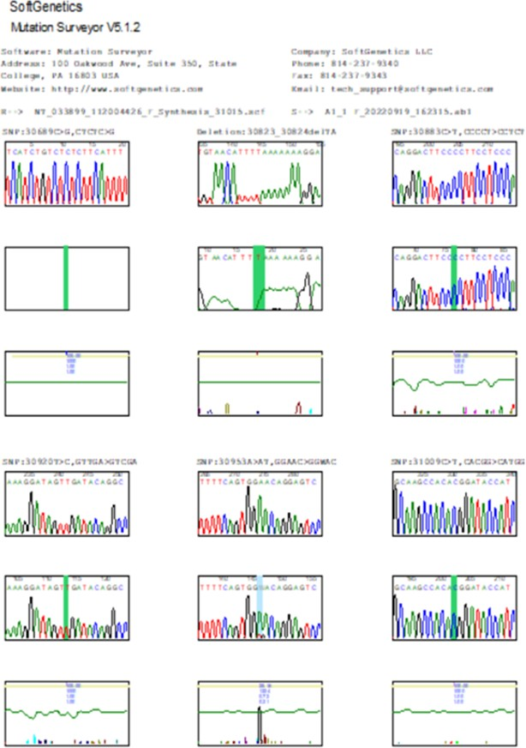

Appendix 1: First sample displays of three different polymorphisms (mutations) on the IL-18 promoter region. The shift from A to AT (30953A>AT$25) is called a nonsense mutation, the shift from T to TG (31033T>TG$43), and A to AC (31082A>AC$28) are referred to as sense mutations, which causes changes in amino acid molecules.

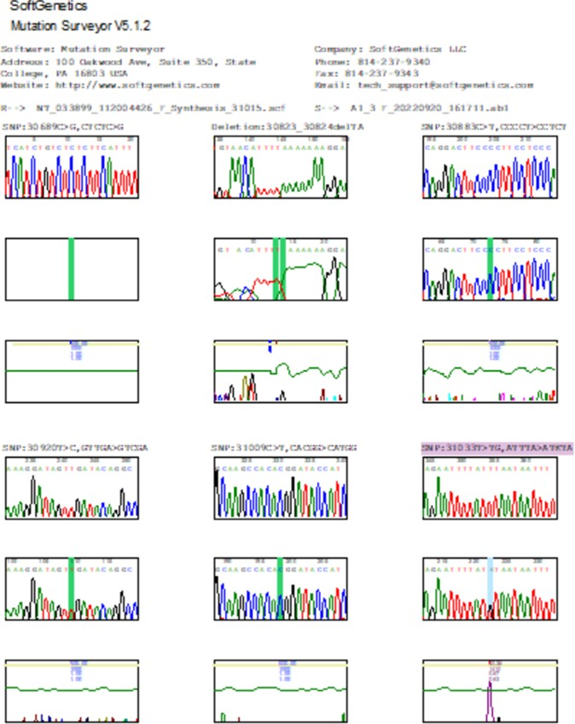

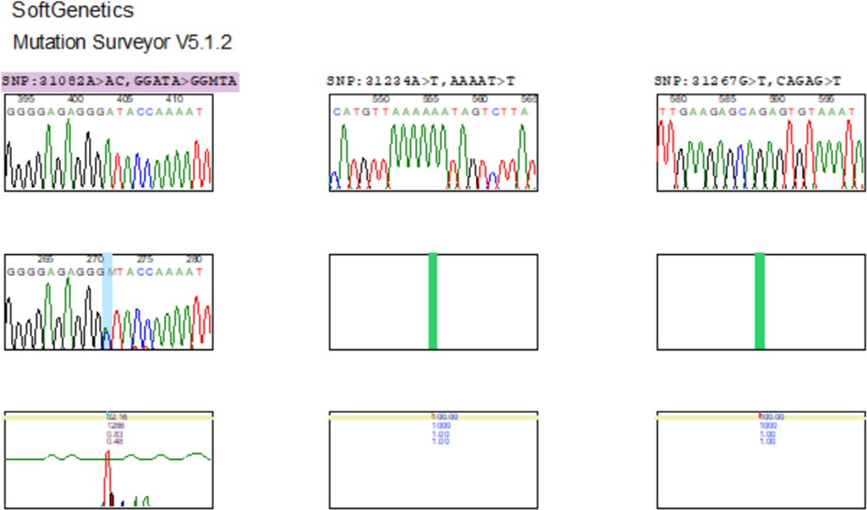

Appendix 2: The second sample presents two different polymorphisms (sense mutations) on the IL-18 promoter region. The shift from T to TG (31033T>TG$40) and the shift from A to AC (31082A>AC$32), signifies that the two mutations lead to changes in the amino acid molecules.

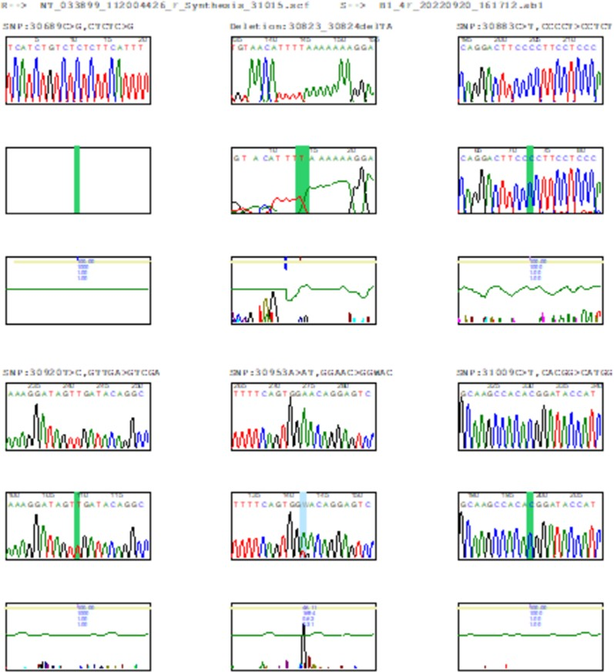

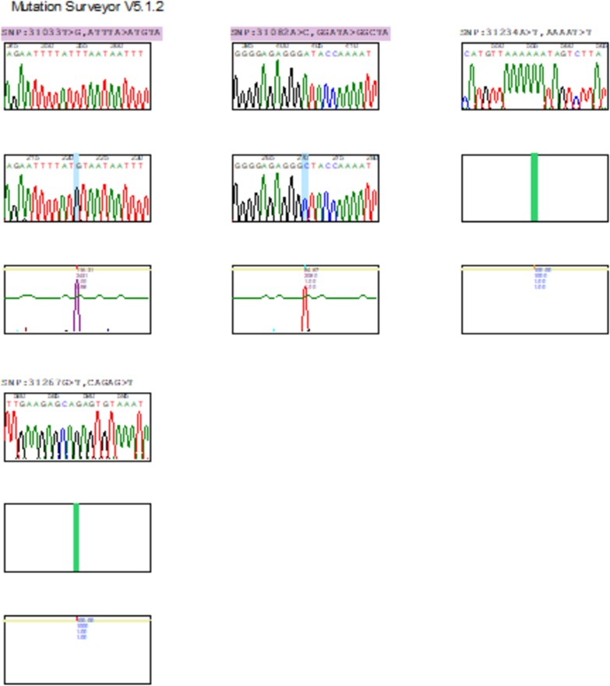

Appendix 3: sample 3 illustrates three different polymorphisms (mutations) on the IL-18 promoter region. The shift from A to AT (30953A>AT$46), T to TG (31033T>TG$44), and A to AC
(31082A>AC$65). The shift A to TG and A to AC were sense mutations, meanwhile, shift A to AT was nonsense.

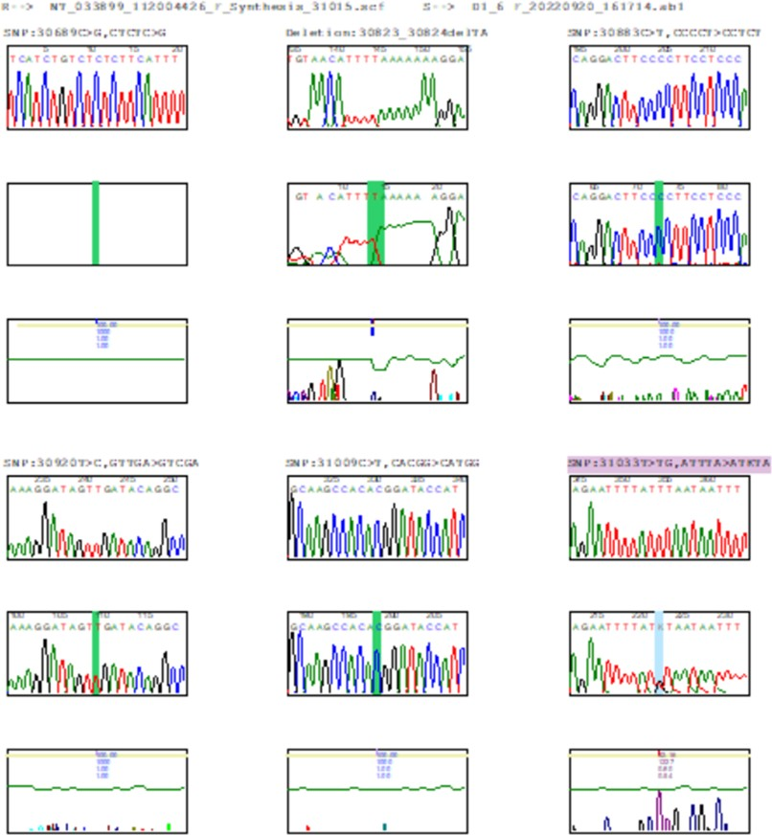

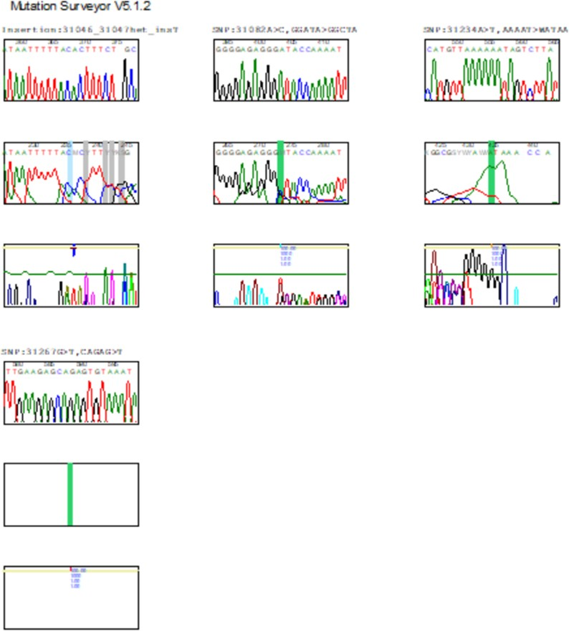

Appendix 4: (Sample 4) revealed two polymorphisms (mutations) on the IL-18 promoter region. The shift from T to TG (31033T>TG$37) and A to AC (31082A>AC$29) were both sense mutations, again, causing changes in the amino acid molecule.

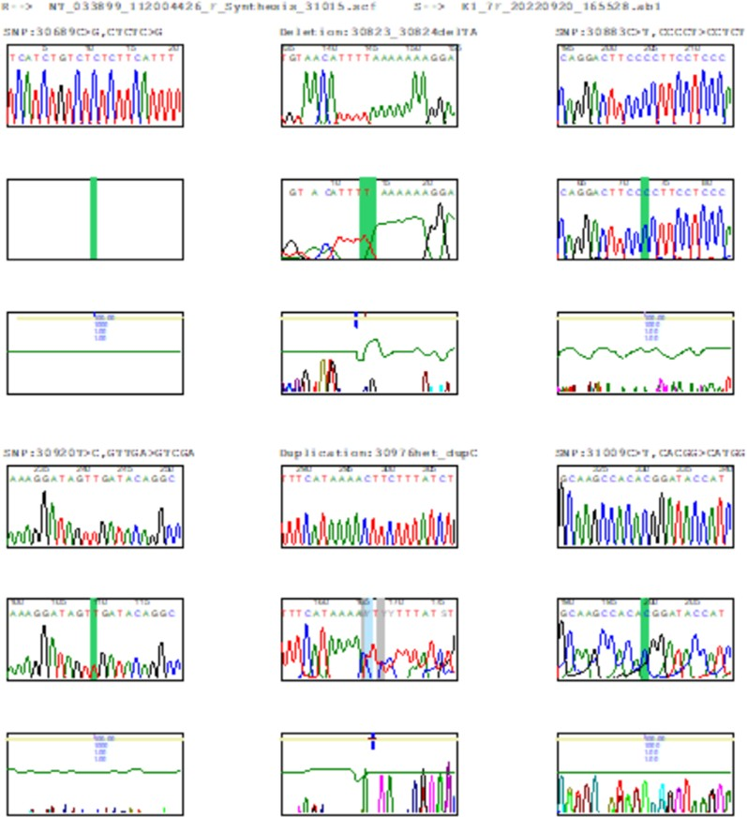

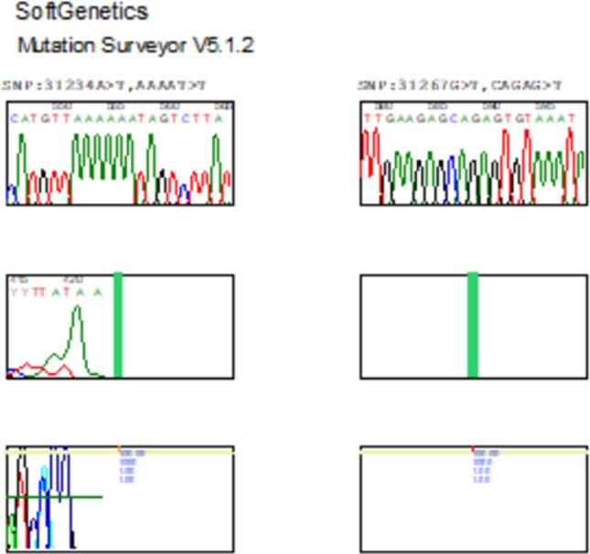

Appendix 5: Sample 5 flaunted three different polymorphisms (mutations) on the IL-18 promoter region. The shift from A to AT (30953A>AT$42), which is a sense mutation, a shift from T to TG (31033T>G$116), and A to AT (31082A>C$85) are nonsense mutations. Thus, the sense mutation affects amino acid molecules in the sequence.

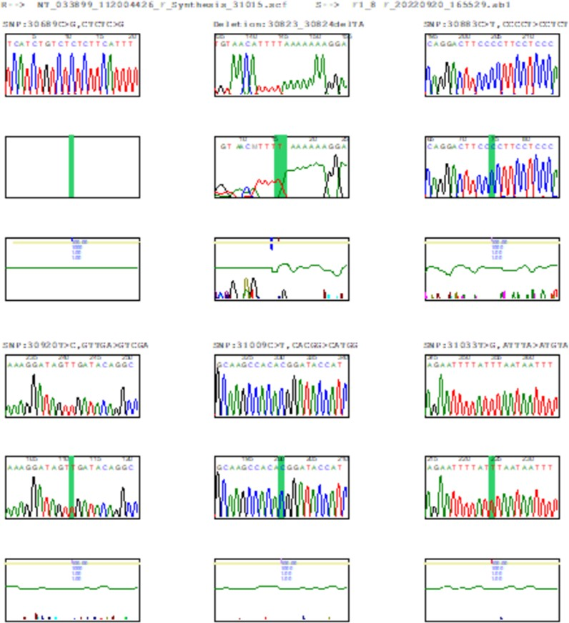

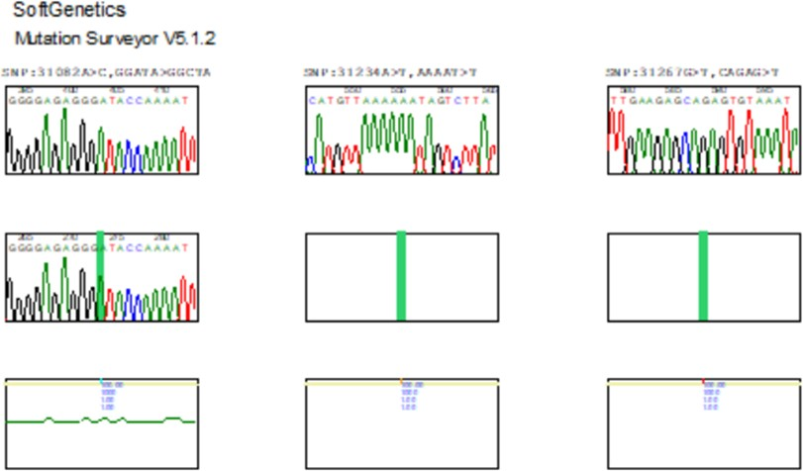

Appendix 6: Sample 6 shows three different polymorphisms (mutations) on the IL-18 promoter region, out of which two were newly discovered in the present findings. The existing SNP is a shift from T to TG (31033T>TG$32) a senesce mutation. The newly discovered SNPs are the shift from T to TA (31040T>TA$14) and A to AT (31045A>AT$15), with an additional insertion mutation that is linked to the promoter region.
Again, the sense mutation affects the amino acid molecules synthesis.

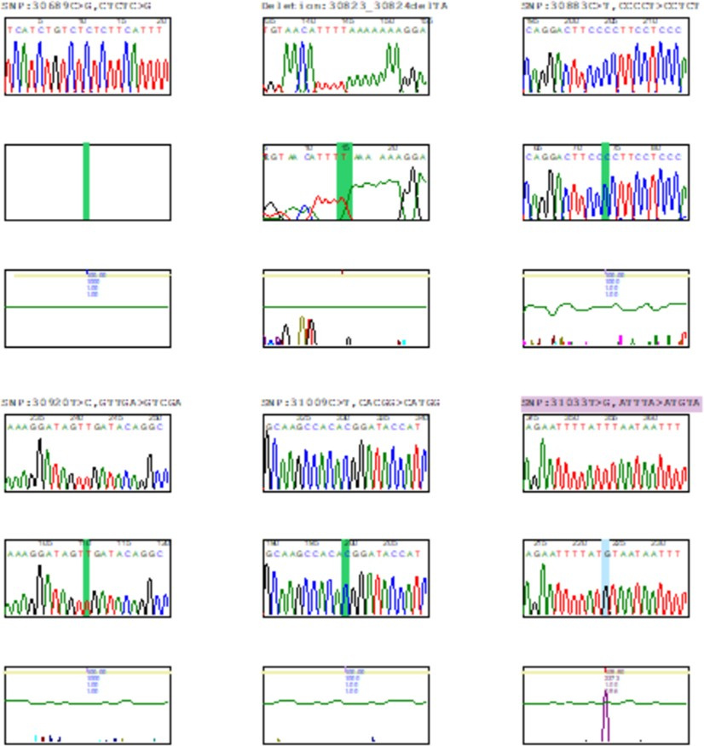

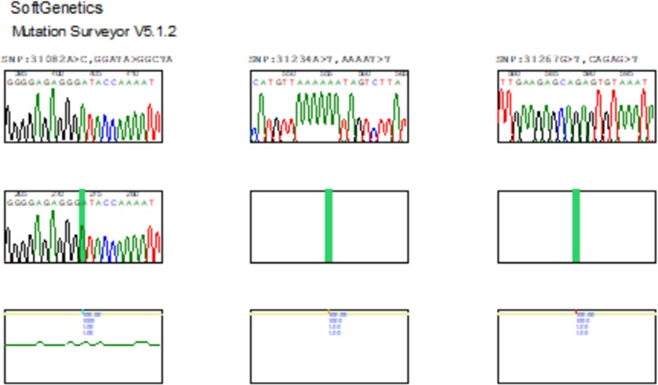

Appendix 7: (Sample 7): The gene in the current sample possessed only one duplication mutation for IL-18 which is 30976het_dupC$18 and is considered nonsense mutation, thus has no effect on the amino acid synthesis.

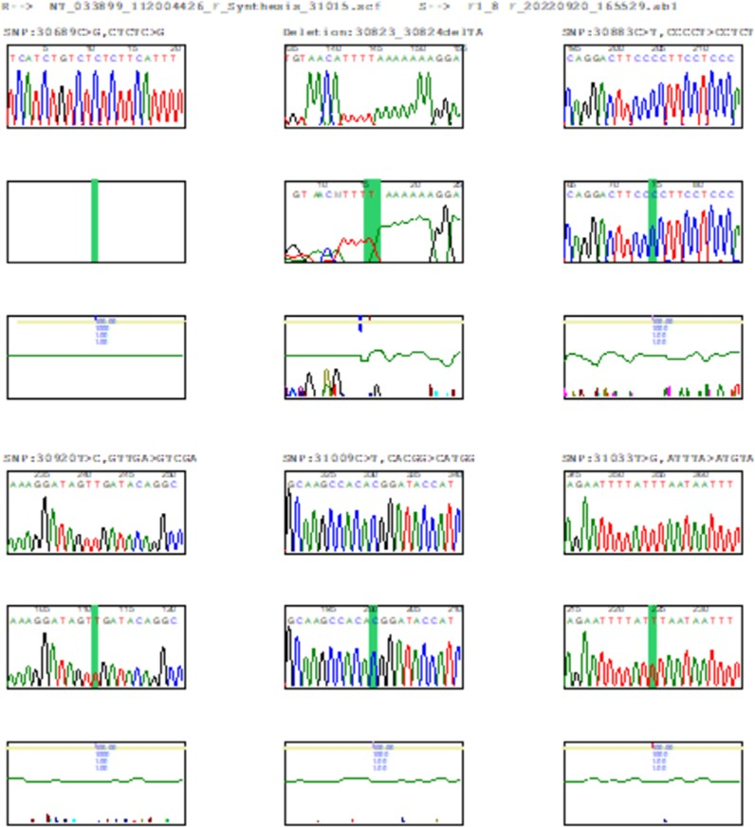

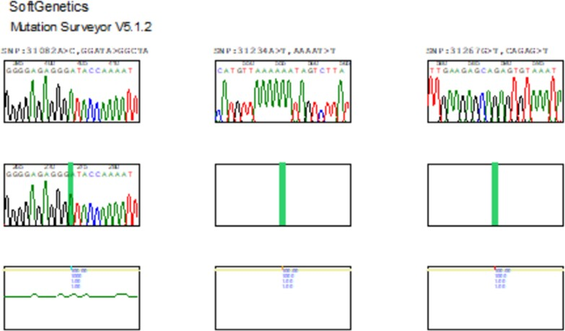

Appendix 8: (Sample 8): this result shows no mutations on the patients IL-18 promoter region. Thus, there was no any effect on amino acid molecule synthesis.

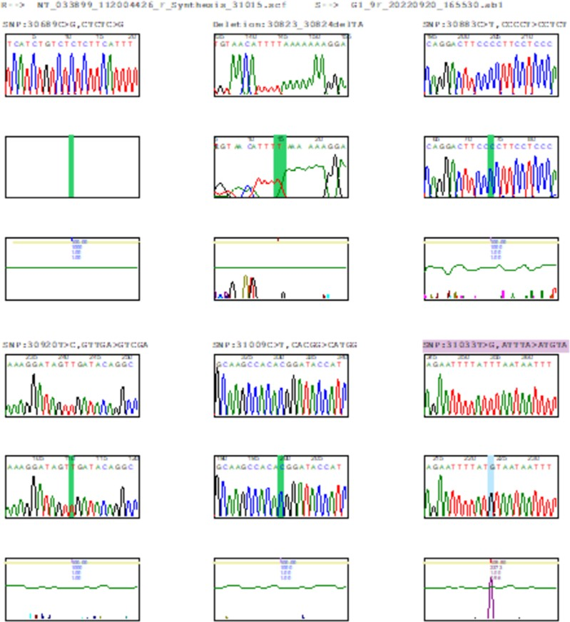

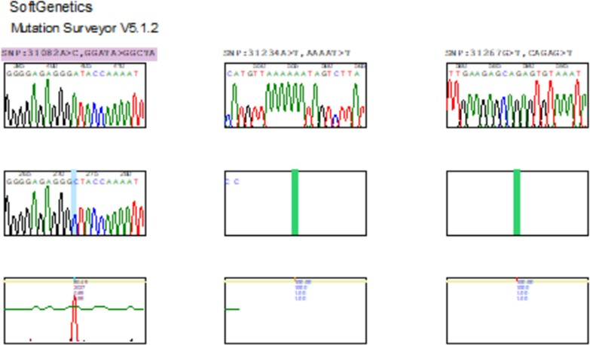

Appendix 9: (Sample 9): the result revealed two different polymorphisms that happened to be sense mutations. The shift from T to G (31033T>G$110) and shift from A to C (31082A>C$80) and both affect amino acid molecule synthesis.

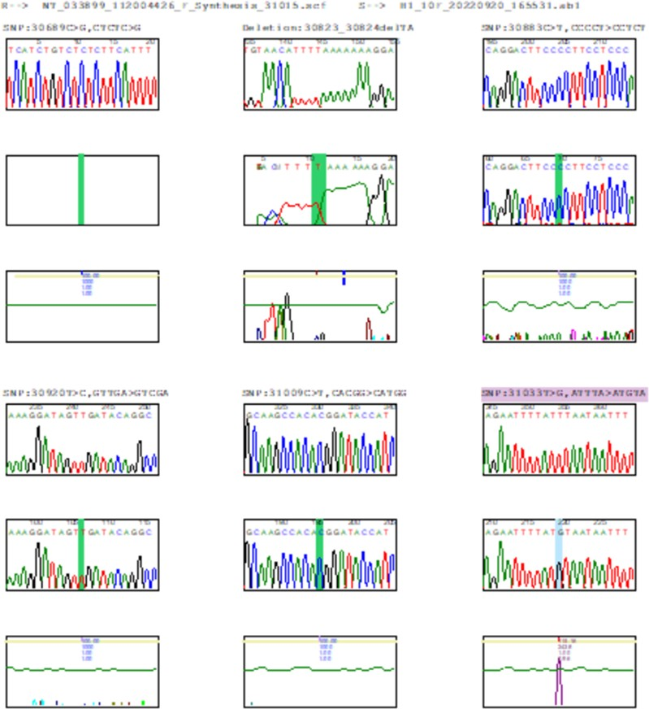

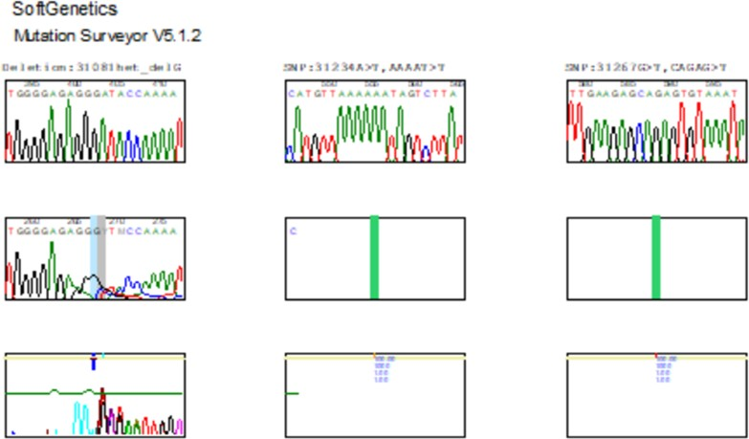

Appendix 10: (Sample 10): This result shows that there is a deletion mutation (31081het delG$4) and two SNPs mutations, one of which is a sense mutation (31033T>G$115) and the other of is a novel SNP and nonsense (31079G>GA$7). Both mutations were detected during the patient's genetic testing.

پوختە

(ALL)
لیوکیمیای توندی لیمفۆباڵستیک
لە جۆری
شێرپەنجەی خوێن
سه رەتا نەخۆشى

بە شێوەیەکی سەرەکی کاریگەری دەکاتە سەر مندااڵن.
شێرپەنجەیی خوێن یە
سیستەمێکی

دروستبوونی نەخۆشی )ALL( ئاڵۆز و فرە هۆکارە، کە هۆکاری جۆراوجۆری بۆماوەیی،و

بەرگریزانی لەخۆدەگرێت. ئامانجی ئەم توێژینەوەیە لێکۆڵینەوە بوو لە فرە روکاری بەرگری

و گەڕان بەدوای
ALL
توشبوو بە
لە نەخۆشانی
IL-18
DNAی له جینی
و فرەجۆری

دەرهاوێشتە پزیشکییە شاراوەکانیان.

کۆی گشتی 51 نەخۆشی تووشبوو بە )ALL( لەم توێژینەوەیەدا تۆمارکراون، بە

لەبەرﭼاوگرتنی تایبەتمەندییە کلینیکییەکانیان، لەوانەش تەمەن، ڕەگەز . )ALL(تۆمارکران.

تێروانین لە پشكنينى تەواوی خوێن )CBC( بۆ هەڵسەنگاندنی ده رخسته خوێنيانه ى كە بۆ نەخۆشەکان ئەنجام درا. شیکردنەوەی فلۆسایتۆمەتری بۆ دیاریکردنی جۆره جیاوازەکانی
)CD( ، لەوانە CD3، CD7، CD10، CD19، CD22، CD33، CD34، سایتۆپالسمی CD79a،
.HLA-DR و TdT ،CD123 ،CD117

پشکنینی ئەندازەی بۆ ماوەیی لە جۆری )PCR( بەکارهات بۆ گەورەکردنی ناوچەی

ئەنجامدرا بۆ
(Sanger sequencing)
IL-18، و ڕێکخستنی سەنگەر
هەلئاوساوی جینی

شیکردنەوەی هەر گۆڕانکارییەک یان پۆلی فرەشێوه تاکە نیوکلیۆتاید )SNPs( لەم ناوچەیەدا. سیستەمی گۆڕانی بەرگریکارانەی گەورەکردنی تێتراپرایمەر )T-ARMS( بەکارهات بۆ جۆری
جین له نمونەکان بۆ فرەجۆری جینی .IL-18

B-Acute
)%75.8( پێش یان دوای
ئەنجامەکان دەریانخست کە زۆربەی نەخۆشەکان

یان هەبووە، لە کاتێکدا )%12.1( شێرپەنجەی
Lymphoblastic Leukemia (B-ALL)

خوێنی (T-ALL) Leukemia Lymphoblastic T-Acute یان هەبووە. جیاوازییەکی بەرچاو
لە دەربڕینی نیشاندەری CD لە نێوان نەخۆشاندا دەربڕینی جیاواز بەدیکرا، لەگەڵ CD19+،

هەبوو.
کە پەیوەندییان بە ڕێژەیەکی بەرزتری خانەی پێنەگەیشتوو
CD10-
و ،CD79a+

تێکڕای تەمەنی دەستنیشانکردن بریتی بوو لە 8.7 ساڵ بوو، هەروەها جیاوازی دیار هەبوو

لە دەربڕینی نیشاندەری CD لەنێوان نێر و مێ لە مەودای تەمەنی سەرووی 15 ساڵ و خوار
15 ساڵ.
دەربڕینی مامناوەندی یان نزمی CD45 ئەرێنی نیە لەگەڵ markers CD common ، وەکو
سایتۆپالزمی CD79a، CD22، CD19، CD10، TdT، HLA-DR، و.CD123

100%ی دانیشتوان، کۆنترۆڵى ئالیلی جۆری کێوی
،IL-18
لە ڕووی فرەجۆری جینی

هاوزایگۆتیان هەبوو، لە کاتێکدا 6 نەخۆش )%18.75( ئالیلی جیاواز )CA( یان هەبوو، و 4

%68.75ی دیکەش دوو ئالیلی
نەخۆش )%12.5( ئالیلی هاوزایگۆت )AA(یان هەبوو.
فرەجۆریان هەبوو لە ناوﭼەی خوازراو .

لە کۆتاییدا، ئەم توێژینەوەیە گرنگیی روكارى بەرگری و شیکاری فرەجۆری DNA( )ه لە تێگەیشتن لە دروستبوونی نەخۆشی )ALL( و کاریگەری شاراوەی لەسەر بەڕێوەبردنی نەخۆشەکان بەرجەستە دەکات. دۆزینەوەکان پێشنیاری ئەوە دەکەن کە هەندێک نیشاندەری
CD و فرەجۆری جینی IL-18 لەوانەیە پەیوەندییان هەبێت بە مەترسی زیاتری گەشەکردن

)ALL(، و لێکۆڵینەوەی زیاتر پێویستە بۆ لێکۆڵینەوە لەم پەیوەندییانە پێویستی بە وردی زیاتر دەبێت. بە گشتی، ئەم توێژینەوەیە تێگەیشتنێکی بەنرخە لە شێوەی گەردیلەکان و زانستی بەرگری نادیار لە )ALL( پەرەپێدەدات و هۆکارە بۆ زەمینەسازی بۆ خوێندنی داهاتوو لەم
بوارەدا.

الخالصة

هو ورم خبيث في الجهاز المكون للدم يصيب األطفال
)ALL(
سرطان الدم الليمفاوي الحاد

معقد ومتعدد العوامل ، ويشمل عوامل وراثية
)ALL(
التسبب في اإلصابة بــ
بشكل أساسي.

وتخلقية ومناعية مختلفة. كان الهدف من هذه الدراسة هو التحقيق في التنميط المناعي وتعدد

أشكال الحمض النووي لجين IL-18 في )ALL( المرضى واستكشاف اآلثار السريرية المحتملة
لهم.

في هذه الدراسة ، وتم تسجيل خصائصهم
)ALL(
مريضا مع
تم تسجيل ما مجموعه 51

السريرية ، بما في ذلك العمر والجنس والنوع الفرعي من .)ALL( تم إجراء تعداد الدم الكامل

تم إجراء تحليل
الموجودة في تحليل صورة عامة لدم للمرضى.
خاليا المكونة
لتقييم
)CBC(

التدفق الخلوي لتحديد التعبير عن عالمات CD المختلفة ، بما في ذلك CD3 و CD7 و CD10
-HLA و TdT و CD123 و CD117 و CD79a و CD34 و CD33 و CD22 و CD19 و
DR . تم استخدام تفاعل البوليميراز المتسلسل )PCR( لتضخيم منطقة المروج لجين IL-18 ،

وتم إجراء تسلسل Sanger لتحليل أي طفرات أو تعدد أشكال النوكليوتيدات المفردة )SNPs(

في هذه المنطقة. تم استخدام نظام الطفرة الحرارية )T-ARMS( لتضخيم رباعي البرايمر للنمط
الجيني لعينات تعدد األشكال الجينية .IL-18

قبل أو الشائع ، بينما
)ALL(
لديهم سرطان الدم
)٪75.8(
أظهرت النتائج أن غالبية المرضى

كان 12.1٪ مصابين بسرطان الدم اللمفاوي التائي .)T-ALL( لوحظت فروق ذات داللة إحصائية في تعبير عالمة القرص المضغوط بين المرضى الذين لديهم تعبيرات CD مختلفة ، مع CD19 + و CD79a + و -CD10 التي ترتبط بنسبة انفجار أعلى. كان متوسط عمرلعمليةالتشخيص

سنة ، وكانت هناك اختالفات واضحة في تعبيرعن مؤشرات CD بين الذكور واإلناث في
8.7

المعتدل أو
التعبير
يكن
لم CD45
عاما.
15 من
وأقل
15 عاما
الفئة العمرية التي تزيد عن

iii

، CD22
السيتوبالزمي ،
CD79a
مثل
إيجابية
CD شائعة
مع عالمات
موجودا
المنخفض

CD19 ، CD10 ، TdT ، HLA-DR ، و .CD123 من حيث تنوع جيني لجيني IL-18 ، كان لدى 100 ٪ من السكان المستخدمين لصيطرة النوعية كان متماثلة من النوع البري ، بينما كان لدى 6 مرضى 18.75( ٪) أليالت متغايرة )CA( ، و 4 مرضى 12.5( ٪) لديهم أليالت متماثلة .)AA( أما النسبة المتبقية البالغة 68.75٪ فكانت تحتوي على أليلين متماثل األشكال على منطقة
المروج. في الختام ، تأشر هذه الدراسة الضوء على أهمية التنميط المناعي وتحليل تعدد أشكال الحمض النووي في فهم اآللية المرضية لـ )ALL( وتأثيرها المحتمل على إدارة ضروف المريض. تشير

قد تترافق مع
IL-18
نوع )CD) وتعدد األشكال الجيني
النتائج إلى أن بعض موشرات من

، وهناك حاجة إلى مزيد من البحوثات للتحقيق النجاح اكثر في
)ALL(
مخاطر أعلى لتطور

هذه االرتباطات للمزيد من التفاصيل. بشكل عام ، توفر هذه الدراسة رؤية مستقبلية حول اآلليات
الجزيئية والمناعية الكامنة وراء ALL وتضع األساس للدراسات المستقبلية في هذا المجال.

iv

ی جینی بەرزکەرەوەی
DNA

فینۆتایپی بەرگری و فرەجۆری

لە شێرپەنجەی خوێنی خانەی پێنەگەیشتووی لیمفاوی

IL-18

نامەیەکە پێشکەشی ئەنجومەنی کۆلێژی تەکنیکی تەندروستی و پزیشکی هەولێر
کراوە لە زانکۆی پۆلی تەکنیکی هەولێر وەک بەشێک لە پێداویستی بەدەست
هێنانی پلەی ماستەر لە شیکاری نەخۆشیەکان )Hematology(

لە الیەن
قادر مصطفی

محمد

تەكنیكی تەندروستی و
لە كۆلێژی
بەکالۆریۆس لە شیکاری نەخۆشیەکان

پزیشكی هەولێر، زانكۆی پۆلی تەكنیكی هەولێر - ٧١٠٢

بە سەرپەرشتی

پ.ی.د. گۆران قادر عثمان

هەولێر، کوردستان

ذو القعدة 1444
جۆزەردان 2723
حوزەیران 2023

